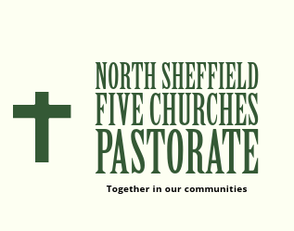
STOCKSBRIDGE CHRISTIAN CENTRE LEP
BRIGHTHOLMLEE METHODIST CHURCH
CRANEMOOR METHODIST CHURCH
CHRIST CHURCH STOCKSBRIDGE LEP
GREENMOOR METHODIST CHURCH

A Living Document for Our Pastorate

Our Profile of who we are and what we do
Who we are

- Christ Church is a United Reformed/Methodist LEP
- The Christian Centre is a Methodist Anglican LEP
- Brightholmlee Methodist Church
- Crane Moor Methodist Church
- Green Moor Methodist Church
Introduction

Stocksbridge & Deepcar is a steel town 10 miles from Sheffield in a valley of the River Don, surrounded by the beautiful Eastern Pennines with a population of about 13,000. Brightholmlee/Wharncliffe Side is a village a couple of miles south of Stocksbridge, Crane Moor and Green Moor are two villages to the north east of Stocksbridge on the border with Barnsley.
The town is vibrant, with a new shopping centre, lots of community activity, and strong networks of local people who have enjoyed the life of a small town. Stocksbridge was always prosperous with the steel, but with the loss of many workers in the last 20 years, the community has suffered. Many less prosperous people from the city housing list have moved here, into six or more areas of social housing, and many have found integration hard.
It remains a friendly and active town, with a really strong independent liberal attitude, and a strong work ethos. Music and drama important strong cultural activities in the town and the local area. There is an annual week-long music festival, an annual Arts Festival “Homegrown” every October, which many of the Christ Church Community groups participate in. There are several local male voice and mixed voice choirs. There is a local football team, Stocksbridge Park Steels FC, an excellent citizen built and managed Leasure Centre, a thriving golf club and The Stocksbridge Rugby Club, which has its home in a former Methodist Church!
Two of the churches in this pastorate are located within the town, The Christian Centre and Christ Church. There are two Anglican churches making up one parish, a Roman Catholic Church, a Salvation Army Meeting House and an Evangelical Church. These churches have worked together in the past under Churches Together in Stocksbridge & District. This group needs reinvigorating and, in the past, the clergy have met regularly to facilitate the working together of the different denominations.
Brightholmlee and Wharncliffe Side is just a mile or so down the road towards Sheffield. Previously a farming community it is now almost entirely residential and it was designated as a conservation area in 1977. Brightholmlee Methodist Church is the only church in this community.
Green Moor sits on a hill above Stocksbridge. Historically it was part of the Parish of Penistone, once known for quarrying of local stone. Stone from Green Moor was use for the paving flags around the Houses of Parliament. It is now predominantly residential surround by farmland. Further to the north east lies the village of Crane Moor. It is situated on the northern most outskirts of Sheffield and is surrounded by beautiful countryside. The village is known for its peaceful and tranquil atmosphere, making it a popular destination for those looking to escape the hustle and bustle of city life.
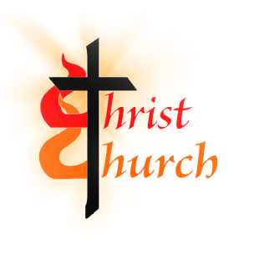
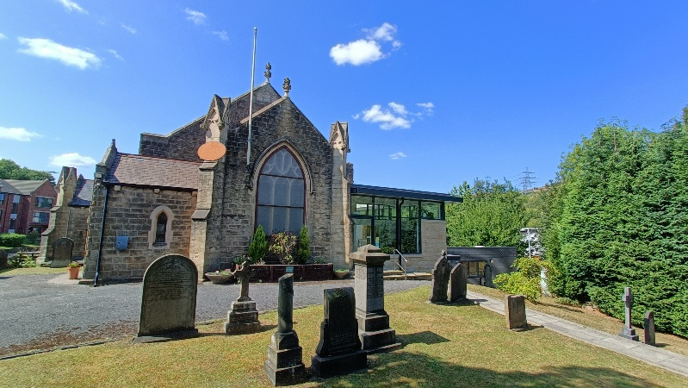
Christ Church Stocksbridge

Christ church is a United Reformed Church/Methodist Church LEP established in 2008 with the coming together of Stocksbridge URC and Deepcar Methodist Church. The leaders of the two churches knew each other from inter-church collaboration, working and social lives, and they came to the view that it made sense to merge the two churches while they were still going concerns.
Theology
There are two key strengths of Christ Church and its congregation and its attraction to people, who have a lot of experience of church and to others who do not:
- It takes a holistic approach to the gospel in that it believes both speaking about Jesus, and following his command to love God and serve your neighbours are essential and co-equal parts of what it means to be a community of disciples.
- It welcomes Christians of all denominational experience and recognises the value of sharing theologies and ways of worship, and encourages a wholesome openness about the various ways in which individuals experience and speak of their faith.
One result of this is that the church is genuinely friendly and welcoming, warm and relaxed, and people state that in various ways.
Worship
Our worship style would best be described as a melding together of traditional URC and Methodist worship. On Sundays there is a morning family service with Junior Church. There are usually around 40 in the congregation, 20 in the choir, and anything from 2-10 children. Sometimes there are over 80 people on a Sunday. Twice monthly this service is led by the minister, the first in the month including Holy Communion and the other Sundays, by one of its own Worship Groups, of which there are 5 and the remainder by Local Preachers.
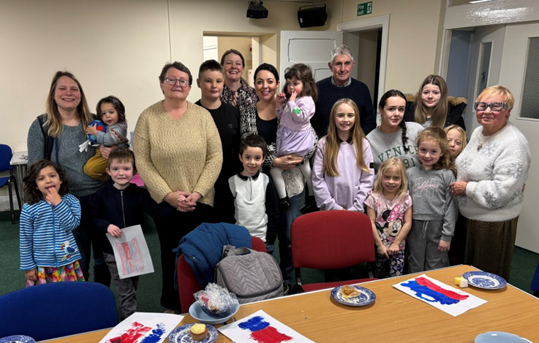
The children and young people join in the main service for the first 20 minutes and then go into their own Junior Church sessions. Junior Church is led by a former RE teacher helped by a group of volunteers.
Sunday and other main services are steamed live to our YouTube Channel and can be watched concurrently or at a later date.
Church Activities
Our church premises are incredibly busy, for which we are delighted. Over 300 people pass through the building on a weekly basis, not counting Sunday Worship. It demonstrates that our vision and mission of providing a vibrant community centre is coming to fruition.
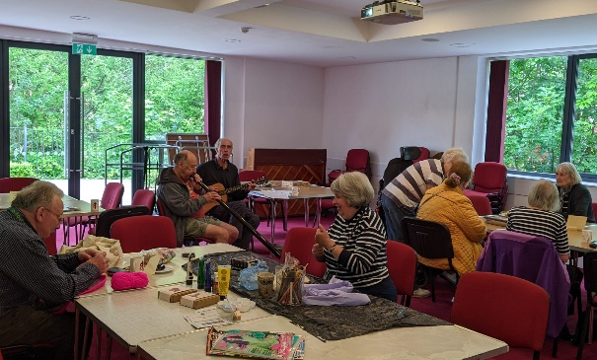
- The Meeting Place
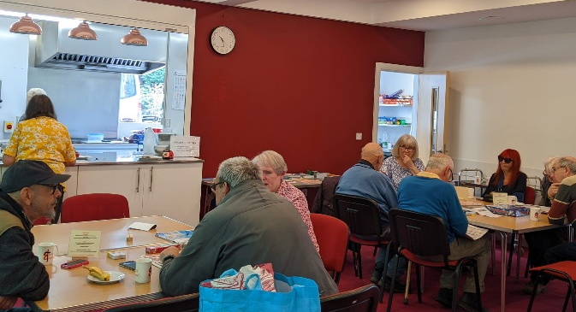
On Mondays we run a social café aimed at all those of any age within our community who feel isolated of any age. This is supported by a grant from the URC Yorkshire Synod, to cover a paid worker to run the cafe. We have also recruited church and community volunteers to help run this. It won the URC Community Work award some years back.
- Choir
There is a mixed voice choir of over 20 members who meet for practice on a Wednesday evening. Hymns are practiced to lead the worship singing and choir items prepared to enhance Sunday Worship. The choir also participates in other secular events throughout the year, such as shows, pantomimes or concerts.
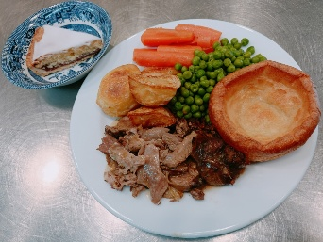
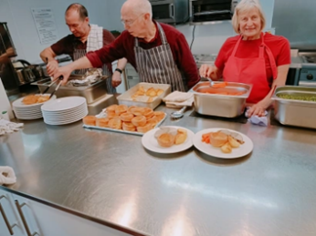
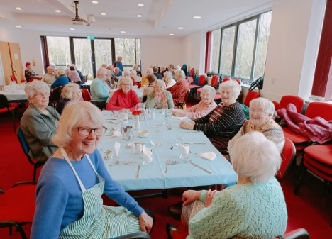
- The Lunch Club

Every Thursday lunch is served to between 45 and 55 people. Run by volunteers from the church and the community, it provides a lifeline for many isolated older people in our community. Users get refreshments in the morning then a range of activities or entertainment before a 2-course hot meal is served. The church has a minibus, provided by Pitsmoor & Shiregreen Community Transport, which is used to help frailer members attend.
- The 3 C’s
On the first and third Friday of every month Coffee, Cake & Chat takes place either in Church or in the Community Hall in the school holidays. Homemade cakes and drinks are served and a good natter had by all.
- Busy Little Hands

Run by our salaried Children’s Worker and helpers, this is our Baby and Toddler group. Equipped with a large selection of Toddler toys, creative crafts are available, story-time, themed events and a Healthy Snack Time. Refreshments provided for parents and carers; this runs every Friday in School termtime.
- Social Events
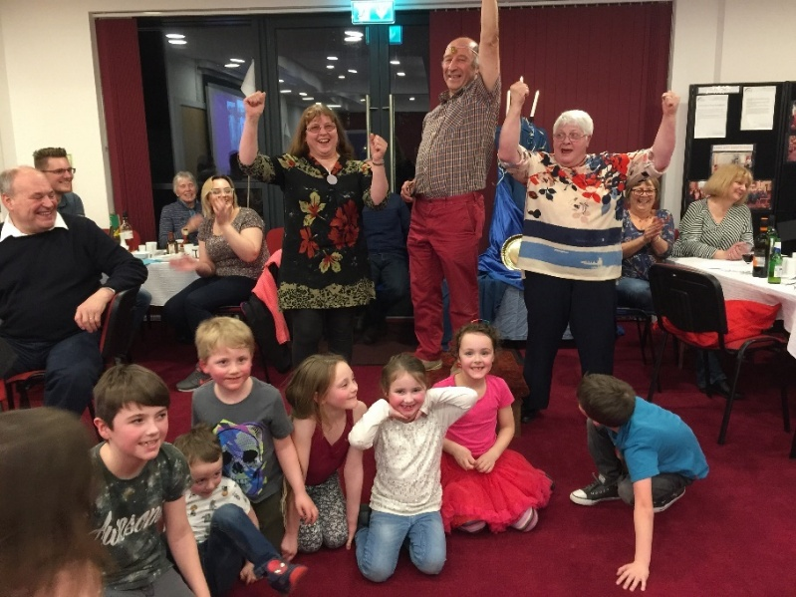
A social event runs most months for all the church family. These range from quizzes, to games nights, themed parties and 4 Course Dinners.
This is the winning team celebrating at our Olympics themed party night.
Alternate years the whole church family comes together to stage a major production, usually staged over three nights to sell out audiences. In the past these have been pantomimes or full blown musicals such as Joseph & The Amazing Technicolor Dream Coat. Our next production in the pipeline is a Christmas extravaganza, Carry On Christmas.
Community Links
Half of the strategy at merger was to create a church for the town, and we have been able to make that happen.
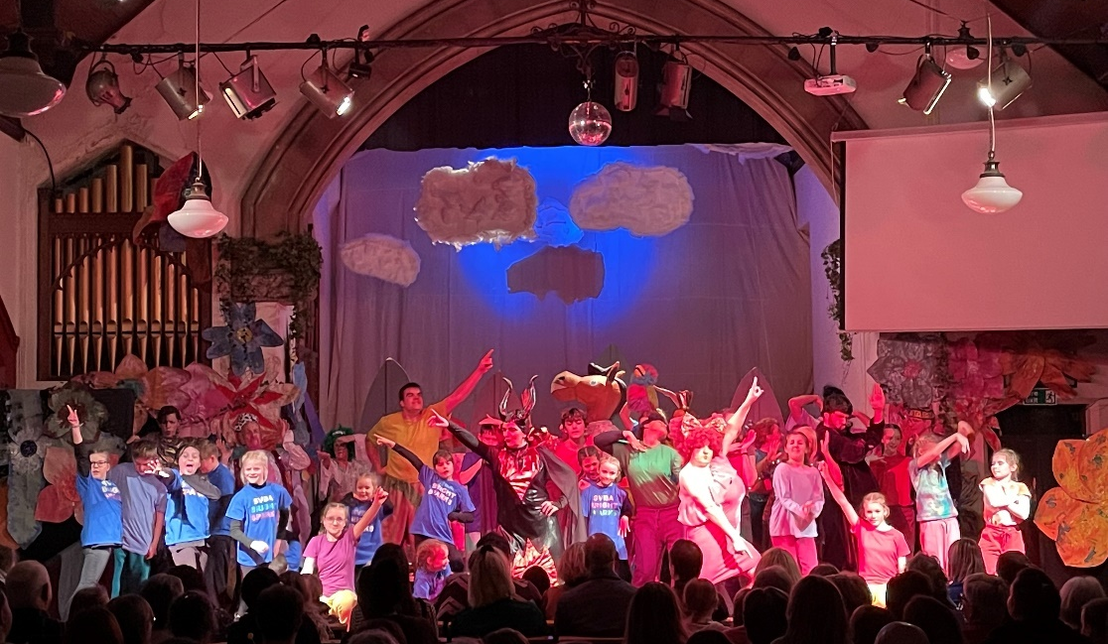
Our largest partner is Steel Valley Beacon Arts, a local registered charity devoted to drama, arts and music for all ages from 7 to 90+. We are now their home for rehearsal and productions.

Supported by a paid, professional producer/director they develop the skills of their members in all aspects of theatre craft. They have access to a professional musical director and singing teacher and a professional theatre technician, who works with them on most of their productions. They recently won a National Theatre Award for their work with young people. They meet on Tuesday and Friday evenings.
On Monday afternoons, once a month, the Stocksbridge Townswomen’s Guild meets.
Alternate Monday evenings Stocksbridge Photographic Society meet
On Tuesday mornings the Stocksbridge Arts Group fills the Community Hall with local people who paint and draw. They also hold an exhibition of their work once a year in the building.
On Wednesday morning Don Valley Probus meets in the Community Hall with a wide range of speakers and activities and Rhythm ‘n’ Rhyme, a music, song and movement group for preschool children meets in The Space
Wednesday evenings the building is full, with choir practice in church and one of Stocksbridge Women’s Institute or Bolsterstone Heritage & Archaeological Society meeting in the Community Hall
On Thursday evenings once a month the Stocksbridge History Society meets in the hall.
Noodle Performance Arts meets in the Community Hall every Saturday morning
Many of these groups contribute towards the Homegrown Festival for the arts which takes place for 2 weeks every October for which Christ Church is one of the host venues.

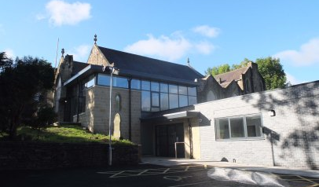
Building & Grounds
The main church worship area, dating from a 1926 rebuild, after a catastrophic fire, and a replica of the 1876 original gothic style church, is now an open space internally.
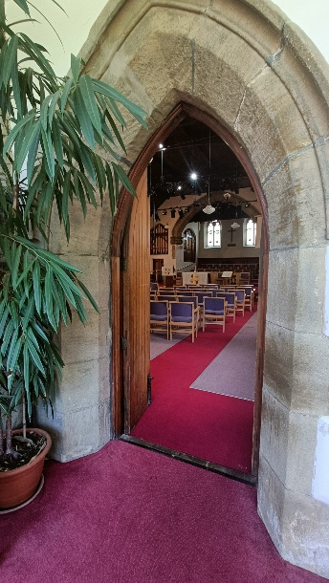
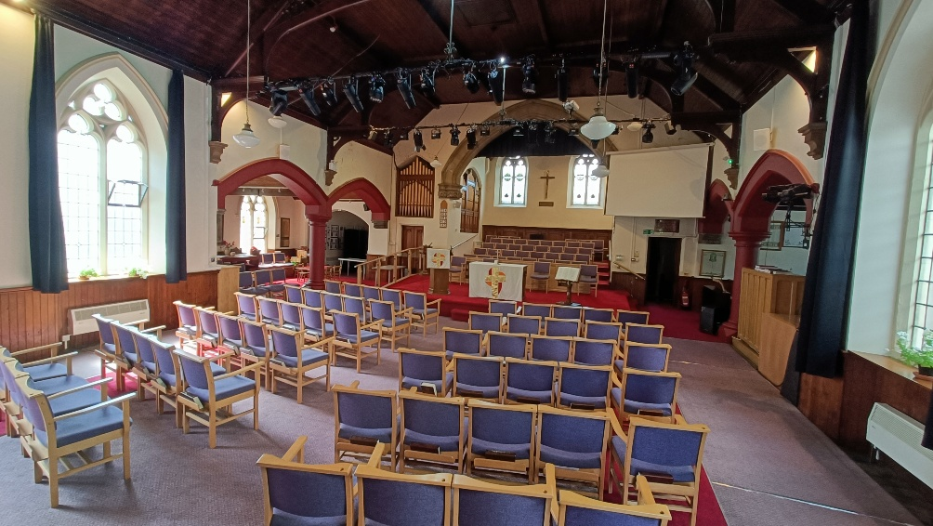
It is a warm and bright and comfortable space which is used for small or large events for worship, concerts, drama, meetings and consultations. The main body has a capacity of 156. The north transept contains the choir preparation area, a new three manual Phoenix concert electric organ, the church sound and vision and online streaming systems. The church benefits from a professionally installed video recording system, utilising fixed and moveable cameras for live streaming and recording services and other events within the church space. The church has front and back projection systems and screens for use in worship and other events.
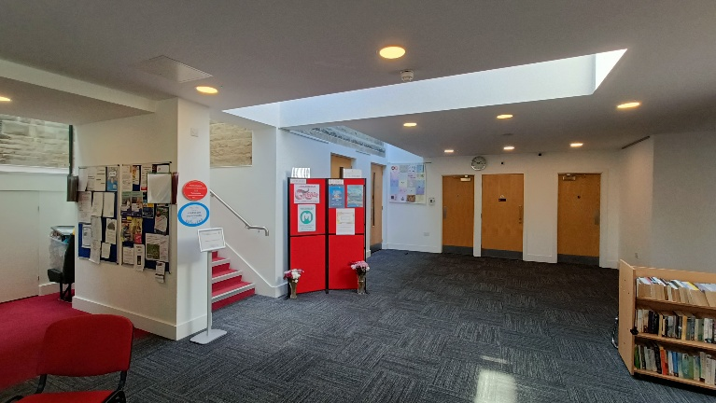
Following a successful application to the Lottery Community Fund, a new theatre lighting system has been installed to benefit all users of the Worship Area.
The lower Ground Floor is accessed directly from the car park or via the lift or stairs from the Ground Floor. Here there is a bright inviting lobby area which leads onto two suites of rooms. The Community Hall and its fully fitted catering kitchen along with modern toilet facilities makes up the newer suit of rooms. The Space is a further multi-purpose meeting area with its own kitchen and toilets and access to the garden.
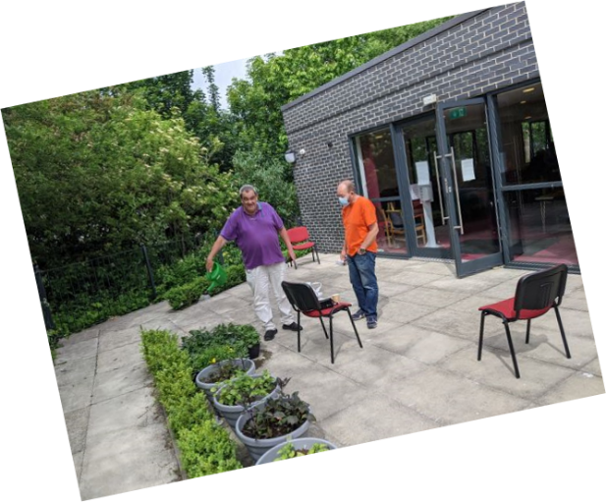
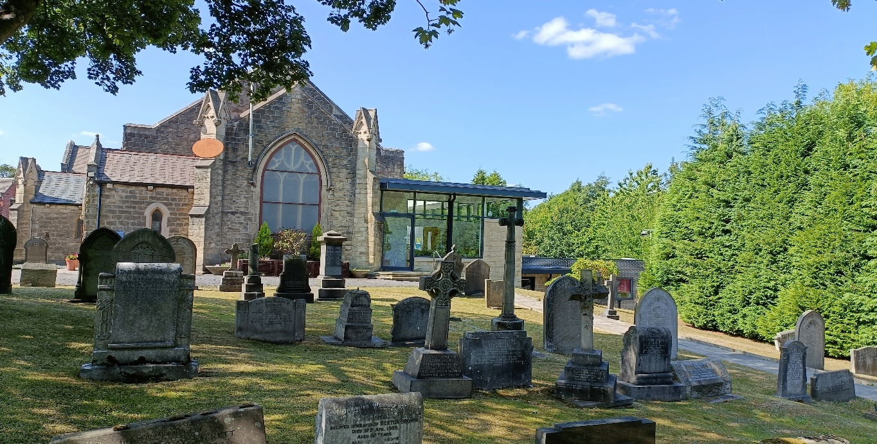
The church is set within a large curtilage, between the main road, and a ribbon of woodland on the steelworks side, which creates a comfortable environment. The Meeting Place recently re-claimed the dead land at the rear of the church to be a relaxing garden space accessible from The Space and the Community Hall, and a place for children to plant flowers and vegetables and a safe play area for the Baby & Toddler group. There is a small churchyard, which is used now only for the burial of cremated remains of members and their close families, which creates a pleasing prospect around the roadside of the church and from inside the church. It is well maintained and planted with trees and bulbs. There are two private car park areas, one of which has accessible parking next to the main building entrance and Community Hall.
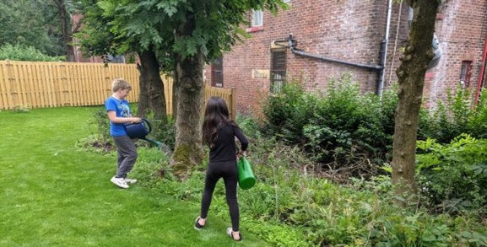

Finances
The church is in a healthy financial state. But like all organizations it is facing increasing challenges in maintaining a financial balance. This has been challenging in recent years with the increasing costs particularly for utilities and reduced income. The church leadership have in place a 3-year plan to bring the church into financial balance. Its financial reserves are ring fenced to clearly define our spending intentions. We have a Mission & Ministry Fund which has individual sub-funds to cover Future Ministry, such as our new Children’s Young People & Family Worker; a Capital Expenditure fund to complete the futureproofing of our premises; A Community Fund to invest in community projects and a Charity Fund to support our chosen charities and good causes.
We have used reserves judiciously over the years, allied to grants for building works, to make sure that the building is not a financial liability and is well-maintained.

Priorities
The church had been clear in its sequence of Strategic Plans that it has adopted since 2012. It has two purposes, both derived from our Lord’s command to us; “Love God and love your neighbour”.
1 People who wish to worship and find discipleship within a worshiping community
The first audience is those who wish to worship Our Lord. We have firmly become one church in our LEP, from our two-church beginning. We are aware of people for whom the faith has not been a part of their life, and a few have joined us over the years. We believe this is particularly true of young families and their children, and this is why the recent appointment of a full-time Church children, Youth and Community Worker is so important to the reach and development of the worshipping community.
2 The community of Stocksbridge
The second audience is the wider community of the town. It was our ambition back in 2013 to enable the re-developed church premises to support community activity in the town. We have worked hard on that. We have been careful not to undercut other charitable and community bodies who also wish to see activity in their premises.
We have entered into an informal partnership with the extra-ordinary community arts charity in the town, and this has created a more significant role in the town for Christ Church. But the number of small groups that use the church is a very helpful contribution to the town and community well-being. We have also welcomed people for baptism, marriage and funerals, and continue to do so.
The keynote comment from first time visitors was one who was surprised on entry and said “Oh, this church is warm.” And it is, both in temperature and attitude.
So our priorities are:-
Priority 1: Create a younger church
Objectives: Build on the recruitment of a children and families worker.
Create suitable outreach programmes and focussed onsite activities.
Priority 2: Reach out to younger people whose faith in Jesus cannot be sustained by the existing church
Objectives: Help them to see a place for being a disciple of Jesus in their lives
Create a place of meeting and discussion for them
Priority 3: Maintain a financially secure church
Objectives: Balance the books by the end of 2026/27 financial year
Develop more rental income from children’s and community work
Explore cost-saving and advantage through collaboration between the churches in
the pastorate.
Reduce reliance on fossil fuels and reduce energy costs.

How will we get there?
We have a five-year funding grant to support our new priorities.
Discuss with the church, and other churches possibly, a new group in town and surrounding area sponsored by the churches, but free to think and express faith and spirituality around the life of Jesus outside the old orthodoxies.
We have a three-year financial plan in its second year.
We have already agreed a common Mission Plan and we are beginning to explore what it could mean for collaboration

