Call to worship
Christ Church Stocksbridge
“Together at Home”
with Crane Moor and Green Moor
Sunday 3rd October 2021
“Let them come to me”

Lord, we don’t always want to accept that we have an inner child. One that longs to skip and dance with you. As we come to you, we pray that you will take away all our stuffiness and self-importance. Then we will be able to come freely
into your presence with a childlike spirit,
and rejoice in your goodness and love. Amen.

Welcome

Hymn 255 by Bryn Rees

The kingdom of God is justice and joy,
for Jesus restores what sin would destroy;
God’s power and glory in Jesus we know,
and here and hereafter the kingdom shall grow.
The kingdom of God is mercy and grace,
the lepers are cleansed, the sinners find place,
the outcast are welcomed God’s banquet to share, and hope is awakened in place of despair.
The kingdom of God is challenge and choice,
believe the Good News, repent and rejoice!
His love for us sinners brought Christ to his cross,
our crisis of judgement for gain or for loss.
The kingdom is come, the gift and the goal,
in Jesus begun, in heaven made whole;
the heirs of the kingdom shall answer his call,
And all things cry glory to God all in all!

Joys and Concerns
Activity
Offertory Prayer
Junior Church go to their own session

The Lectionary : Genesis 2.18-24; Psalm 8; Hebrews 1.1-4; 2.5-12; Mark 10.2-16

Bible Reading : Mark 10.2-16

² Some Pharisees came and tested him by asking, “Is it lawful for a man to divorce his wife?” ³ “What did Moses command you?” he replied.
⁴ They said, “Moses permitted a man to write a certificate of divorce and send her away.”
⁵ “It was because your hearts were hard that Moses wrote you this law,” Jesus replied. ⁶ “But at the beginning of creation God ‘made them male and female.’ ⁷ ‘For this reason a man will leave his father and mother and be united to his wife, ⁸ and the two will become one flesh.’ So they are no longer two, but one flesh. ⁹ Therefore, what God has joined together, let no one separate.”
¹⁰ When they were in the house again, the disciples asked Jesus about this. ¹¹ He answered, “Anyone who divorces his wife and marries another woman commits adultery against her. ¹² And if she divorces her husband and marries another man, she commits adultery.”
¹³ People were bringing little children to Jesus for him to place his hands on them, but the disciples rebuked them. ¹⁴ When Jesus saw this, he was indignant. He said to them, “Let the little children come to me, and do not hinder them, for the kingdom of God belongs to such as these. ¹⁵ Truly, I tell you, anyone who will not receive the kingdom of God like a little child will never enter it.” ¹⁶ And he took the children in his arms, placed his hands on them and blessed them.
Word

Hymn 595 by Fred Pratt Green
Lord, we have come at your own invitation,
chosen by you, to be counted your friends;
yours is the strength that sustains dedication,
ours a commitment we know never ends.

Here, at your table, confirm our intention,
give it your seal of forgiveness and grace;
teach us to serve, without pride or pretension,
Lord, in your Kingdom, whatever our place.

When, at your table, each time of returning,
vows are renewed and our courage restored:
may we increasingly glory in learning
all that it means to accept you as Lord.

So, in the world, were each duty assigned us
gives us the chance to create or destroy,
help us to make those decision that bind us,
Lord, to yourself, in obedience and joy.

Prayers

Lord, sometimes we find it so hard to come to you, to confess our sins to you.
Sometimes our relationships – with you and with each other – aren’t right.
It can be all too easy to let other people, or things, keep us away from you.
And sometimes we try and keep others away. Please forgive us, Lord, and teach us what truly matters to you. Amen.

Lord, we pray for all who have decisions to make today, or who face difficulties or challenges in their lives.
We pray for those who are making decisions on behalf of others, and those whose decisions affect lives other than their own.
We pray that they may have courage to do what is right, and the vision to see what is important,
when there are so many other distractions.
We pray that they may all have the wisdom that comes from you – pure, peace-loving, gentle and merciful.
We pray for your Church, in all its diversity,
that it may seek you above all, that you may grant it discernment and compassion.
We pray that we may yield good fruit in our lives,
not ‘lording’ it over others or squabbling about what we deserve but instead considering the needs of others first.
Let us receive as we have been received, forgive as we have been forgiven, and love as we have been loved. For your sake and for ours. Amen.

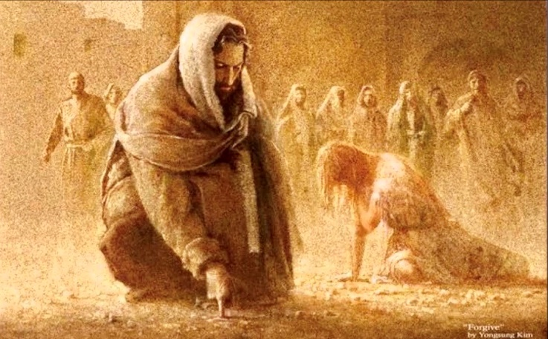
Our Father, who art in heaven, hallowed be thy name; thy kingdom come; thy will be done; on earth as it is in heaven. Give us this day our daily bread. And forgive us our trespasses, as we forgive those who trespass against us. And lead us not into temptation; but deliver us from evil. For thine is the kingdom, the power and the glory, for ever and ever. Amen.

Communion

Hymn : 613 : by Ruth Dick

God, how can we forgive
when bonds of love are torn?
How can we rise and start anew,
our trust reborn?
When human loving fails
and every hope is gone,
your love give strength beyond our own
to face the dawn.

When we have missed the mark,
and tears of anguish flow,
how can you still release our guilt,
the debt we owe?
The ocean depth of grace
surpasses all our needs.
A priest who shares our human pain,
Christ intercedes.

Who dares to throw the stone
to damn another's sin,
when you, while knowing all our past,
forgive again?
No more we play the judge,
for by your grace we live.
As you, O God, forgive our sin,
may we forgive.

The Grace and the Vesper

Loving Lord, as we leave this place,
knowing that we are valued and loved,
help us to know this so deep in our being
that we live it in our words and actions,
and especially in our openness and welcome to others.
May Jesus’ invitation shine through our lives.
Amen.

The grace of our Lord, Jesus Christ, the love of God, and fellowship together in the Holy Spirit, be with us all, now and evermore.

Take, oh take me as I am; summon out what I shall be; set your seal upon my heart, and live in me. Repeat

Now let us all enjoy a cup of tea or coffee together.

