


Christ Church Stocksbridge
Crane Moor Methodist Church
Sunday 5th September 2021
Green Moor Methodist Church

Dear

Greetings to you all at Christ Church, Crane Moor and Green Moor!
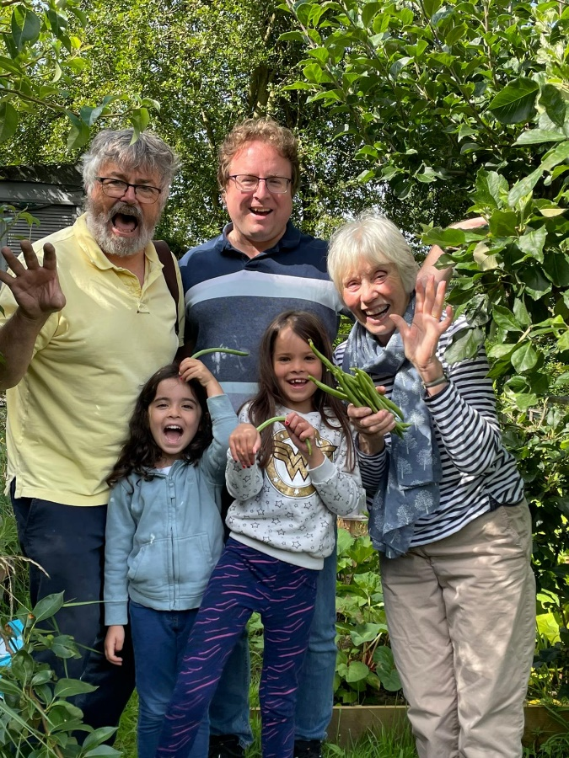
As I write, we are watching the last awful days before the borders are closed in Afghanistan, and hearing the terrified voices of women, girls, parents, who fear the possible coming of a reign of religious terror across their land. It reminds me of the fear that must have stalked our country during the civil war, when men who believed themselves ‘of God’, thought they had the right to abuse and kill others whose views were different, and especially vulnerable women and girls. Though for us that was a long time ago, I cannot imagine how hopeless they must have felt then, and these people in Afghanistan do now. I’m conscious that many of our own children gave their lives to try to create a more hopeful nation, and I weep for their families at this point. Though I know it is a long way away, I cannot but consider that the impact of this evil there may have an effect on us here. I hope that those who do make it to our shores will find a better way of life and living, so that they can themselves truly believe in the sanctity of each individual and the rights of each person to live and love and worship in their own way.
Gwen and I have had a couple of weeks with less work. We would normally have taken the caravan away somewhere; we haven’t been to France for three years now, and miss going. We’ve had some childcare days helping in Pontefract for our grand-daughter there during the school holiday. We’ve been cooking once a week for Shiregreen United Reformed Church, where they are running a summer food and activities scheme for the children who would normally be in receipt of free school meals. I’ve been doing a lot of support for the Pitsmoor and Shiregreen Community Transport to make sure we have the minibuses back in time for the activities to start again. And best of all my son Daniel and his wife Mithu and their girls, Tara and Monica, have been here for a few days. The photo shows them picking French beans (and going Ooh la la!) with us on the allotment, which is overgrown where it shouldn’t be, but providing us with some delicious home-grown food.
We are all gradually creeping out from under the blanket of fear that the virus has spread across us. Slowly activities are becoming easier for us to share; though we still sense a need to be watchful and careful, and see what the coming weeks may hold.
We have now had over a month of services in person at Christ Church, and Green Moor and Crane Moor have re-started their services in person. So on Tuesday, 7th September, the Leadership Team at Christ Church will be reviewing the situation at Christ Church, amongst its other duties.
I think that we have become increasingly comfortable in church on Sundays. We have shared communion already, and sung behind masks, and perhaps we can re-introduce coffee after church. I think we will still want to maintain some forms of social distancing, and we will have to discuss what they may be. Among the other considerations will be:
What we do about the weekly mailing? This has been a powerful force for us to hold everyone within the circle of our church. But it has taken a lot of work from a few individuals, and a weekly commitment from several others in taking them round to homes each week to save on post. We are really grateful for all your efforts. Your care in doing this has been a major part of holding our church family together during this terrible time. One of the most surprising features of the mailing is how many people who have not in the past come to Sunday Services have valued getting the letter each week. And similarly we have been thrilled that a number of people we have not seen here in person have joined us in the online services. So I think there are several questions to decide.
- Do we continue to send out the weekly service sheet to everyone? We will put some of it on the projection screen in church, so that we do not pass round lots of sheets of paper in church. And it will be available online if the preacher prepares one, but will we always ask the preacher to do this?
- Do we continue to have a weekly letter from the minister? This has helped many who are not able to get out a lot to feel included. I wonder whether we might want to continue that in some other way, but for those who would really benefit from receiving it. This might mean a greatly reduced number to produce and post or deliver. I am keen that those who cannot get to church retain a regular communication if it helps. We previously had the weekly newssheet and perhaps we could combine it with that, and make sure that it goes to the people who cannot get to worship. Though that would require a bit more work it would be less than a separate letter each week.
- How do we reach out to those who have shared the online service, and lived in the locality, and offer them a way to share with us in person as well; either in worship or in one or other of our other activities? I think I will approach each one individually, and carefully, without breaching their own space, to offer them that invitation.
The Meeting Place has been carrying on through most of the pandemic. Well done for your care and support. The Friday Coffee Club has started and welcome to one or two new members of the coffee club who have joined us in worship.
Heather has told me that she is hoping that Busy Little Hands toddler group will be able to start around the end of September, carefully watching what is going on in the schools.
The new group for young babies is also going well. I met them a few weeks ago and they are loving the chance to meet and talk and play.
Lunch Club is planning its re-opening soon, and while they will have to make some changes to how they manage things everyone will be delighted at its re-commencement.

So it feels like a fresh start for us all; gentle, careful, conscious of those we have lost, but re-emerging as a community of Christ’s disciples. We might even put a poster up on the big blue church notice-board welcoming people back! Gwen and I send you our love and best wishes,
Ian
Christ Church Stocksbridge LEP, Manchester Road, Stocksbridge, S36 1DY : 0114 288 7899
Rev Ian Lucraft, 136 Wadsley Lane, Sheffield, S6 4EE
ianlucraft@btinternet.com : 0114 234 7153 : 07428 744 014
Website for Worship is www.christchurchonline.org : and on Facebook at @christchurchstocksbridge

