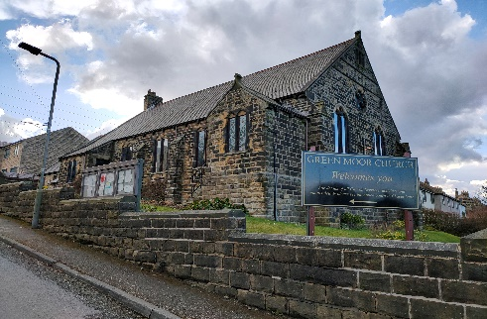

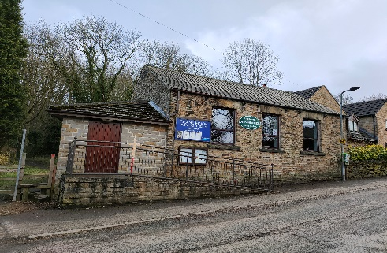
Crane Moor Methodist Church,
Green Moor Methodist Church,
Christ Church Stocksbridge,

I am writing to you this week on Tuesday the 17th, after walking on Kinder Scout yesterday with a friend,

For Sunday 13th June, 2021

Dear

Hello again one and all.

Well, I feel very blessed writing this letter today as I am sat sitting, as Terry Wogan used to say, in the garden in glorious sunshine and warmth at 8.30 in the morning. Let’s hope the good weather stays as we bid farewell to a rather glum May.

There is good news and bad news in the media, with the death rate from covid down into single figures in the daily count and some degree of normality is returning. However, the rate of spread of the delta variant (formerly known as the Indian variant) is giving cause for concern. Sarah, our Church Secretary at Christ Church and her young daughter Emily, are not well at the moment and have tested positive for Covid-19. A warning to us all that we are not out of the woods yet. We still must be careful and cautious and not run the risk of undoing the progress we have made so far. Let us hope that sense and science and not politics, prevails when the government makes its next major decision on 14th June.

As you will see on Sunday, the Junior Church at Christ Church have been busy again preparing another contribution to our on-line worship. As the “Road-map” rules have allowed, our young people have been able to meet up together, hence the title of the service “Together Again”. It will be a slightly different service as it is the 205th Anniversary Service. The young people have been looking at the history of the Sunday Schools of both our former constituent churches, namely Stocksbridge Methodist and Stocksbridge URC.
What would those members of those church congregations and Sunday Schools make of our on-line worship two hundred years on?

Rachel Proctor, the new Christ Church Junior Church Lead has been hard at work, ploughing through the quagmire of rules and regulations, in order to get Junior Church up and running. It will meet for the first time on Sunday 6th June for a picnic and time together. Let us hope this good spell of weather holds for them. We wish them luck and God’s blessing as they start up again.

As John said last week in his letter, the Church Officers at Christ Church have had a lengthy discussion about moving forward as lockdown continues to ease. Ian has written as summary report of the discussions, and it will be presented to the Leadership Team the day after the expected governments next announcement about the road-map. This will hopefully enable the meeting to make an informed and safe decision about how we progress towards worshipping together again, in person, in the church building.

The new filming and recording system is now fully installed and working well. I think I have mastered the workings, but this is still a work in progress! John also said last week that the Worship Group, now much larger I am delighted to say, met on zoom. Within that group we hope to have quite a number of people, who will be fully versed in the “law of the new system”. This will mean that it does not fall to just one or two to ensure that, as and when the church building reopens for worship, it will be streamed live into peoples homes and recorded for access at any time on our website. So, whether you are able to be in the building in person or at home, we will all be together as one worshipping church family. As leader of the Worship Group, I am delighted that so many people are willing and able to help with our future services and that new people are putting themselves forward to help lead this initiative. We are truly blessed in our church community.

As Crane Moor and Green Moor move forward also to worshipping in their respective buildings, I hope that the link created during this pandemic time remains. We are stronger together and are all working with the same goal of spreading the Gospel of Christ. We will always be together in the Spirit.

You will have noticed that there is no activity sheet in this week’s mailing. But that doesn’t mean there isn’t an activity. You will need to do a bit of homework first. You need to find the inside of a toilet roll or kitchen roll, two elastic bands, some scrap paper (you could recycle this letter) some dry rice, pasta or pulses or some small coins or pebbles. Then be ready to follow the instructions on Sunday. I shall say no more.

I’ll close now, to deliver this to the envelope stuffers, stamp stickers and postal team.

God bless.

Love and best wishes,


Simon.

Christ Church Stocksbridge LEP, Manchester Road, Stocksbridge, S36 1DY: 0114 288 7899

Rev. Ian Lucraft, 136 Wadsley Land Sheffield S6 4EE
ianlucraft@btinternet.com : 0114 234 7153 and 07428 744 014

Website for Worship is: www.christchurchonline.org
and on facebook at @christchurchstocksbrige

