


Christ Church Stocksbridge
Crane Moor Methodist Church
Green Moor Methodist Church
Sunday 20th June 2021

Dear

Greetings to you all at Christ Church, Crane Moor and Green Moor!
We’ve one birthday to celebrate this week – Sam Guihano, from Sam’s family on Thursday 24th. Happy Birthday to you, Sam!
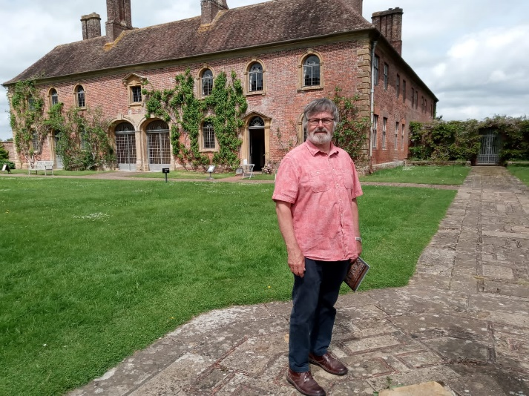
Gwen and I are glad to be back from our travels! One week we took our caravan down to Dorset for our son, Andrew and his family to use for a week, stopping at Daniel’s for a couple of days on the way. The next week we went back to Dorset to bring it home. Four journeys seems a lot. We had a couple of days to ourselves each time, though, and that was lovely. We revisited Swanage and the Globe at Durlestone, and went to Barrington Court National Trust for the first time.

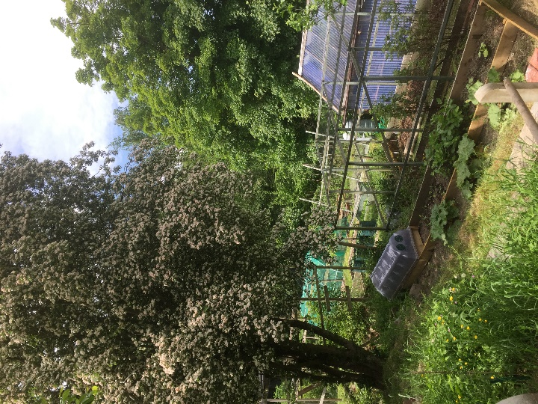
In-between we’ve been planting and chasing to keep the growth in order on the allotments. We’ve finally moved a roof-full of slates I stored 10 years ago for when they might ‘come in’. They haven’t yet so they have been put to one side to make two more beds for rhubarb, squash, parsnips and turnips. Here’s hoping for our own parsnips on the table at Christmas, though under the tree is not good!
This Sunday I have included the words of a song by Miley Cyrus, as part of our prayer-time. “Everybody needs inspiration”. I’m going to refer to it in the short sermon. For those of you with computers, or smartphones, or tablets, you can listen to her singing it on YouTube if you want. It’s a great song.
I’ve had to put just the words in the sheet. I would have liked to play it during the service itself. But Facebook, and YouTube, both check when you are playing songs etc., from professional performers, and they block the music if you haven’t paid for the permission. And it is very difficult to do that for single songs or performers. That is why John and Simon and I have all at times had difficulties with music in the online services. We are exploring moving to YouTube to make access easier for people, but this will not remove the music copyright issues.
I want to express my admiration for our worship groups and their work in leading the services. This is very important for our on-going sustainability, and it brings different insights and viewpoints to our services. There are so many people in the churches with the ability to help in these services, and I am sure that we will extend it further in future. And of course the children have been wonderful, haven’t they, as we saw last week.
All three churches are still cautiously reviewing when we can start Sunday worship again. But as I write we are waiting for news about the lockdown restrictions. I have written a paper for the Leadership Team at Christ Church to review on Tuesday 16 June, but even then that may have to be put back further in the light of the announcements we expect this week. Crane Moor and Green Moor are monitoring the situation too.
Crane Moor village was mentioned on “Springwatch” on Tuesday last week! The piece was about the re-introduction of cranes, those large flying birds, into Britain, and its name probably comes for pre-medieval description of a place where cranes live.
I expect there will be lots more to say as I get back in the swing. We hope those managing holidays away are having a good time. (They may even be watching us online!) Nick and Robyn are preparing to move house and welcome a baby, and our thoughts go out to them. Brian’s ashes are being interred on Wednesday 23rd in a private family service in our graveyard. Our thoughts and prayers are with Dorothy and her daughters.

Gwen and I send you all our love and best wishes.

Ian Lucraft
Christ Church Stocksbridge LEP, Manchester Road, Stocksbridge, S36 1DY : 0114 288 7899
Rev Ian Lucraft, 136 Wadsley Lane, Sheffield, S6 4EE
ianlucraft@btinternet.com : 0114 234 7153 : 07428 744 014
Website for Worship is www.christchurchonline.org : and on Facebook at @christchurchstocksbridge

