Call to worship
Christ Church Stocksbridge
“Together at Home”
with Crane Moor and Green Moor
Sunday 16th May 2021
Florence and the Dam

Hymn : 102 by Folliott Sandford Pierpoint

For the beauty of the earth,
for the glory of the skies,
for the love which from our birth
over and around us lies.
Christ, our Lord, to you we raise
this, our hymn of grateful praise.

For the wonder of each hour
of the day and of the night,
hill and vale and tree and flower,
sun and moon and stars of light,

For the joy of human love,
brother, sister, parent, child,
friends on earth, and friends above,
for all gentle thoughts and mild,

For yourself, best gift divine,
to the world so freely given,
agent of God's grand design:
peace on earth and joy in heaven.

Welcome
Joys and Concerns
Offertory Prayer
The Lectionary :Acts 1.15-17,21-26; Psalm 1; 1 John 5.9-13; John 17.6-19
Bible Reading : John 15 vv 9-17 read by Stella
Story
Activity

Hymn : by Sheila Erena Murray

For everyone born, a place at the table,
for everyone born, clean water and bread,
a shelter, a space, a safe place for growing,
for everyone born, a star overhead,
and God will delight when we are creators
of justice and joy, compassion and peace:
yes, God will delight when we are creators
of justice, justice and joy!

For woman and man, a place at the table,
revising the roles, deciding the share,
with wisdom and grace, dividing the power,
for woman and man, a system that's fair,
and God will delight when we are creators
of justice and joy, compassion and peace:
yes, God will delight when we are creators
of justice, justice and joy!
For young and for old, a place at the table,
a voice to be heard, a part in the song,
the hands of a child in hands that are wrinkled,
for young and for old, the right to belong,
and God will delight when we are creators
of justice and joy, compassion and peace:
yes, God will delight when we are creators
of justice, justice and joy!

For just and unjust, a place at the table,
abuser, abused, with need to forgive,
in anger, in hurt, a mindset of mercy,
for just and unjust, a new way to live,
and God will delight when we are creators
of justice and joy, compassion and peace:
yes, God will delight when we are creators
of justice, justice and joy!

For everyone born, a place at the table,
to live without fear, and simply to be,
to work, to speak out, to witness and worship,
for everyone born, the right to be free,
and God will delight when we are creators
of justice and joy, compassion and peace:
yes, God will delight when we are creators
of justice, justice and joy!

Word

Prayers

God of abundant life, we see your goodness all around us and we thank you for every part of it; from the plants and animals which play their part in complex ecosystems, to the dry deserts and stormy seas which test the limits of life. We pray that in this time of climate crisis and ecological emergency, you may help us to rediscover your love of creation and to reflect that in our own lives. Lord, in your mercy, hear our prayer.

God who speaks through unexpected people, We thank you for contemporary prophets who are challenging us to act on climate change; for indigenous people and their invaluable knowledge of the land and sea where they live, for scientists dedicating their careers to warning us about changes to the planet, and for young people striking for their future. We pray that you will help those in power to hear their prophetic voices. Help them to see beyond short-term political priorities and business plans. and give them wisdom and courage when they face difficult decisions. Lord, in your mercy, hear our prayer.

God of second chances, we recognise the damage we have done to the Earth and the injustice we see in society every day, all of it fuelled by worship of profit and possessions. We pray for the coming of a better world with justice, kindness and humility at its heart. We ask that you guide us to be co-creators of this new world. Give us confidence to follow the prophetic voices to stand against injustice to people and to planet. So that together, in your strength, we stop this climate crisis. Lord, in your mercy, hear our prayer.

Our Father, who art in heaven, hallowed be thy name; thy kingdom come; thy will be done; on earth as it is in heaven. Give us this day our daily bread. And forgive us our trespasses, as we forgive those who trespass against us. And lead us not into temptation; but deliver us from evil. For thine is the kingdom, the power and the glory, for ever and ever. Amen.

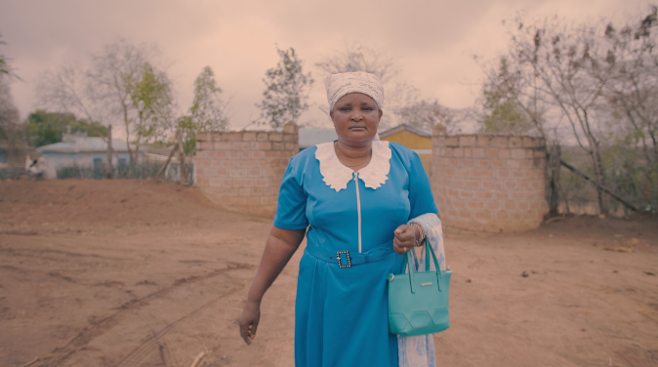
Hymn : 729 by Shirley Erena Murray
Touch the earth lightly,
use the earth gently,
nourish the life of the world in our care:
gift of great wonder,
ours to surrender,
trust for the children tomorrow will bear.

We who endanger,
who create hunger,
agents of death for all creatures that live,
we who would foster
clouds of disaster--
God of our planet, forestall and forgive!

Let there be greening,
birth from the burning,
water that blesses and air that is sweet,
health in God's garden,
hope in God's children,
regeneration that peace will complete.

God of all living,
God of all loving,
God of the seedling, the snow and the sun,
teach us, deflect us,
Christ reconnect us,
using us gently, and making us one.

The Grace and the Vesper

The grace of our Lord, Jesus Christ, the love of God, and fellowship together in the Holy Spirit, be with us all, now and evermore.
Take, oh take me as I am; summon out what I shall be; set your seal upon my heart, and live in me. Repeat
Now let us all enjoy a cup of tea or coffee together.

