Sunday 11th April 2021
Testing Truth
Christ Church Stocksbridge
Together at Home
With
Green Moor & Crane Moor
Opening Words

Call to Worship

We come from a world confused about truth.
We come with our own uncertainties.
Let us bring the darkness of human understanding
into the presence of God, who is light.
Let us bring the story of our search for truth
and share in fellowship the things we have heard and seen and touched

Welcome

God, whose light shines in the darkness,
shine on us today.
God, made known to those who met Jesus,
touch us through the experiences of our lives.
God, who gave Thomas what he asked,
give us what we need – that we too may come to believe.
Amen.

1st Hymn: StF 311 by St John of Damascus.

The day of resurrection!
Earth, tell it out abroad;
the passover of gladness,
the passover of God.
From death to life eternal,
from earth unto the sky,
our Christ hath brought us over,
with hymns of victory.

Our hearts be pure from evil,
that we may see aright
the Lord in rays eternal
of resurrection light;
and listening to his accents,
may hear, so calm and plain,
his own "All hail!" and, hearing,
may raise the victor strain.

Now let the heavens be joyful!
Let earth the song begin!
Let the round world keep triumph,
and all that is therein!
Let all things seen and unseen
their notes in gladness blend,
for Christ the Lord hath risen,
our joy that hath no end.

Activity

Joys & Concerns

Offertory Prayer

Heavenly Father, we thank you for the example of Thomas who had the courage to test the truth of what he’d been told, even if it meant he had to stand alone.
We thank you for the example of the other disciples and Jesus, who did not reject Thomas but helped him find what he needed to believe.
We thank you for all you have given us and in return we make our offering to further the spreading of the good news of the gospel.
Amen

Lectionary Readings for Easter 2

Acts 4.32-35; Psalm 133; 1 John 1.1-2.2;
John 20.19-31
John 20.19-31

It was late that Sunday evening, and the disciples were gathered together behind locked doors, because they were afraid of the Jewish authorities. Then Jesus came and stood among them. "Peace be with you," he said.
After saying this, he showed them his hands and his side. The disciples were filled with joy at seeing the Lord.
Jesus said to them again, "Peace be with you. As the Father sent me, so I send you."
Then he breathed on them and said, "Receive the Holy Spirit.
If you forgive people's sins, they are forgiven; if you do not forgive them, they are not forgiven."

One of the twelve disciples, Thomas (called the Twin), was not with them when Jesus came.
So the other disciples told him, "We have seen the Lord!" Thomas said to them, "Unless I see the scars of the nails in his hands and put my finger on those scars and my hand in his side, I will not believe."
A week later the disciples were together again indoors, and Thomas was with them. The doors were locked, but Jesus came and stood among them and said, "Peace be with you."
Then he said to Thomas, "Put your finger here, and look at my hands; then reach out your hand and put it in my side. Stop your doubting, and believe!"

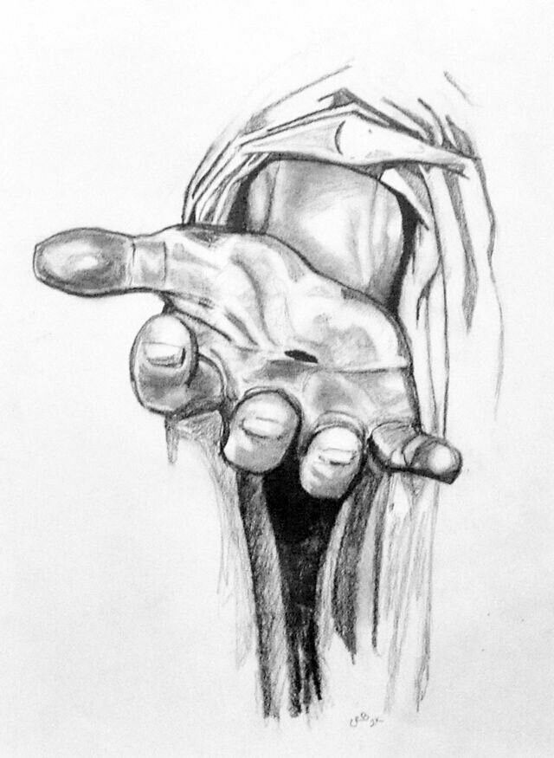

Our Father who art in heaven,
Hallowed be thy name
Thy kingdom come,
thy will be done
on earth as it is in heaven.
Give us this day our daily bread
Forgive us our trespasses,
as we forgive those who trespass against us.
Lead us not into temptation,
but deliver us from evil
For thine is the kingdom, the power
And the glory, for ever and ever,
Amen.

Closing Hymn: StF 297 by Brian Wren

Christ is alive! Let Christians sing.
The cross stands empty to the sky.
Let streets and homes with praises ring.
Love, drowned in death, shall never die.

Christ is alive! No longer bound
to distant years in Palestine,
but saving, healing, here and now,
and touching every place and time.

In every insult, rift and war,
where colour, scorn or wealth divide,
Christ suffers still, yet loves the more,
and lives, where even hope has died.

Women and men, in age and youth,
can feel the Spirit, hear the call,
and find the way, the life, the truth,
revealed in Jesus, freed for all.

Christ is alive, and comes to bring
good news to this and every age,
till earth and sky and ocean ring
with joy, with justice, love and praise.

Closing Prayer & The Grace

We say together

The grace of our Lord Jesus Christ,
the love of God and the fellowship of the Holy Spirit
Be with us all, evermore.
Amen

Vesper

Take Oh take me as I am;
Summon out what I shall be;
Set your seal upon my heart and live in me.
Take Oh take me as I am;
Summon out what I shall be;
Set your seal upon my heart and live in me.

Now let’s all enjoy a coffee or tea together.

Thomas answered him, "My Lord and my God!"
Jesus said to him, "Do you believe because you see me? How happy are those who believe without seeing me!"
In his disciples' presence Jesus performed many other miracles which are not written down in this book.
But these have been written in order that you may believe that Jesus is the Messiah, the Son of God, and that through your faith in him you may have life.

Word

2nd Hymn: StF 309
by Stuart Townend & Keith Getty

See, what a morning, gloriously bright
With the dawning of hope in Jerusalem
Folded the grave-clothes, tomb filled with light
As the angels announce, "Christ is risen!"
See God's salvation plan
Wrought in love, borne in pain, paid in sacrifice
Fulfilled in Christ, the Man
For He lives, Christ is risen from the dead!

See Mary weeping, "Where is He laid?"
As in sorrow, she turns from the empty tomb
Hears a voice speaking, calling her name
It's the Master, the Lord raised to life again!
This voice that spans the years
Speaking life, stirring hope, bringing peace to us
Will sound 'til He appears
For He lives, Christ is risen from the dead!

One with the Father, Ancient of Days
Through the Spirit who clothes faith with certainty
Honor and blessing, glory and praise
To the King crowned with pow'r and authority!
And we are raised with Him
Death is dead, love has won, Christ has conquered
And we shall reign with Him
For He lives, Christ is risen from the dead!

Prayers of Intercession

Prayer of Thanksgiving

Thanks be to the God who embraces us even in our times of greatest doubt.
When our thinking is clouded and our spirit bewildered, God holds sacred space for us.
Thanks be to the Son who accepts our questions without judgement.
He who was questioned by pauper and priest alike remains a touching place for us.
Thanks be to the Holy Spirit who guides us to answers in our day.
The one who breathes God’s understanding into us opens a safe place for us. Amen.

