Call to worship
Christ Church Stocksbridge
“Together at Home”
with Crane Moor and Green Moor
Sunday 18th April 2021
Open Minds

Against the noise of the world we cover our ears;
at distressing sights we close our eyes;
to confusing thoughts we close our minds;
amid the clamour of distress we close our hearts.
Loving God, your ears and eyes are ever open to our needs;
help us to worship with open hearts and minds,
that we may have open ears and eyes
to see the work that you call us to do,
and open hands to do it. Amen.

Hymn : : Hymns and Psalms 608 by Horatius Bonar. Tune StF 235 St Agnes

Here, O my Lord, I see thee face to face;
here would I touch and handle things unseen,
here grasp with firmer hand th'eternal grace,
and all my weariness upon thee lean.

Here would I feed upon the bread of God,
here drink with thee the royal wine of heav'n;
here would I lay aside each earthly load,
here taste afresh the calm of sin forgiv'n.

This is the hour of banquet and of song;
this is the heav'nly table spread for me:
here let me feast, and, feasting, still prolong
the brief, bright hour of fellowship with thee.

I have no help but thine, nor do I need
another arm save thine to lean upon:
it is enough, my Lord, enough indeed;
my strength is in thy might, thy might alone.

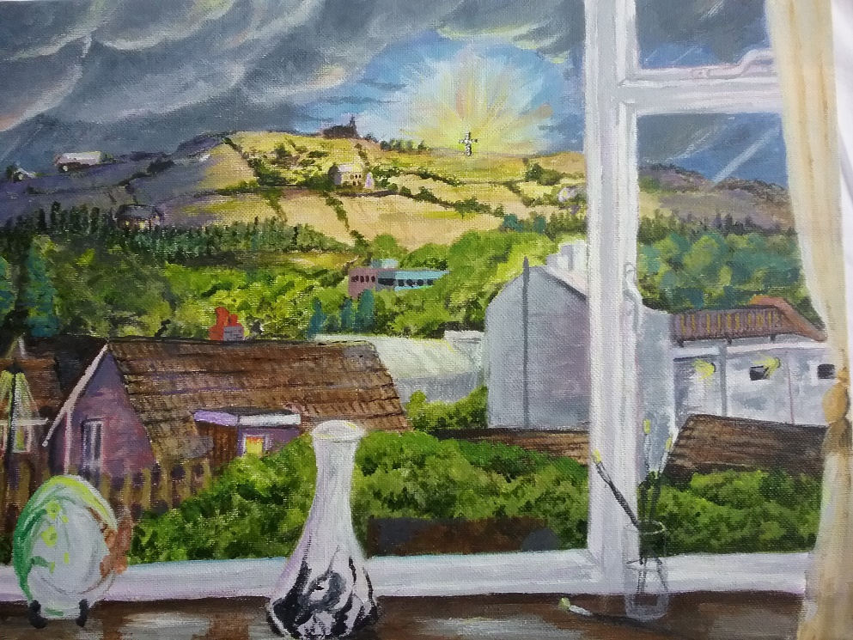
Mine is the sin, but thine the righteousness;
mine is the guilt, but thine the cleansing blood;
here is my robe, my refuge, and my peace:
thy blood, thy righteousness, O Lord my God
Welcome and Activity
Joys and Concerns
Offertory Prayer

The Lectionary
Acts 3.12-19; Psalm 4; 1 John 3.1-7; Luke 24.36b-48

Bible Reading Luke 24.36b-48

³⁶ While they were still talking about this, Jesus himself stood among them and said to them, “Peace be with you.”

³⁷ They were startled and frightened, thinking they saw a ghost. ³⁸ He said to them, “Why are you troubled, and why do doubts rise in your minds? ³⁹ Look at my hands and my feet. It is I myself! Touch me and see; a ghost does not have flesh and bones, as you see I have.”

⁴⁰ When he had said this, he showed them his hands and feet. ⁴¹ And while they still did not believe it because of joy and amazement, he asked them, “Do you have anything here to eat?” ⁴² They gave him a piece of broiled fish, ⁴³ and he took it and ate it in their presence.

⁴⁴ He said to them, “This is what I told you while I was still with you: Everything must be fulfilled that is written about me in the Law of Moses, the Prophets and the Psalms.”

⁴⁵ Then he opened their minds so they could understand the Scriptures. ⁴⁶ He told them, “This is what is written: The Messiah will suffer and rise from the dead on the third day, ⁴⁷ and repentance for the forgiveness of sins will be preached in his name to all nations, beginning at Jerusalem. ⁴⁸ You are witnesses of these things.
Sandra Taylor’s painting from her window
Word

Hymn : StF 582 by Daniel Charles Damon

Eat this bread and never hunger,
drink this cup and never thirst;
Christ invites us to the table
where the last become the first.

Asking for a cup of water,
Jesus touched forbidden ground;
and the woman, with a question,
told the world what she had found.

Walking down a desert highway,
Jesus healed a man born blind;
soon the man became a witness
to the truth we seek and find.

Weeping for his friend at graveside,
Jesus felt the pain of death;
yet he knew God's power to waken:
living water, living breath.

Prayers

Response after each line: We pray to you, O Lord.
Let us bring before God
those who have never known the transformative power of love:
those who live in fear of what others may do to them:
those who have the strength to stand up to that which is wrong:
those who have the courage and the opportunity to speak out against injustice:
those who give of themselves to help those in need:
those who work to make this world a better place:
those known to us who need our prayers at this time: Amen.

Jesus, when life or faith throws us into turmoil,
meet us in the everyday things; (look around)
meet us in the Scriptures; (make book sign with hands)
open our hearts to your love, (hands over heart)
and open our minds to your will. (touch forehead then open arms wide) Amen.

Our Father, who art in heaven, hallowed be thy name; thy kingdom come; thy will be done; on earth as it is in heaven. Give us this day our daily bread. And forgive us our trespasses, as we forgive those who trespass against us. And lead us not into temptation; but deliver us from evil. For thine is the kingdom, the power and the glory, for ever and ever. Amen.
Hymn StF 307 by Michael Peterson
Tune 122 Shipston

On the day of resurrection
to Emmaus we return;
while confused, amazed and frightened,
Jesus comes to us unknown.

Then the stranger asks a question,
‘What is this which troubles you?’
Meets us in our pain and suffering,
Jesus walks with us, unknown.

In our trouble, words come from him;
burning fire within our hearts
tells to us the scripture’s meaning.
Jesus speaks to us, unknown.

Then we near our destination.
Then we ask the stranger in,
and he yields unto our urging;
Jesus stays with us, unknown.

Day of sorrow is forgotten
when the guest becomes the host.
Taking bread and blessing, breaking,
Jesus is himself made known.

Opened eyes, renewed convictions,
journey back to scenes of pain;
telling all that Christ is risen.
Jesus is through us made known.

The Grace and the Vesper

Jesus said to his disciples, ‘Peace be with you’ –
they responded with turmoil.
Jesus said, ‘Have you anything to eat?’ –
they served him fish.
Jesus opened their minds –
they became his witnesses.
So, Lord, may we too find peace in your service,
with opened minds and hearts on fire. Amen.

The grace of our Lord, Jesus Christ, the love of God, and fellowship together in the Holy Spirit, be with us all, now and evermore.

Take, oh take me as I am; summon out what I shall be; set your seal upon my heart, and live in me. Repeat

Now let us all enjoy a cup of tea or coffee together.

