

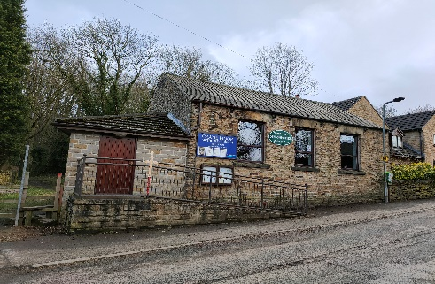
Crane Moor Methodist Church,
Green Moor Methodist Church,
Christ Church Stocksbridge,

I am writing to you this week on Tuesday the 17th, after walking on Kinder Scout yesterday with a friend,

Sunday 28th March, 2021

Dear

Well, who would have imagined it, a year on and we are still in lockdown in the throws of the Covid 19 Pandemic? But at least, as the numbers being vaccinated are looking promising, a potential end is in sight, but we must continue with caution and heed the advice of the scientists. Life may start to look a bit more normal, but we are still a long way off from true normality or whatever the future holds in store. Let us pray, that sense prevails and people don’t behave irresponsibly as lockdown eases.

But enough of that. This week we are looking forward to the most important festival in the Christian year, Easter, a time of hope. We kick off the festival with our Palm Sunday Service. I want to say a huge thank you to all those who are taking part and hopefully getting Holy Week off to a roaring start. Our young people are joining in enthusiastically with the preparations for the service. They are being wonderfully supported by their parents and grandparents to make our plans possible.

Easter 2021 Events

Thursday 1st April (It’s not an April Fool’s joke – promise.)

In Holy Week itself, there will be a Church Family Meal on Maundy Thursday and Junior Church are hoping that as many of the church family will join in. It will take place over Zoom at 5pm on 1st April. The details have changed slightly since the magazine was published. It was suggested that it was more environmentally friendly, not to be delivering soup all around the valley, so those joining are being asked to prepare their own soup and a bread roll for the meal. The Food Bank will be providing the soup for the families of Junior Church members, for which we thank Ronnie and Ray and their Team. The end of the meal will conclude with a short act of Communion led by Ian, so save some bread and a drink. To join the zoom (any time after 4.30pm) via computer, laptop, tablet, smartphone or landline telephone here are the details:-

Meeting Name: Maundy Thursday Family Meal & Communion
Meeting ID: 821 5980 9519
Passcode: 341487

Telephone numbers to join: 0203 901 7895
0203 051 2874
0203 481 5237
0203 481 5240
0131 460 1196

A recorded voice will answer and ask you to type in, using your telephone keys the meeting ID as above followed by the # key. The next bit you can ignore about giving your personal ID, just press # again. Then you type in the passcode as above followed by the # key. You will then be in the meeting.
Friday 2nd April

There will be a service on Good Friday, which will be available as per Sunday services on the Church website and Facebook page. More details will be available in Sundays Service Joys and Concerns.

Saturday 3rd April

There will be an Easter Egg Hunt around Christ Church grounds. Answer sheets will be available at the Lych Gate and completed question sheets should be posted through the church letterbox in the Roadside door. All participants will get a prize, but the winner will be drawn from the correct answer sheets during the Joys and Concerns in the service on Sunday 11th March. If you can’t get there on the Saturday, the eggs will still be around for hunting on Easter Sunday too. Please remember to observe social distancing rules whilst you enjoy the fun.

Easter Sunday, 4th April

Our Easter Sunday Service, including communion, will be on the church website and Facebook page as usual, led by Ian.

Lent Sponsored Walk

The Junior Church Sponsored Walk along Steel Valley Way is still ongoing to raise funds for The Sheffield Children’s Hospital Charity. Some of young people have already completed the walk, but as school holidays are later this year, some will be completing the walk after Easter. Thank you to those generous people who have already sponsored our young people, but there is still time to sponsor them if you haven’t. Sponsor forms are available in the church magazine or on the website.

The UNICEF Concert is still available on the website or via Facebook and we are delighted that it has been enjoyed by so many people. I will be announcing the total raised for UNICEF in Sundays Service, but the concert will still be accessible after that date, if you haven’t seen it yet.

So, a busy week ahead, I wish you all a happy Easter and look forward to you joining us over the Easter period. I will close now to catch the post and our band of volunteer “posties”. Again, I say a huge thank you to Jenny and Mike Clarke for the marathon task of envelope stuffing. Hope to see as many of you as possible on Sunday, so until then God Bless.

Love and best wishes,


Simon.
Christ Church Stocksbridge LEP, Manchester Road, Stocksbridge, S36 1DY: 0114 288 7899

Rev. Ian Lucraft, 136 Wadsley Land Sheffield S6 4EE
ianlucraft@btinternet.com : 0114 234 7153 and 07428 744 014

Website for Worship is: www.christchurchonline.org
and on facebook at @christchurchstocksbrige

