

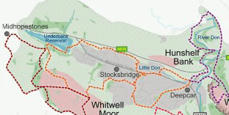
Christ Church Stocksbridge Junior Church
Sponsored Walk
Lent 2021

I would like to support

……………………………………………………………………… (insert name)

On their 2 ½ miles walk (or 5 miles return journey) from Vaughton Hill to Underbank Lane on the Fox Valley Trail.

I enclose my sponsorhip of £ ……………………….

I understand that all monies raised will go to
The Sheffield Children’s Hospital Charity

Cheques should be made payable to Christ Church Stocksbridge

In order to claim Gift Aid from HMRC please complete the details below
Name (Please Print)……………….…………………………………….
Postcode………………………

Christ Church Stocksbridge Junior Church
Sponsored Walk
Lent 2021

I would like to support

……………………………………………………………………… (insert name)

On their 2 ½ miles walk (or 5 miles return journey) from Vaughton Hill to Underbank Lane on the Fox Valley Trail.

I enclose my sponsorhip of £ ……………………….

I understand that all monies raised will go to
The Sheffield Children’s Hospital Charity

Cheques should be made payable to Christ Church Stocksbridge

In order to claim Gift Aid from HMRC please complete the details below
Name (Please Print)……………….…………………………………….
Postcode………………………

