write to him and also send him a huge hamper of food, drinks and medicines to help him get his strength back! Although Ruth Palmer had not heard back from Santa she did understand that Christmas was an extremely busy time of year for him! But as with everyone else on earth she and Eamon and Imelda of course were so relieved that Mr. Clause was finally on the mend!

On the Christmas Eve of 2020 as the big Clock Tower Clock standing in the main square at the North Pole struck midnight Santa Clause waved goodbye to all his exhausted elves who had worked so hard for him in making sure all the children’s presents were made and wrapped up. He then checked that his trusty and loyal reindeers Rudy, Foody, Trudy, Judy and Suzy were all ready and safely attached to the big brightly lit sleigh before he jumped on board and went off up high! Zooming all over the night sky on what was a beautiful warm and clear 24th of December! In fact that night of 2020 Father Christmas and his reindeer were able to break the world record previously set by himself for delivering all his presents to the millions of children on earth!!!

Imelda and her mum and dad didn't see Santa again during this Christmas Eve of the year 2020 as she had been so lucky to do the previous year! But there was to be an even bigger surprise and an extra big Xmas Present for Imelda by lunchtime on the Christmas Day of 2020!!!

At the Meeting Place building where the Cafe Social was held every Monday throughout the year, in the town of Steelsbridge, all the delicious Christmas dinner, mince pies as well as all of the festive chocolates had all been thoroughly enjoyed by everyone. Carols were sang really well with Ruth’s good friend Doctor Johnny performing on the piano that was pulled out from the corner of the main room. After everyone had eaten and enjoyed their Christmas at the Cafe Social there were a lot of sleepy and well-fed folks. Imelda had been helping out a lot with her mum and dad on the big day! They were so proud of the volunteers too who had been preparing and helping for the past few weeks.

“ Ho…. ! Ho…... ! Ho…. ! !!! MERRY CHRISTMAS CAFE SOCIAL !!! Here I am Folks to Bring You All Festive Cheer !!! With My Big Sack Of Pressies I Do Call For Imelda , Ruth And All !!! For I Am Santa Clause And I Am Here !!!! “

Everyone in the Cafe Social suddenly looked around in absolute amazement and Imelda then ran over from her seat next to her mum and dad and then grabbed Big Old Santa Clause around his legs before helping him to pass out all the wonderful gifts and presents he had brought them all.!!!
S A N T A S A V E S C H R I S T M A S

T H E E N D.

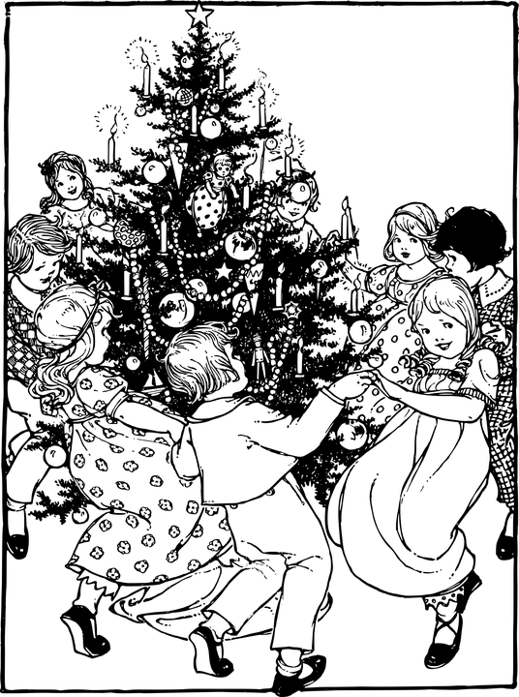
By Craig W. Minto

This little festive story is dedicated to all who work and give of their time so generously at the Social Cafe, Stocksbridge, near Sheffield.

E N J O Y .

Would Father Christmas be able to make all his present deliveries all around the world this Christmas of 2020? But what was even more important to Santa was to be able to attend the Social Cafe Christmas Lunch! The reason Santa was possibly not going to be able to do these things was that he was in hospital in his home town at the North Pole recovering from something called ‘The Corona Virus’!

On the 23rd of November of the year 2020 Father Christmas was not himself! He had so much work to do for the Big Day! He had so many countries to visit in just over a month's time and he had been poorly for so long!

For 2020 had been the year when the world had been overtaken by something called ‘The Corona Virus’! A deadly and shocking illness which meant so much hardship for all those children he loved so much and had two presents for! But what was so much worse was that old Santa himself had been very poorly with this virus as well!

In Steelsbridge on Christmas Day of 2019 Imelda had been so overjoyed with the presents Father Christmas had brought for her! In fact Imelda’s 9th Christmas had been the very best! The best ever! She had been so grateful for receiving all her Harry Potter books, films and costumes to dress up in over the festive season. Even better was the fact Santa had replied personally to her carefully written letter all in good time before the Big Day to say he always looked forward to dropping off her presents as he always enjoyed the delicious mince pies and large glass of mulled wine Imelda’s mum Ruth and father Eamon had left for him on their mantelpiece.

Because by the time the Big Man had arrived on his brightly lit sleigh at Number 1 Joy Crescent in the town of Steelsbridge in the north of England he was so exhausted and grateful for this wine and deep filled mince pies! This was because old Santa had not had a break from delivering all his millions of gifts to the children of the world for 5 or 6 hours! He had flown to the United States, Canada, Russia, Norway, France, Spain and all over Great Britain throughout the night and thought that Imelda, Ruth and Eamon wouldn't mind if he were to slip off his big black shiny polished boots with the white fur around the tops of them and wiggle his big aching and sore feet and have a well-earned rest! To put his feet up in front of the warm and wonderful coal fire in the living room of Number 1 Joy Crescent and then enjoy his mince pies and big glass of mulled wine!

What Santa and Imelda’s mum and dad did not know however about last Christmas, the Christmas of 2019, and what had made this the most wonderful of Christmas Days in Imelda’s young life, was that she had not been able to sleep because of all the wonder and excitement of the Big Day and was able to watch Santa sitting in front of the glorious coal fire warming his long feet with a huge smile on his face and his big rosy red cheeks beaming!

As he was munching away on the mince pies and slurping the huge glass of mulled wine Imelda was in the kitchen and was peeking through the serving hatch which the family used every meal time to pass food and drinks through to their living room. Imelda’s eyes were so wide with wonder and excitement watching Santa firstly place all of her presents under the Christmas Tree with all the multi-coloured flashing lights before then having himself a rest!

Mrs Palmer always knew that the mince pies and mulled wine would be eaten and drank every year. As ever since Imelda had been born Eamon Palmer had always made sure the pies and drink were polished off so as to convince his only daughter that Santa Clause had been along to appreciate this Christmas Fayre! Before this Mr Palmer had made sure he had neatly placed and arranged for all of Imelda’s full Xmas Stocking of gift-wrapped presents beneath the tree!

Imelda had fallen asleep eventually that early morning of Christmas Day 2019 and for the first time in her young life she had raced down the staircase from her bedroom at 10.00 a.m!!! Not 6.00 a.m as she had done just like clockwork of every other year!!!

This Mr. and Mrs. Palmer did find extremely unusual!

By the 30th of November 2020 at the grand old age of sixty years old Father Christmas was collected from his home and huge workshop by ambulance and then taken to the nearby hospital - The North Pole Infirmary. There was a great deal of heartache and sleepless nights for the next three weeks as far as the world was concerned! In particular those children who adored Santa, and there were certainly very many of those, were praying hard and sending lots of messages of goodwill to Mr Clause. Sack-loads of cards and get well soon gifts were piling up outside of both the Infirmary and at Santa’s large stately home at the North Pole!

World television stations soon heard of Father Christmas being so poorly and they were broadcasting daily updates constantly. All about how the Big Lad was getting on and his condition in the North Pole Hospital. One particular news reporter by the name of Carol Holly was even camping outside the Infirmary and going to all kinds of lengths to get herself allowed into the place. So she would be able to possibly get an exclusive interview with Father Christmas. She even managed to acquire a long white coat, stethoscope, and one of those old fashioned Gladstone black leather bags. All in an effort to fool the hospital staff and security folk who were looking after Santa. But Miss Holly’s endeavours to get into Santa’s private room were unsuccessful as security was very tight indeed!

Santa’s condition in the first week of the December of 2020 became so grave that the television and the newspapers began to announce that things were looking so terribly serious that Christmas may have to be cancelled altogether!!

By the first week of December 2020 Santa Clause was so poorly that a priest had to be called. His name was Mr Hope and he came along to the North Pole Hospital room of Mr Santa Clause along with his family, and of course Mrs Clause, as an all-night vigil took place. The children of the world prayed and prayed and the t.v and press held their collective breath! The world willed and hoped and prayed that Father Christmas would pull on through and so be able to still fly high over the world to deliver all the presents to all the beautiful children!

That night was long and difficult for the world! Children the globe over didn't sleep a wink as they prayed and prayed their little hearts out that the Big Fella Santa would pull through!!
By Tuesday the 8th of December 2020 there was so much relief and celebration throughout the world! Especially coming from the children of the earth! The previous day Monday the 7th of December had been such a very dark time and when Santa finally woke up and began to rally there was enormous relief!! There had been such a positive change from Mr. Clause being so critical to him looking splendid once more, with those familiar rosy-coloured cheeks and the jolly old personality returning!

So by the Thursday afternoon of the 10th of December 2020 good old Father Christmas was once again wearing his bright suit with fluffy glaring white fur on the lapels and down the front of his tunic as well as all around the waist and on the tops of his gleaming and mirror shiny black boots!

By 9.00 a.m in the morning of Thursday the 9th of December there was only a fortnight left before Christmas Eve! Santa had taken dozens of phone calls from the children from all four corners of the earth - from girls and boys in China, America, Japan, England, Australia. Santa’s elves had been working every hour God had sent to make sure all the toys and presents were ready! Santa was determined that all the millions of kids the world over would not be disappointed come the night of Christmas Eve! So on 24.12.20 Santa could bring his usual delight and excitement to them all!

On Friday the 11th of December 2020 at breakfast time the Big Man himself, Santa Clause, had been invited to appear on NPTV to be able to reassure all the children worldwide that he was fit, ready and determined to get his reindeers nicely dressed and his sleigh well oiled , painted and lit up with spectacular lights of red, green, and white. The North Pole Television breakfast show was streamed worldwide and old Santa was in terrific form! He looked as fit as a fiddle. Fitter in fact than any of the children and their parents watching had seen before on all the many Christmas Cards or on the television adverts and special broadcast programmes at his North Pole Work-Station!

Meanwhile back at Number 1 Joy Crescent in the small town of Steelsbridge, Imelda Palmer, like all the other nine year old children on earth, had been having a worrying couple of weeks due to Santa Clause being so very poorly and on the night that the Big Lad of the North Pole had been so very close to losing the biggest fight of his life as the horrible Corona Virus had almost taken him from this world, Imelda and her parents were praying hard and didn't get a lot of sleep!

But once Father Christmas had appeared on the television and looked so happy and jolly with his bright red glowing cheeks and that infectious laugh of his everyone was so relieved! He was seen chuckling and holding his big belly, then chose to talk straight into the television camera to be able to reassure all his special children of the planet that they would all be receiving their presents on time. All those gifts they had written to Santa for! Santa told them all.

“Now then children I must remind you all that going to bed nice and early on Christmas Eve as soon as your mum and dad say to do so is important. So you all get a beautiful night's sleep. This will make me Santa so very happy! I am always so excited and proud to be able to fly around the world every 24th of December to drop on down all your house chimney’s with your presents! So thank you for being all so very well behaved and praying for me as I've not been myself at all lately. So thank you ever so much! Big old Jolly Santa is so pleased to be well again! ”

Imelda’s mum Ruth had a very special job in running what was called ‘ The Cafe Social ‘. This was a place that was really important for the community of Steelsbridge Town!

Mrs Palmer had been that worried about Father Christmas as she could see when he had appeared on television that he had lost so much weight when he had fallen so ill with the Corona Virus. The weight had fallen from him so much that his cute plump belly had shrunk while he had been laid up in a hospital bed for such a long time in the North Pole!

So just as her daughter Imelda had done when Santa had been so ill, Ruth had decided to

