Call to worship
Christ Church Stocksbridge
“Together at Home”
with Crane Moor and Green Moor
Sunday 31st January 2021
Authority - Communion

We are called to recognise our Lord’s authority
and to submit to it in every area of our lives.
Let us invite our Lord to direct our thinking and our prayers.
Let us give our Lord the highest place in our lives.
Let us worship the living God. Amen

Remind Communion

Hymn : 692 by Edward Hayes Plumtree
Your hand, O God, has guided
your flock, from age to age;
the wondrous tale is written,
full clear on every page;
our forebears, owned your goodness,
and we their deeds record;
and both of this bear witness:
one Church, one faith, one Lord.
Your heralds brought glad tidings
to greatest as to least;
they summoned all to hasten
and share the great King’s feast;
their gospel of redemption,
sin pardoned, right restored,
was all in this enfolded:
one Church, one Faith, one Lord.
Your mercy will not fail us,
nor leave your work undone;
with your right hand to help us,
the victory shall be won;
and then, by all creation,
your name shall be adored,
and this shall be our anthem:
one Church, one faith, one Lord.
Welcome and Activity
Joys and Concerns
Offertory Prayer

Lectionary

Deuteronomy 18.15-20; Psalm 111; 1 Corinthians 8.1-13; Mark 1.21-28

Bible Reading : Mark 1.21-28

A Man with an Evil Spirit

²¹ Jesus and his disciples came to the town of Capernaum, and on the next Sabbath Jesus went to the synagogue and began to teach. ²² The people who heard him were amazed at the way he taught, for he wasn't like the teachers of the Law; instead, he taught with authority.

²³ Just then a man with an evil spirit came into the synagogue and screamed, ²⁴ “What do you want with us, Jesus of Nazareth? Are you here to destroy us? I know who you are—you are God's holy messenger!”

²⁵ Jesus ordered the spirit, “Be quiet, and come out of the man!”

²⁶ The evil spirit shook the man hard, gave a loud scream, and came out of him. ²⁷ The people were all so amazed that they started saying to one another, “What is this? Is it some kind of new teaching? This man has authority to give orders to the evil spirits, and they obey him!”

²⁸ And so the news about Jesus spread quickly everywhere in the province of Galilee.

Word

Hymn : 233 by Fred Pratt Green

When Jesus came to Jordan
to be baptized by John,
he did not come for pardon,
but as his Father's Son.
He came to share repentance
with all who mourn their sins,
to speak the vital sentence
with which good news begins.

He came to share temptation,
our utmost woe and loss,
for us and our salvation
to die upon the cross.
So when the Dove descended
on him, the Son of Man,
the hidden years had ended,
the age of grace began.
Come, Holy Spirit, aid us
to keep the vows we make,
this very day invade us,
and every bondage break.
Come, give our lives direction,
the gift we covet most:
to share the resurrection
that leads to Pentecost.

Prayers of forgiveness and healing

- Will you light a tea light or candle if you have one?
- Recall authority figures in our lives who have let us down (e.g. by not living up to expectations, or by abusing their authority). A minute for reflection and then let us say together:

Lord, you know our hearts, and you know the situations we are thinking about. In Jesus’ name, help us to forgive those who have hurt us. Amen.
- Recall any situations where we might have hurt other people we had authority over (of any kind). A minute for reflection and then let us say together:

Lord, you know us and love us. We are sorry for where our actions haven’t matched our words or our faith in you.
Forgive us and heal those who may have been hurt.
Amen.

- If you have one will you light a second candle or tea-light, placing it near the lit candle as a sign of commitment to allow the authority of Christ to rule our lives. Let us say together the Lord’s Prayer.

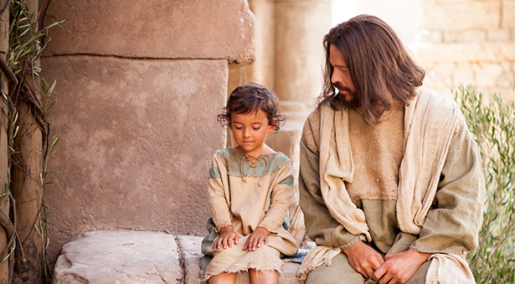
Our Father, who art in heaven, hallowed be thy name; thy kingdom come; thy will be done; on earth as it is in heaven. Give us this day our daily bread. And forgive us our trespasses, as we forgive those who trespass against us. And lead us not into temptation; but deliver us from evil. For thine is the kingdom, the power and the glory, for ever and ever. Amen.

Communion
Hymn : 588 by Brian Wren
I come with joy to meet my Lord,
forgiven, loved and free,
the life of Jesus to recall,
in love laid down for me.

I come with Christians far and near
to find, as all are fed,
the new community of love
in Christ’s communion bread.

As Christ breaks bread and bids us share
each proud division ends.
The love that made us, makes us one,
and strangers now are friends.

The Spirit of the risen Christ
unseen, but ever near,
is in such friendship better known
alive among us here.

Together met, together bound,
we’ll go our different ways,
we’ll go with joy to give the world
the love that makes us one.

The Grace and the Vesper
Almighty God, be with us this week.
Meet with us each morning, and in every situation throughout the day, whoever we are with,
help us to draw on your strength and wisdom,
that we may be faithful and true in following the example and pattern given to us by Jesus.
Amen.

And now may the love of God, the life of our Lord Jesus Christ, and fellowship together in the Holy Spirit, be with us all, this week and for ever.

Take, oh take me as I am; summon out what I shall be; set your seal upon my heart, and live in me. Repeat

Now let us all enjoy a cup of tea or coffee together.

