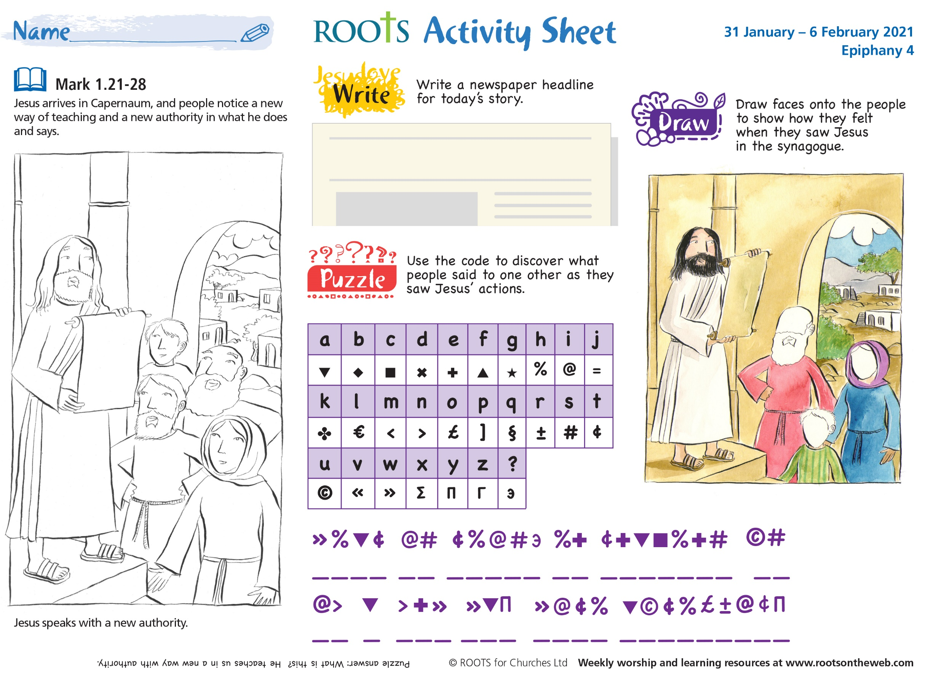
Talk together
Use these questions to discuss the Bible passage and then bring your thoughts together in the two-line prayer at the end.
Talk together
Use these questions to discuss the Bible passage.
- Who are the people that you and your friends listen to today who have the power to tell you what to do?
- What makes Jesus so different from the other people in the story?
- How could you make sure your words and actions match up?

Reflect about the impression those in authority leave
You will need a bit of play dough.
- Ask the children to flatten out their piece of play dough and mark it with a tick.
- Say together: “Jesus’ words and actions were good. He spoke with a new power and he left a lasting impression.
- Ask the children to remould their play dough, flatten it out and mark it with the sign of the cross.
- Finish by praying:
- May we follow the example of Jesus
in our words and our actions.
Amen.

