Call to worship
Christ Church Stocksbridge
“Together at Home”
with Crane Moor and Green Moor
24 December 2020
Midnight Communion

Tonight let us celebrate Christmas in the Spirit of Jesus Christ, who opens to us the heart of God’s own being, who took the form of a servant, being born in human likeness.
Let us celebrate God’s entering into our lives, to offer us a new way of life, and through that redemption,
to call us to bring light to all the world. May love be re-born in our hearts this night. Amen

Welcome

Carol : 198 by Valerie Collinson

Come and join the celebration, it’s a very special day;
Come and share our jubilation, there’s a new King born today.

See the shepherds hurry down to Bethlehem,
Gaze in wonder at the Son of God who lay before them:

Wise men journey, led to worship by a star,
Kneel in homage, bringing precious gifts from lands afar, so,

‘God is with us’, round the world the message bring,
He is with us, ‘Welcome’, all the bells on earth are pealing:
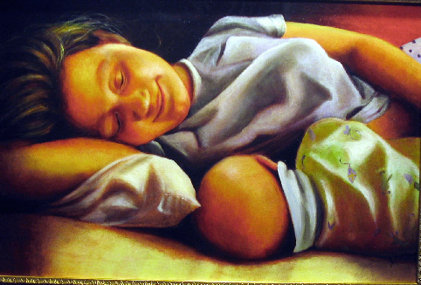
Prayer

Let us recall the words of Jesus. Jesus said: ‘You must be perfect, even as your Father in heaven is perfect.’
Jesus also said: ‘I come not to call the righteous but sinners to make a new start.’
Lord, your words disturb us and restore us. If our prayers make us hypocrites, if our money distorts our lives, if our anxiety stops us being free to live, you know our condition and you can heal us. Make us honest with ourselves, yet deliver us from despair. Giver of life and hope, we come to you neither to plead nor to boast, but as we are. Accept us we pray. Amen

(Silence for a time)

Carol : 210 : by Christina Rosetti

Love came down at Christmas,
Love all lovely, Love divine;
Love was born at Christmas,
Star and angels gave the sign.

Worship we the Godhead,
Love incarnate, Love divine;
Worship we our Jesus:
But wherewith for sacred sign?

Love shall be our token,
Love be yours and love be mine,
Love to God and all men,
Love for plea and gift and sign.

Bible Reading : Luke 1:39-55

In those days Mary set out and went with haste to a Judean town in the hill country, where she entered the house of Zechariah and greeted Elizabeth. When Elizabeth heard Mary's greeting, the child leaped in her womb. And Elizabeth was filled with the Holy Spirit and exclaimed with a loud cry, "Blessed are you among women, and blessed is the fruit of your womb. And why has this happened to me, that the mother of my Lord comes to me? For as soon as I heard the sound of your greeting, the child in my womb leaped for joy. And blessed is she who believed that there would be a fulfilment of what was spoken to her by the Lord."
Carol 191

Away in a manger, no crib for a bed,
The little Lord Jesus laid down his sweet head.
The stars in the bright sky looked down where he lay,
The little Lord Jesus asleep on the hay.
The cattle are lowing, the baby awakes,
But little Lord Jesus, no crying he makes.
I love thee, Lord Jesus! look down from the sky,
And stay by my cradle till morning is nigh.
Be near me, Lord Jesus; I ask thee to stay
Close by me forever, and love me I pray.
Bless all the dear children in thy tender care,
And take us to heaven to live with thee there.
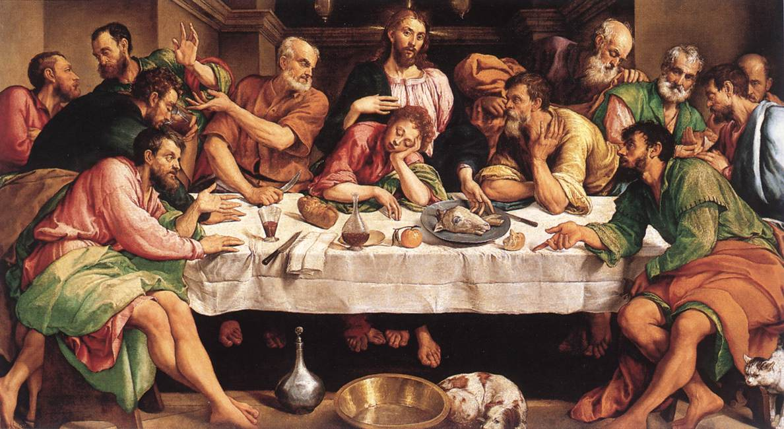
The Act of Thanksgiving
Lift up your hearts.
We lift them to the Lord.
Let us give thanks for God’s glory.
We give thanks, we rejoice in the glory of all creation.
All glory be to you, O Father, who sent your only begotten Son into the world, to be a man, born of a woman’s womb, to die for us on a cross that was made by.
He came for us. Help us to accept his coming.
He walked among us, a man, on our earth, in our world of conflict, and commanded us to remember his death, his death which gives us life: and to wait for him until he comes again in glory.
We remember his death. We live by his presence. We wait for his coming.
On the night he was betrayed, the Lord Jesus took bread, he gave thanks, he broke it and gave it to his disciples saying: “Take, eat, this is my body. Do this in remembrance of me.” He also took the cup, he gave thanks, and gave it to them, saying: “Drink of it, all of you; this is my blood of the covenant, which is poured out for many for the forgiveness of sins.”
Come, Lord Jesus, come.
Therefore, remembering his death, believing in his rising from the grave, longing to recognise his presence, now in this place we obey his command; we offer bread and wine, we offer ourselves, to be used.
Everything is yours, O Lord. We return the gift which first you gave us.
Accept it Father. Send down the Spirit of life and power, glory and love, upon us, upon this bread and wine, that to us they may be His body and His blood.
Come, risen Lord, live in us that we may live in you.
Now with all people who ever were, are and will be, with all creation in all time, with joy we say:
Holy, Holy, Holy, Lord God Almighty, all space and all time show forth your glory now and always. Amen.
Our Father, who art in heaven, hallowed be thy name; thy kingdom come; thy will be done; on earth as it is in heaven. Give us this day our daily bread. And forgive us our trespasses, as we forgive those who trespass against us. And lead us not into temptation; but deliver us from evil. For thine is the kingdom, the power and the glory, for ever and ever. Amen.

The breaking and sharing of bread and wine.

Carol : 212 : by John Francis Wade

O Come all ye faithful
Joyful and triumphant,
O come ye, o come ye to Bethlehem;
Come and behold him,
Born the King of Angels.
O come, let us adore him, Christ the King.

See how the shepherds,
Summoned to his cradle,
Leaving their flocks, draw nigh to gaze;
We too will thither
Bend our joyful footsteps:
O come, let us adore him, Christ the King.

Yea, Lord, we greet thee,
Born this happy morning,
Jesus, to thee be glory given:
Word of the Father,
Now in flesh appearing:
O come, let us adore him, Christ the King.

The Grace
The grace of our Lord, Jesus Christ, the love of God, and fellowship together in the Holy Spirit, be with us now and evermore.

It is Christmas morning.

Let us light the final Candle for our Lord.

