


Christ Church Stocksbridge
Crane Moor Methodist Church
Green Moor Methodist Church

Monday 7th December 2020

Dear
Greetings to each of you.
Well, I’m sure that most of you have started to put some Christmas decorations up, even if not the tree, yet! We have and ‘it’s starting to look a lot like Christmas’, as the old quote goes. This Sunday is the last one in Advent before the special services begin.
I know our online services are only available to those who can get online, but I hope we will have service orders for you all to use, as we share together this special time of the Christian year. I hope we can think especially of those who cannot be connected online this Christmas, to make sure they receive our love and support, phone calls and cards and greetings; we know how much the simplest gestures mean this year.
And I have a real sense that we are blessed as people of faith, because for us the meaning of Christmas has not been ‘taken away’ by the restrictions we are willingly undertaking, in order that we may all be safe, and not be a cause of sickness to others. For us it almost seems highlighted this year. Through all the decorations, the online shopping, and the private eating and drinking, we are able to discern more clearly that the birth of this child has made such a difference not only to the whole of history, but to our own lives. And we are humble at its effect on us, and grateful that we can say that we belong to Him who lived our lives, and offered us the hope of salvation through loving God and loving our neighbour. This is Christmas.
I write this before the funerals of this week, so I cannot reflect on the services, but I have felt the extra privilege of being invited into the lives of Brian’s and Arthur’s families, and being able to share their memories and their emotions. I would say that a minister has an immediate welcome, for which I am so grateful. And also that the families have both been warm in their appreciation of the church’s openness to them and the greetings that many of you have been able to send to them. It has meant a lot.
I had an email from a former member who now lives in Weston Super Mare, Pauline Longden. She watches the service regularly, and this is her letter which I thought others might be interested to read……
Dear Ian,
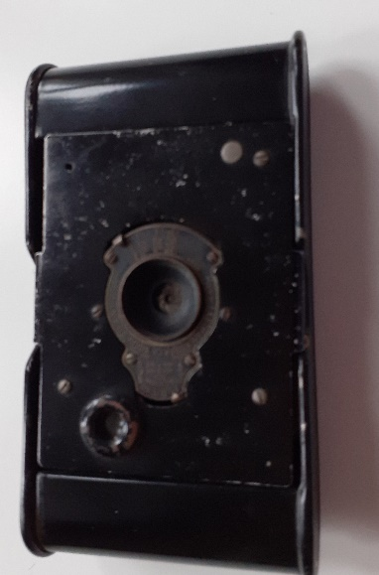
I just want to thank you for your input in the Remembrance Day service re the soldiers’ camera. I have what I think is an identical camera. I have never known anything about it so was delighted to hear the background history of the model from you.
The camera that I have came from my father, but I knew nothing of it’s history. His father (my grandfather) John Cook, did not serve in WW1; we presume he was in a reserved occupation, being an electrical technician in Deepcar. He died in 1927. His brothers who all lived in Orchard Street, Deepcar may have served but my sister and I are wondering whether in fact the camera may have come into the family from Donald Crossley, my grandmother’s cousin.
The most amazing thing is that there is still a film in the camera. I have researched photographers who still operate with a dark room and once we have our freedom from travelling restrictions I hope to take the camera to a photographer I have found in Cheltenham to see if they can remove the film and develop it. I thought you might find this coincidence of interest. It’s a small world isn’t it? Kind regards, Pauline
I’m wondering if anyone has had any thoughts of offering to be one of our Pastoral Carers at Christ Church, as I mentioned a couple of weeks ago. Please speak with me if you are thinking about it.
Some of the children from Christ Church and Green Moor have appeared in the Shiregreen URC Advent Candles, with photos or videos of them lighting the candles on Sundays in Advent. You can see them any time at www.shiregreenurc.org.uk .
Next Sunday, 20th December, it is Simon leading a Nativity service in the morning, online at 10.45 either from Facebook or on the Church website as usual. There are going to be some real treats, and some Awwh! moments…
And in the evening, from 6.00, I am leading Carols by Candlelight from church, on Facebook and the Church Website.

The Church leaders are still of the view that it is not safe for us to open the church for worship. The numbers are coming down, but we do not want to take any unnecessary action to risk spreading the virus. We know some churches are doing so. Many are not. Each church is making its own decision. We wish you all the best as you prepare for Christmas; please join us when you can. Love and best wishes from Gwen and me,
Ian.
Christ Church Stocksbridge LEP, Manchester Road, Stocksbridge, S36 1DY : 0114 288 7899
Rev Ian Lucraft, 136 Wadsley Lane, Sheffield, S6 4EE
ianlucraft@btinternet.com : 0114 234 7153 : 07428 744 014
Website for Worship is www.christchurchonline.org : and on Facebook at @christchurchstocksbridge

