


Christ Church Stocksbridge
Crane Moor Methodist Church
Green Moor Methodist Church

Wednesday 29th September 2020

Dear

Greetings to you at Christ Church, Crane Moor and Green Moor!
First, I want to say a big thankyou to those of you who have taken up the request to offer yourselves to do some of the essential roles that keep the life and work of Christ Church alive and well. We have had several individual responses, most for some particular role, and we will be considering these and talking with the people who have offered themselves over the coming weeks. Once we have talked through with each one we will bring names to the Church Leadership Team for their recommendations to the Church Meeting to make decisions and appointments.
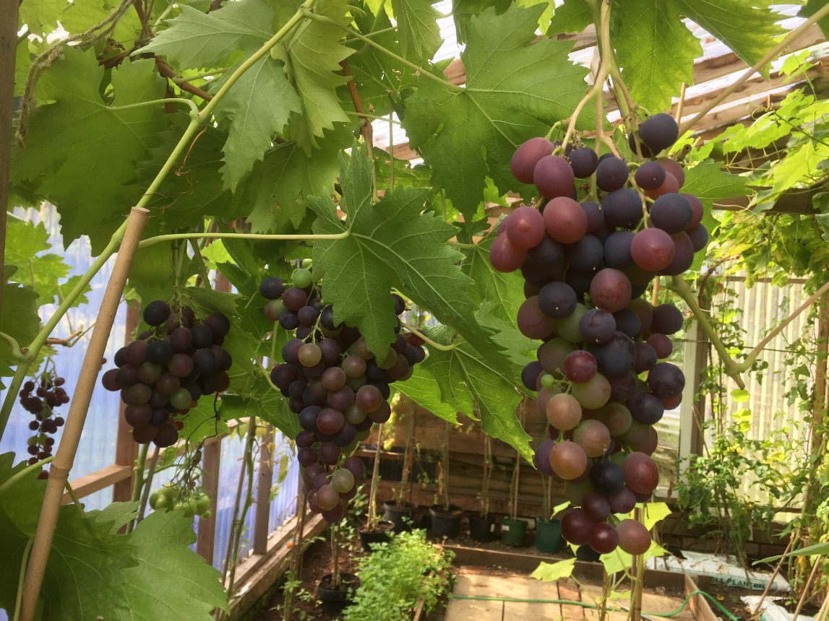
Though there have been some offers, please do not think that we have all we need yet. If you are thinking about it, please let me know, and we will have a conversation. Thank you. It has all been so uplifting that there are members and friends who are prepared to offer themselves. Bless you.
Many of you have been growing fruit and vegetables, and some of you have been able to share it with others. A

big thank you to Margaret and Phil Lundquist especially for their generous sharing of their produce.
Gwen and I are not so productive on our allotment, but it is still a place of peace, pleasure, exercise and “awayness”. I thought this photo of some of the grapes growing there this week in our greenhouse, made mainly from re-cycled materials, would be a suitable one to go along with the service on Sunday, which includes the story of a vineyard. There was not room for it on the service sheet.
This Sunday for our online service it will be communion, so have your bread and “wine” ready to share with everyone. We will be celebrating the communion service live, really live, from church, at 10.45 on Sunday morning, and you will be able to get it as usual on the Church’s Facebook page. It will be available on the Church website at about 12.00 noon. I wanted to have a simple service where we all shared together in the same way at the same time, or whenever suited, so we will not have the Zoom option this week.
With this letter you will receive the leaflet about the Children’s shoe boxes. Because of the Covid there are changed arrangements. Please read the leaflet. There are a few ready-covered boxes, which Dorothy or Mike will get to you if you need one. But please consider covering one yourself if you can, to make it easier to handle the number that we may need. Also, if, at this time, you cannot get hold of many of the things that are suggested, if you could get multiples of one or two of the items, so that you fill your box, the organisers will spread your multiples around other boxes. If you haven’t done one before, it would be wonderful if you could do one this year. I suspect that it will be even more welcome this year. You must get your filled box to Christ Church by 20th October. If you need help to get it to church, please ring Mike or Dorothy, or me. My number is at the foot of this page.
Thankyou also to everyone who has continued to send Christ Church your offering. It is important to keep the income steady. If you are wondering what is happening while Simon is away, just keep on doing what you were doing, and there are arrangements in place to collect from Simon and Church. Thank you.
Gwen joins me in sending you our best wishes for the week.
Bless you,

Ian Lucraft
Christ Church Stocksbridge LEP, Manchester Road, Stocksbridge, S36 1DY : 0114 288 7899
Rev Ian Lucraft, 136 Wadsley Lane, Sheffield, S6 4EE
ianlucraft@btinternet.com : 0114 234 7153 : 07428 744 014
Website for Worship is www.christchurchonline.org : and on Facebook at @christchurchstocksbridge

