


Christ Church Stocksbridge
Crane Moor Methodist Church
Green Moor Methodist Church
Wednesday 14th October 2020

Dear

Greetings to you at Christ Church, Crane Moor and Green Moor!
Harvest Sunday. This Sunday, 18th October, the third Sunday in October, we will celebrate Harvest in our Sunday worship. I would like you to be prepared for is for us all to share a Harvest “Meal” together. I hope the children will be able to create a harvest posy or collage, and so it would be great if they could collect a few leaves and berries (careful!) to create a picture, or posy, or wreath, or whatever their creative artistry suggests. And I wonder if all the adults could have ready on Harvest Sunday something to eat that contains fresh harvest produce. It could be an apple pie, or a tomato salad, or whatever you can do. The idea that it would contain something fresh and clearly linked to harvest. You might make it yourselves or buy it in. Then instead of a biscuit with coffee after church we could share our lunch together in Harvest thanksgiving.
David Hurrell. We celebrated the life of this disciple of Jesus at services in our church and Grenoside Crematorium. That way more people were able to attend. Amy has rung me to ask me to say a big “Thank you” to all those who shared in it, especially to those who braved the rain to line the graveyard railings and honour him as he was brought into church. And thank you too to all those who sent messages on WhatsApp, or through other channels, and were taking a moment to remember David at 12.30.
Christmas Greetings. Ronnie is asking if anyone would like to send Christmas greetings to the whole church by putting a message into the next newsletter. If you do, please get it to Ronnie in the next week.
Alexandra Jenkins. Some sad news. We have heard of the sudden death of Alex, whose children I have baptised here at Christ Church, and whose father’s funeral was held here a couple of years ago. Her Grandmother, Hilda, was a pillar of this church for many years. We don’t know any details yet, but I have spoken with her sister, Kimberley, who was very touched that the church reached out to them, both through me and through others. From what she said I expect that I may be able to help with other arrangements in due course. In this tragic time we will hold the whole family in our thoughts and prayers.
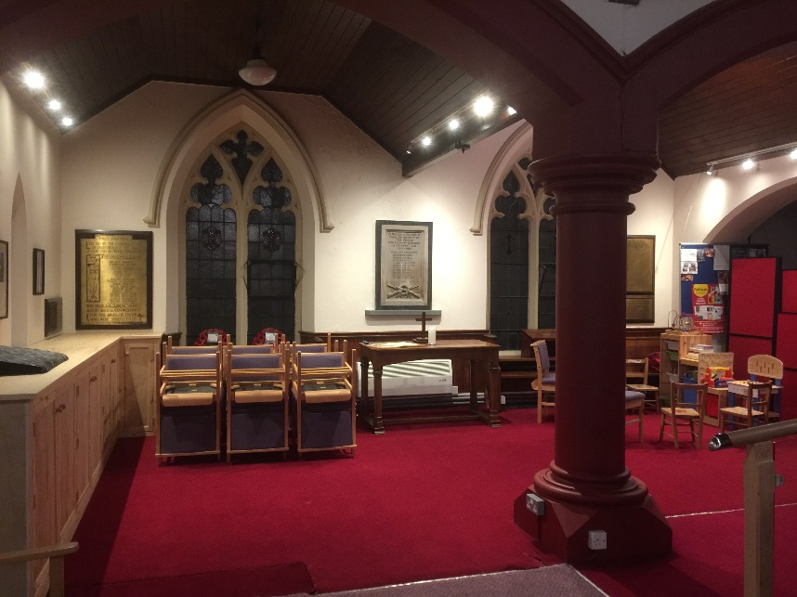
Church Improvements. There are two improvements that we have been planning for a while but are complete or nearing completion. The first is a row of new cupboards in the Peace Chapel. These will house the lighting equipment safely and out of sight, and the various electrical gear that is needed for the performances. Nick and Robyn Bryan have done a great job of creating a replica of the work Roy did in the organ transept, and the peace chapel now looks a lot more open and useful.
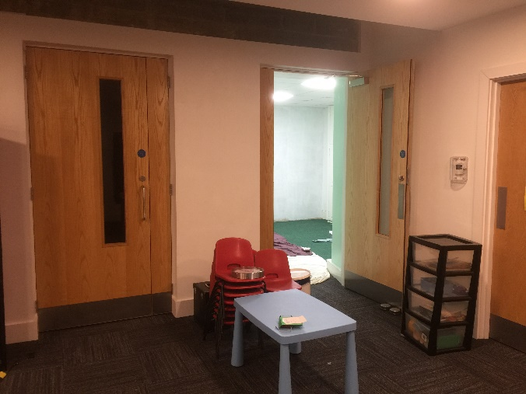
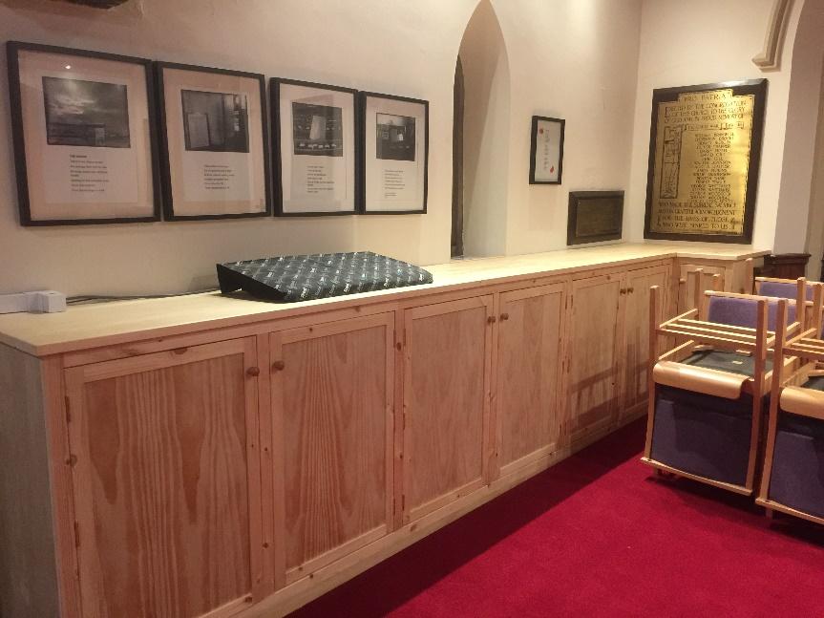
They have also, with help from Simon and Mike and David I think, completed the new room that we have created off the lobby to the Church Hall. You’ll remember that when we built the new hall, we lowered the ground level, and replaced two dark windows into the Lecture Room with two lovely matching oak doors, either side of a central pillar. Well now we have created a new room, using the dumping ground we had in the Lecture Hall. The lights have been modified, and it is being painted. We are having a new trolley for the folding tables, which we will store in there, with the children’s chairs. But otherwise it will be a useful small meeting room or breakout space for private conversations. Thank you to Robyn and Nick.
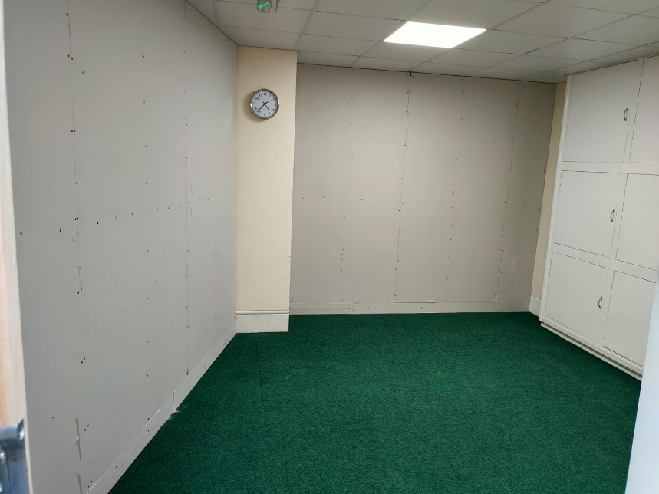

Gwen joins me in sending you our best wishes for the week.
Bless you, Ian Lucraft
Christ Church Stocksbridge LEP, Manchester Road, Stocksbridge, S36 1DY : 0114 288 7899
Rev Ian Lucraft, 136 Wadsley Lane, Sheffield, S6 4EE
ianlucraft@btinternet.com : 0114 234 7153 : 07428 744 014
Website for Worship is www.christchurchonline.org : and on Facebook at @christchurchstocksbridge

