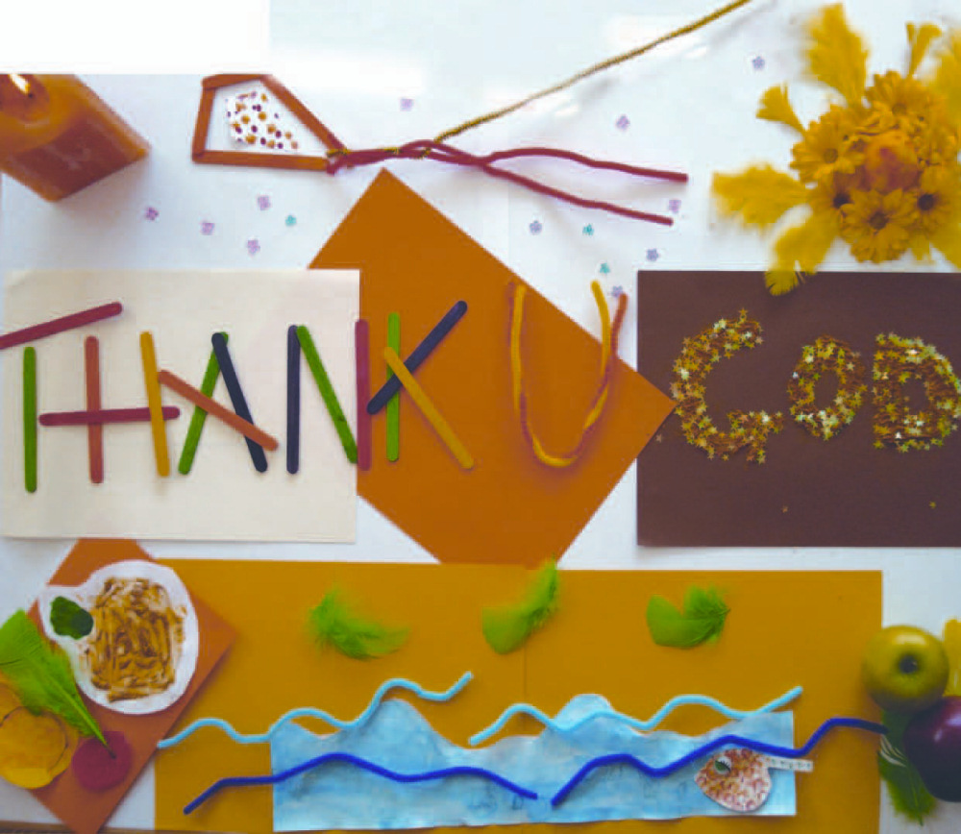
Harvest Activity

I know lots of you can do craft and scrap-booking and collage….
Why not do your own “Thank you God” collage for this Harvest Sunday?
Can you see all the Harvest things in this one?
Then you might be able to take a picture of your art and post it on WhatsApp for us all to see.

Christ Church
Together at Home
With Crane Moor and
Green Moor

