Prelude 677 Westminster Abbey

Call to worship
Christ Church Stocksbridge
“Together at Home”
with Crane Moor and Green Moor
Sunday 6th September 2020
Binding all the church in one

Christ is made the sure foundation,
Christ the head and cornerstone,
chosen of the Lord and precious,
binding all the church in one;
holy Zion's help forever,
and her confidence alone.

To this temple, where we call thee,
come, O Lord of hosts, today:
with thy constant loving-kindness
hear thy servants as they pray;
and thy fullest benediction
shed within its walls alway.

7th or 8th Century (John Mason Neale b1811)

Welcome and introduction

Activity

Joys and Concerns, and Offertory Prayer

Lighting our candles
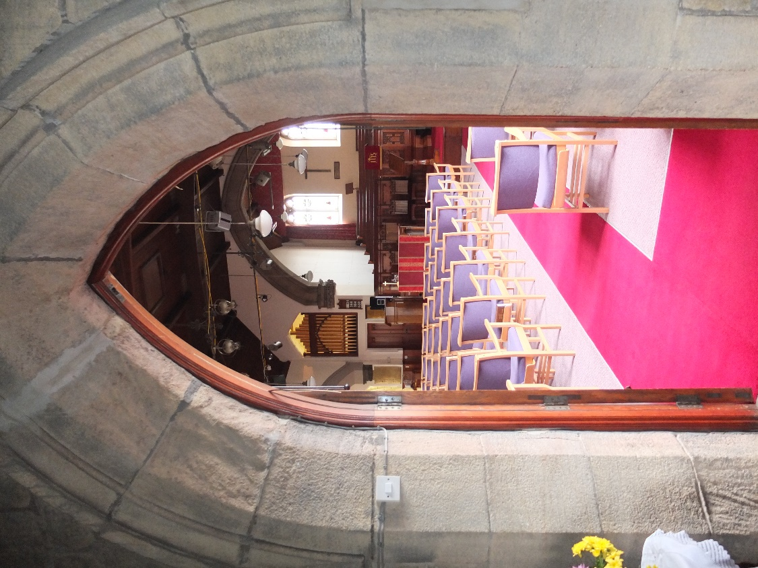
Longing for light, we wait in darkness.
Longing for truth, we turn to you.
Make us your own, your holy people,
Light for the world to see.

Longing for peace, our world is troubled.
Longing for hope, many despair.
Your word alone has power to save us.
Make us your living voice.

Longing for food, many are hungry.
Longing for water, many still thirst.
Make us your bread, broken for others,
Shared until all are fed.

Longing for shelter, many are homeless.
Longing for warmth, many are cold.
Make us your building, sheltering others,
Walls make of living stone.

Many the gifts, many the people,
Many the hearts that yearn to belong.
Let us be servants to one another,
Making your kingdom come.

Christ, be our light! Shine in our hearts,
Shine through the darkness.
Christ, be our light!
Shine in your church gathered today.

Bernadette Farrell b 1957

Gospel Reading : Matthew 18 vv 15-20
¹⁵ “If your brother or sister sins, go and point out their fault, just between the two of you. If they listen to you, you have won them over. ¹⁶ But if they will not listen, take one or two others along, so that ‘every matter may be established by the testimony of two or three witnesses.’ ¹⁷ If they still refuse to listen, tell it to the church; and if they refuse to listen even to the church, treat them as you would a pagan or a tax collector. ¹⁸ “Truly I tell you, whatever you bind on earth will be bound in heaven, and whatever you loose on earth will be^{[f]} loosed in heaven.
¹⁹ “Again, truly I tell you that if two of you on earth agree about anything they ask for, it will be done for them by my Father in heaven. ²⁰ For where two or three gather in my name, there am I with them.”
The Epistle : Romans 13 vv 8-10
⁸ Let no debt remain outstanding, except the continuing debt to love one another, for whoever loves others has fulfilled the law. ⁹ The commandments, “You shall not commit adultery,” “You shall not murder,” “You shall not steal,” “You shall not covet,” and whatever other command there may be, are summed up in this one command: “Love your neighbour as yourself.” ¹⁰ Love does no harm to a neighbour. Therefore love is the fulfilment of the law.
Word

Prayers

In the higgledy-piggledy ways of life, Lord,
with challenges and changes pulling us this way and that,
we sometimes find it hard, in the heat of the moment,
to know what is right and what is wrong.
Forgive us for our failings and wrongdoings.
Forgive our insensitivities to the ways of others.
Forgive anything that cuts us off from each other or from you.

Lord, we pray for those who this day need our prayers:
those we see around us…
those we have left at home…
those who are sharing this service from a distance…
family and friends near and far…
strangers and communities we will never meet or know,
but whose peril we hear of and see on our screens…
those whose life is ebbing away
consumed by old age, frailty, illness or neglect…
those who grieve deeply for lives and loves lost…
those who cause grief and chaos in society
and who live seemingly with different values from ours,
for them and their victims and their families…
those who are forgotten, unnoticed, unloved, unmissed…
Lord, in your abundance of mercy,
hear these and all our prayers.

Our Father, who art in heaven, hallowed be thy name; thy kingdom come; thy will be done; on earth as it is in heaven. Give us this day our daily bread. And forgive us our trespasses, as we forgive those who trespass against us. And lead us not into temptation; but deliver us from evil. For thine is the kingdom, the power and the glory, for ever and ever. Amen.

Meditative Hymn 370 Breathe on me breath of God
Breathe on me, Breath of God,
fill me with life anew,
that I may love what thou dost love,
and do what thou wouldst do.
Breathe on me, Breath of God,
until my heart is pure,
until my will is one with thine,
to do and to endure.
Breathe on me, Breath of God,
'til I am wholly thine,
until this earthly part of me
glows with thy fire divine.
Breathe on me, Breath of God,
so shall I never die,
but live with thee the perfect life
of thine eternity.
Edwin Hatch b 1835

Let us pray together…
Being Christian, Lord, is not just about ‘me and you’,
not just about our conversations and our love, not just about coming here together and singing and praying.
Help us to hold together every day of the week those who cannot be here in the flesh today.
Help us to see those we meet beyond these doors
in the way that you see them.
Help us to offer love and support from what we know of you.
Send us out from here to be a shining light for you,
to be a guiding light for those in confusion, aloneness and darkness, to be a visible sign of the love of God made real through Jesus our Lord. Amen

The Grace and the Vesper
Let us say the Grace together

Take, oh take me as I am; summon out what I shall be; set your seal upon my heart, and live in me. Repeat

Now let us all enjoy a cup of tea or coffee together.

Postlude : Variations on Westminster Abbey

