


Christ Church Stocksbridge
Crane Moor Methodist Church
Wednesday 15th September 2020
Green Moor Methodist Church

Dear

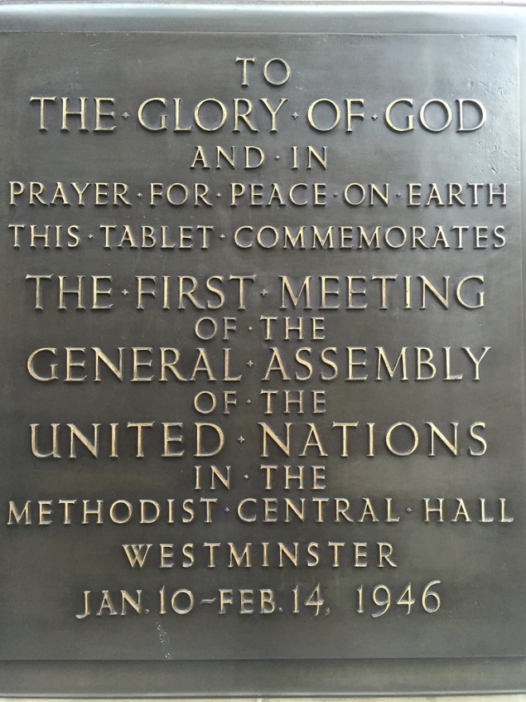
Today, Battle of Britain Day, is a day my parents lived through 80 years ago, and they had no idea what the outcome would be. But they knew they were in a fight for their very survival. They each had hard and dangerous things to do, my father in the RAF extracting the fragments of rear gunners from their turrets, and my mother in the Air Ministry, on the roof throwing incendiaries off during the night-time blitz. They had no idea what their future would be like, nor how the world would change. But they knew they had to stick together and fight on. So did those few brave men in the air over southern Britain in that hot summer, supported by almost everyone in the country, and many around the world, to overcome evil and create a better world.
And they did. If you walk round the side of the Methodist Central Hall in London, you will find a plaque on the wall which commemorates the first meeting of the United Nations in Central Hall in 1946. The great leaders of those days knew that out of the conquest over evil, nations needed to beat their swords into ploughshares in order to make a world where nations worked together for the greater good of all. I know some leaders and nations have felt that they wanted to exert their own control over the United Nations, and ignore its force for good for the benefit of their own states, and so it has not been what it could have been. But its work for mutuality and co-operation still goes on in the background, and still is focussed on a world where we can collaborate: to support peace, and resolve conflict, to feed the hungry and conquer disease, to bring people together, to help young people work alongside each other. I remember working as a young man in Bechuanaland, on the edge of the Kalahari desert in Africa, alongside another English young man. On behalf of the United Nations aid programme he was a volunteer in charge of distributing thousands of tons of maize corn given by America, and powdered milk given by Germany to Bechuanaland, where the people had had no rain for 7 years. It felt Biblical in its enormity. Every year in our own church Pearl helps us remember the work of the United Nations among children with her concert in support of UNICEF, and gives us each an opportunity to support the work of the United Nations, and educate us and some of our young people about its work.
While we are not faced with the cataclysm of world war I hear people saying to me weekly now that it feels like several crises are coming together; Covid-19 here and around the world, climate change and its associated destruction of wild-life habitats and human habitats, and population movements where people in crisis, usually created by warring factions, seek safety, food and a decent life. We fear that the combined effect of these crises may have as massive an effect as global wars have in the past. The truth is that we cannot have peace, safety and a decent life for ourselves unless the whole world shares in that. We cannot preserve our standard of living if others do not share it too. There is no wall long enough to protect us. We have to go out and improve the realities of life for the people who suffer and the habitats that are disappearing. That will be our salvation
Hearing the veterans talk, they knew they had to conquer evil; they knew they wanted a better world, they came home determined to make things better. And they did for many of us. Now we live in a more global world, and the challenge for us will be how to put to one side the siren calls of demagogues and those who would covet the riches of the world for themselves at the expense of others.
The call of Christ is to love one another. And that goes beyond our own families and folk. America knew once that the Marshall Plan was needed to overcome desperation, destruction, and demagoguery and gave of its bounty to build a new democracy in Europe. America rebuilt the land of its former enemies as well as its continuing friends. We cannot fall behind in that same cause of development. We must not forget that lesson. We have to daily speak and act in ways that will help us, and those around us, to know for sure that we have to hang together in this world or we will surely hang separately. The legacy of those who fought and died was to have a better world for those whose future was given by those who died. The same legacy for future generations will arise only from the actions we take to fight evil and create a better world for those who are suffering and dying. We cannot do the really big things on our own in our personal lives. But we can take the little steps that are available to us, and we can speak as if it matters and talk with others about how they too can help. Unless we take our own little steps and tell our friends, it will not happen.
Sunday Worship
This Sunday the online worship will be led by John Cornell and the Worship Group. We thought it would be helpful to begin to share the experience of leading online worship among the Worship Group, and so I am grateful to them for taking this step.
We expect to have the Facebook service running live, with Zoom, and the recording on the church website later. We are thinking through the long-term sustainability of how we do this, and the balance between new technology and the sanctity of our worship. We will learn and improve and make our fellowship more possible and more real, as we take this journey of being a church, ‘called out’ in this Covid world.

Blessings to you all, in your homes, at your work, on holiday breaks, in careful seclusion. Love to each of your from our community.
Best wishes, Ian Lucraft
Christ Church Stocksbridge LEP, Manchester Road, Stocksbridge, S36 1DY : 0114 288 7899
Rev Ian Lucraft, 136 Wadsley Lane, Sheffield, S6 4EE
ianlucraft@btinternet.com : 0114 234 7153 : 07428 744 014
Website for Worship is www.christchurchonline.org : and on Facebook at @christchurchstocksbridge

