Christ Church Stocksbridge
“Together at Home”
with Crane Moor and Green Moor
Sunday 9th August 2020
Walking on water
Tin Mill Stepping Stones, by Julie Lowry

Call to worship
Lord, sometimes life following you can be difficult.
We find so many dilemmas and struggle so much, wishing it could be easier.
We so want to trust you and see your plan for us.
Help us this morning to relax into your presence,
to clearly hear your word and be prepared to act on it.
Welcome and introduction
Hymn Rejoice and Sing 388
Jesus, stand among us
in your risen power;
let this time of worship
be a hallowed hour.
Breathe the Holy Spirit
into every heart;
bid the fears and sorrows
from each soul depart.
Thus with quickened footsteps
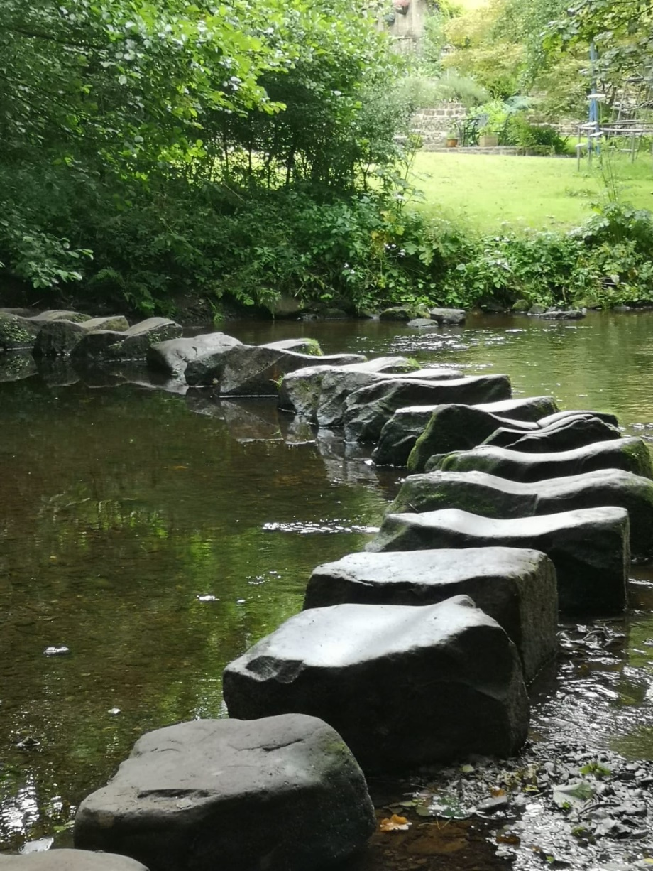
we pursue our way,
watching for the dawning
of eternal day.
William Pennefather b 1816

Activity

Joys and Concerns
Reading Matthew 14 vv 22-33
²² Immediately Jesus made the disciples get into the boat and go on ahead of him to the other side, while he dismissed the crowd. ²³ After he had dismissed them, he went up on a mountainside by himself to pray.

Later that night, he was there alone, ²⁴ and the boat was already a considerable distance from land, buffeted by the waves because the wind was against it.

²⁵ Shortly before dawn Jesus went out to them, walking on the lake. ²⁶ When the disciples saw him walking on the lake, they were terrified. “It’s a ghost,” they said, and cried out in fear.

²⁷ But Jesus immediately said to them: “Take courage! It is I. Don’t be afraid.” ²⁸ “Lord, if it’s you,” Peter replied, “tell me to come to you on the water.” ²⁹ “Come,” he said.
Then Peter got down out of the boat, walked on the water and came toward Jesus. ³⁰ But when he saw the wind, he was afraid and, beginning to sink, cried out, “Lord, save me!”

³¹ Immediately Jesus reached out his hand and caught him. “You of little faith,” he said, “why did you doubt?”

³² And when they climbed into the boat, the wind died down. ³³ Then those who were in the boat worshiped him, saying, “Truly you are the Son of God.”

Word

Hymn Singing the Faith 435

We come to you with no pretence,
yet nourished by your grace.
We come as people needing love,
within this time and place.

We come confessing all we are,
yet all we have to give.
We ask for your renewing power
to teach us how to live.

We need your spirit to be strong,
your risking, leaping faith,
that brings the love of God to bear
in every aching space.

Then from this point, restored, renewed,
we pledge to take your way;
to live responding to your call
with each succeeding day.
Andrew Pitt b 1948

Prayers

As we approach you today, Lord,
we probably feel pretty much like Peter –
full of bravado to begin with,
but then just not quite so certain of ourselves.
We come to you, Jesus,
trusting that even if we feel ourselves
beginning to sink under the pressures that we face,
we know you are still there holding us up.
Please reassure us that you won’t let go,
no matter how we feel.
Thank you, Lord.
Amen.

Lord,
I’m sorry for the times I take my eyes off you,
and seek to do things in my own strength.
I’m sorry for the times I doubt that
you can keep me on the straight and narrow.
I’m sorry for the times I ask you for signs.
Lord, I pray that you will forgive
my doubts and hesitations,
show me your loving presence,
especially when I most need it,
and teach me to trust you at all times.
Amen.

Lord, we come before you to pray for all those people
for whom taking risks is a way of life.
Lord, reveal yourself to them and keep them safe.
We pray for our emergency services – paramedics, the police,
the fire service – all who daily face difficult situations
as they seek to help to protect us and make our world a safer
and more peaceful place.
Lord, reveal yourself to them and keep them safe.
We pray for people who work in troubled areas
– the armed forces in war zones,
those who bring humanitarian aid
into areas of natural disaster, and many more.
Lord, reveal yourself to them and keep them safe.
We pray for people who take risks in your name, Lord Jesus
– those who take your word where it is most needed
– and for people who grapple with faith and doubt.
Lord, reveal yourself to them and keep them safe.
Amen

Our Father, who art in heaven, hallowed be thy name; thy kingdom come; thy will be done; on earth as it is in heaven. Give us this day our daily bread. And forgive us our trespasses, as we forgive those who trespass against us. And lead us not into temptation; but deliver us from evil. For thine is the kingdom, the power and the glory, for ever and ever. Amen.
Hymn Singing the Faith 660

Called by Christ to be disciples
every day in every place,
we are not to hide as hermits
but to spread the way of grace;
citizens of heaven’s kingdom.
though this world is where we live,
as we serve a faithful Master,
faithful service may we give.

Richly varied are our pathways,
many callings we pursue;
may we use our gifts and talents
always, Lord, to honour you;
so in government or commerce,
college, hospice, farm or home,
whether volunteers or earning,
may we see your kingdom come.

Hard decisions may confront us,
urging us to compromise;
still obedience is our watchword –
make us strong and make us wise!
Secular is turned to sacred,
made a precious offering,
as our daily lives are fashioned
in submission to our King.
Martin Leckebusch b 1962

The Grace and the Vesper
Take, oh take me as I am; summon out what I shall be; set your seal upon my heart, and live in me. Repeat

Now let us all enjoy a cup of tea or coffee together.

