Call to worship
Christ Church Stocksbridge
Together at Home
Sunday 12th July 2020
All may be fruitful!

Lord, we might not be sitting by a lake today.
However, as the crowds eagerly gathered
to listen to the stories and truths you told them,
we too await your word to us.
With joy in our hearts, and anticipation,
we pray that you will give us listening ears,
and hearts open to receive your love,
your teaching, and your wisdom.
Help our lives to be full to bursting, bearing your fruit.
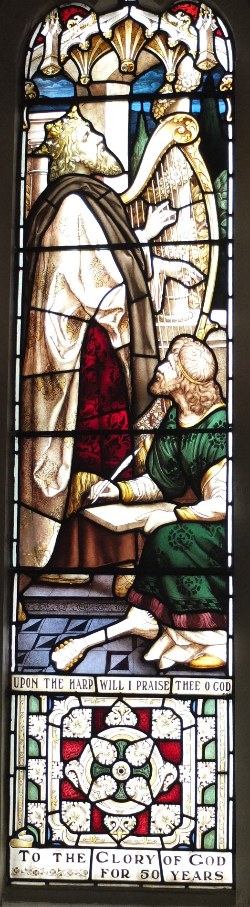
Welcome and introduction
Let the birds sing, let the wind sing,
let the bees sing, let all the skies and everything in them…..
sing to the Music Maker,
sing to the One Creator, (repeat)

Let the waves sing, let the whales sing,
let the seals sing, let all the seas and everything in them….

Let the trees sing, let the animals sing,
let the children sing, earth and everything in it,,,,
Stephen Fischbacher

Hymn
For the music of creation,
for the song your Spirit sings,
for your sound's divine expression,
burst of joy in living things:
God, our God, the world's composer,
hear us, echoes of your voice --
music is your art, your glory,
let the human heart rejoice!

Psalms and symphonies exalt you,
drum and trumpet, string and reed,
simple melodies acclaim you,
tunes that rise from deepest need,
hymns of longing and belonging,
carols from a cheerful throat,
lilt of lullaby and love-song
catching heaven in a note.

All the voices of the ages
in transcendent chorus meet,
worship lifting up the senses,
hands that praise, and dancing feet;
over discord and division
music speaks your joy and peace,
harmony of earth and heaven,
song of God that cannot cease.
Shirley Erena Murray

Joys and Concerns
Reading Matthew 13 v 1-9, 18-23
13 That same day Jesus went out of the house and sat by the lake. ² Such large crowds gathered around him that he got into a boat and sat in it, while all the people stood on the shore. ³

Then he told them many things in parables, saying: “A farmer went out to sow his seed. ⁴ As he was scattering the seed, some fell along the path, and the birds came and ate it up. ⁵ Some fell on rocky places, where it did not have much soil. It sprang up quickly, because the soil was shallow. ⁶ But when the sun came up, the plants were scorched, and they withered because they had no root. ⁷ Other seed fell among thorns, which grew up and choked the plants. ⁸ Still other seed fell on good soil, where it produced a crop—a hundred, sixty or thirty times what was sown. ⁹ Whoever has ears, let them hear.”

¹⁸ “Listen then to what the parable of the sower means: ¹⁹ When anyone hears the message about the kingdom and does not understand it, the evil one comes and snatches away what was sown in their heart. This is the seed sown along the path. ²⁰ The seed falling on rocky ground refers to someone who hears the word and at once receives it with joy. ²¹ But since they have no root, they last only a short time. When trouble or persecution comes because of the word, they quickly fall away. ²² The seed falling among the thorns refers to someone who hears the word, but the worries of this life and the deceitfulness of wealth choke the word, making it unfruitful. ²³ But the seed falling on good soil refers to someone who hears the word and understands it. This is the one who produces a crop, yielding a hundred, sixty or thirty times what was sown.”

Word

Hymn

God’s Spirit is in my heart,
He has called me and set me apart.
This is what I have to do,
what I have to do.
He sent me to give the Good News to the poor,
Tell prisoners that they are prisoners no more,
Tell blind people that they can see,
And set the downtrodden free
And go tell everyone the news that
the Kingdom of God has come,
And go tell everyone the news that
the Kingdom of God has come.
Just as the Father sent me,
So I'm sending you out to be
My witnesses throughout the world,
The whole of the world.

Don’t carry a load in your pack;
you don’t need two shirts on your back;
God’s workers can earn their own keep –
can earn their own keep:
Don't worry what you have to say,
Don't worry because on that day
God's Spirit will speak in your heart,
Will speak in your heart.
v1 Alan Dale. vv2-4 Hubert Richards

Prayers

Lord, it is so good to read your Word,
and hear the parables you told.
But, Lord, we can’t leave it there.
We must take note of the explanation,
and work it out in our own lives.
Help us, O Lord, to listen, to learn and to act.
For the times we dash haphazardly into your presence,
finding it hard to leave behind our cares and worries:
forgive us, good Lord, and make us new.
For the times when we don’t learn from our experiences:
forgive us, good Lord, and make us new.
For the times when we don’t take care of ourselves,
or the people we share our lives with:
forgive us, good Lord, and make us new.
For the times we don’t see what you want us to see
and just take things at face value:
forgive us, good Lord, and make us new.
For the times when we want our seed planted in neat rows,
when our own plans become more important than yours,
rather than letting the Holy Spirit prepare the soil of our lives
and blow where the Spirit wants to:
forgive us, good Lord, and make us new.
Amen.
Our Father, who art in heaven, hallowed be thy name; thy kingdom come; thy will be done; on earth as it is in heaven. Give us this day our daily bread. And forgive us our trespasses, as we forgive those who trespass against us. And lead us not into temptation; but deliver us from evil. For thine is the kingdom, the power and the glory, for ever and ever. Amen.
Hymn

The Church of Christ in every age
Beset by change but Spirit led,
Must claim and test its heritage
And keep on rising from the dead.

Across the world, across the street,
The victims of injustice cry
For shelter and for bread to eat,
And never live until they die.

Then let the servant Church arise,
A caring Church that longs to be
A partner in Christ's sacrifice,
And clothed in Christ's humanity.

For he alone, whose blood was shed,
Can cure the fever in our blood,
And teach us how to share our bread
And feed the starving multitude.

We have no mission but to serve
In full obedience to our Lord:
To care for all, without reserve,
And to spread his liberating Word.
Fred Pratt Green

The Grace and the Vesper
Take, oh take me as I am; summon out what I shall be; set your seal upon my heart, and live in me. Repeat
Now let’s all enjoy a coffee or tea together.

