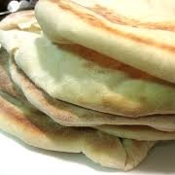
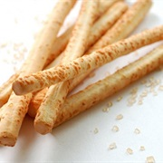
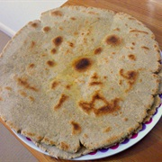
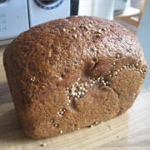
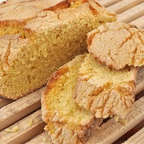
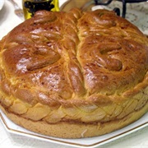
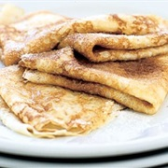
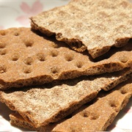
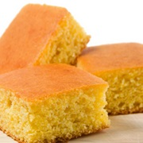
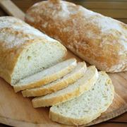

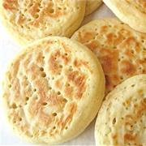
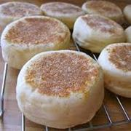
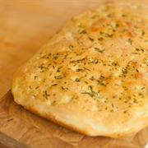
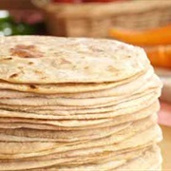
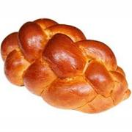
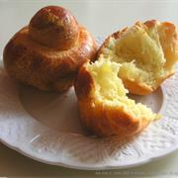
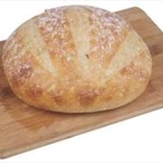
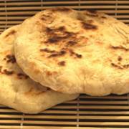
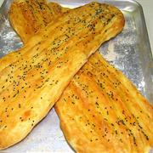
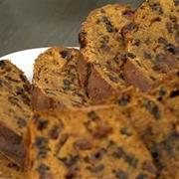
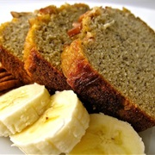
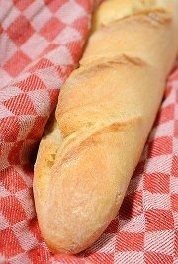
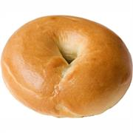
What is each of these breads called? Write it in. Answers after the service!
Jesus told them still another parable: “The kingdom of heaven is like yeast that a woman took and mixed into about sixty pounds of flour until it worked all through the dough.”
Christ Church Stocksbridge
with Crane Moor and Green Moor
“Together at Home”
Sunday 26th July 2020
Secrets of the Kingdom

This week there are two activities.
- Make some bread.
- Try the quiz on the other side.
Perhaps it is your first time to make bread; perhaps you are experienced as a bread-maker. But you could join with the others.
(And if you do make the bread, and stick it in the freezer, you could use it for our Communion together next Sunday. Perhaps have half of the bread plain for Communion?)

Here’s a recipe for a simple bread dish; you can use it either of two ways, as pizza or naan. My thanks to Rebecca Morgan (nee Wild) for this recipe which we have tried and it is really quick and easy and very yummie!
Becca’s Brilliant Bread Recipe
You can adapt this to a Naan recipe by adding some tumeric and cumin, or whatever you fancy, to the dough.
Then just lightly oil a frying pan, almost dry, and fry on both sides for just a couple of minutes.
- Mix together in a bowl 80g of SR flour and 80g of Natural or Greek yoghurt.
- If it is a little soggy, add a little more flour until it is a firmer dough.
- Roll it out into a round, like a pizza base. (This is enough for two child-size pizzas.)
- Spread some tomato paste over and grate some cheese.
- Add some basil, salt or pepper to taste if you want.
- Bake on a baking tray in the oven at 190° fan, for about 25 minutes or until done.

