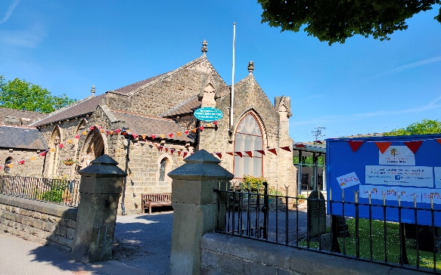
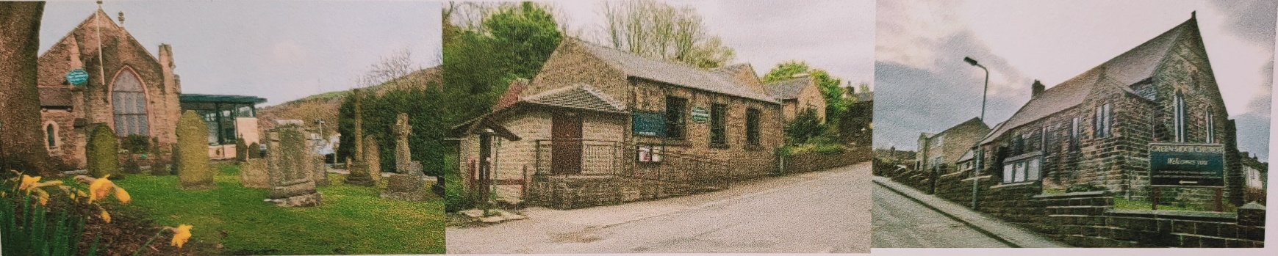
Christ Church Stocksbridge
Green Moor Methodist Church
Crane Moor Methodist Church

Dear 2nd June, 2020

So whilst Ian and Gwen have another well deserved rest it has fallen to me to write this weeks’ letter. A task that I am more than happy to do. That is, if my laptop will pick up the wifi signal whilst I sit in the garden to type!

I cannot believe that five weeks have gone past since my last letter. The weeks are flying past. Summer is upon us, although it has felt like summer for some time now with all the lovely weather we’ve been having, though I know the gardeners amongst us, would like some decent rain to relieve the burden of daily watering. My five water butts are severely depleted. But, mustn’t grumble as they say, at least it has meant time could be spent out in the warmth, making us all feel a little better in lockdown. Apologies to those who don’t have access to a garden, but I still hope you have managed some fresh air in the sunshine.

This week has a number of milestones.

First and foremost, huge congratulations to Becca and Matt Morgan on the safe arrival of a baby boy, a little brother for Freya born at 4:21pm yesterday. At the time of going to print, no name as yet, but we are all so glad that Mum and baby are safe and well (Matt’s ok too!).

Some schools are starting back and more peoples working lives are moving back to closer to “normal”. But as I shall be saying in the service this coming Sunday, we really need to look at what that new normal will look like. I think we will be keeping in touch via these letters, the whatsapp group and our on-line services for some time yet.

Shops are opening, though I have resisted the urge to rush off to Ikea, in spite of them deluging me with emails to announce their re-opening on 1st June. I am not rushing off to Attercliffe, mainly because Ikea’s restaurant cannot yet open, for my fix of Swedish meatballs with lingonberry sauce! I don’t have an urge to build flat pack furniture at the moment, I will have to save that particular pleasure, until our son Joshua, heads back to Lancaster when work want him back on site.

I hope you will see from this weeks’ service sheet that Christ Church is looking a bit colourful. So many churches I have passed have looked dark, closed and deserted, so I felt moved to make people aware that we are alive and kicking, witnessing and worshipping. So if you are able to be about in Stocksbridge, just pause for a moment to see Christ Church decked out in its red and orange bunting, with the gate wide open to welcome people into the graveyard should they want to stop and reflect, just for a moment. I hope after next Sunday that we will be able to put a display up in the windows to further encourage passers-by to pause a little longer.

The activity sheet enclosed with this letter to go along with next Sunday’s service for Trinity Sunday will not be the same for everyone, so we can get a bit of variety for the display I mentioned above. More information on this in this Sunday’s Service. Keep calm, I know the suspense is killing!

I shall sign off now to get this duplicated and packed into the envelopes in time to catch the last post tonight.

Remember, continue to stay safe, stay at home as much as you can and if you have to go out don’t forget social distancing. We want to see you all safe and sound when our churches re-open.

God bless,

Simon

