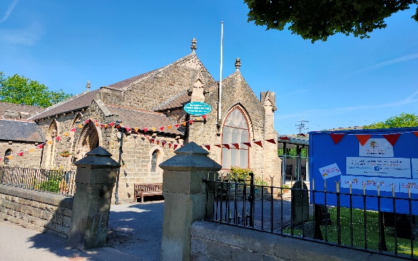
Sunday 7th June 2020

TRINITY SUNDAY

Christ Church Stocksbridge

Greenmoor

Crane Moor
Joys & Concerns

Heavenly Father,
We thank you for the work, dedication,
love, leadership and guidance of a true man of God.
We thank you that he has been called to continue his greatly valued work with us.
We thank you for the love and support given to him by Gwen, in order to continue the mission of Christ amongst us.

Amen

Joys & Concerns Continued

Offertory Prayer
Let us pray.
Lord Jesus, we thank you for all you have given to us and we ask that you accept our offerings for the continued work of the gospel in this place. We pray for Christian Aid and all they do for all those who find themselves in difficulty. I know some of us have found the isolation these past weeks difficult, but we have each other and you to support us. Others less fortunate do not. May Christian Aid bring these people a measure of support and relief. Amen.

Readings:

Genesis Chapter 1 v 1-4

2 Corinthians Chapter 13 V 11 – 13

Matthew Chapter 28 v 16 – 20

At the end of the Gospel reading

This is the word of the lord

Thanks be to God

Welcome

A call to worship for today

The word of the eternal Father created us
The love of the gracious Son redeemed us
The presence of the Holy Spirit unites and empowers us
Come and worship the glorious Trinity,
Our God of power and love. Amen

Activity

Holy, holy, holy! Lord God Almighty
Early in the morning our song shall rise to Thee
Holy, holy, holy! Merciful and mighty
God in three persons, blessed Trinity!

Holy, holy, holy! All the saints adore thee,
Casting down their golden crowns around the glassy sea;
Cherubin and seraphim failing down before thee,
Who wert, and art, and evermore shall be.

Holy, holy, holy! Though the darkness hide thee
Though the eye of sinful man thy glory may not see
Only Thou art holy, there is none beside Thee
Perfect in power, in love and purity.

Holy, holy, holy! Lord God Almighty
All thy works shall praise thy name In earth and sky and sea
Holy, holy, holy! Merciful and mighty
God in three persons, blessed Trinity.
Reginald Heber

To those whose minds are tormented by depression, especially at this tiem
To those whose hold on life is fragile
To those whose lives are filled with stress
God of peace
May your peace be known
To those who are nearing the end of life
To those who care for them
God of peace
May your peace be known
May your peace be known to us
And may we be bearers of peace and Christs message in our world. Amen

Our Father who art in heaven
Hallowed be thy name
Thy kingdom come, thy will be done
on earth as it is in heaven.
Give us this day our daily bread
Forgive us our trespasses
As we forgive those who trespass against us.
Lead us not into temptation
But deliver us from evil
For thine is the kingdom, the power
And the glory, for ever and ever
Amen.

Meditation

The Father holds us firmly in his hands
The Father holds us firmly in his hands
The Father holds us firmly in his hands
He’s got the whole world in his hands

Jesus guides us truly with his hands
Jesus guides us truly with his hands
Jesus guides us truly with his hands
He’s got the whole world in his hands

The Holy Spirit surely moves our hands
The Holy Spirit surely moves our hands
The Holy Spirit surely moves our hands
He’s got the whole world in his hands

He’s got the whole world in his hands
He’s got the whole world in his hands
He’s got the whole wide world in his hands
He’s got the whole world in his hands

The grace of our Lord Jesus Christ, the love of God and the fellowship of the Holy Spirit be with now and for evermore. Amen

Take Oh take me as I am;
Summon out what I shall be;
Set your seal upon my heart and live in me.

Coffee Time

God, whose almighty word
Chaos and darkness heard
And took their flight:
Hear us, we humble pray,
And where the Gospel day
Sheds not its glorious ray,
Let there be light!

Christ you have come to bring,
On your redeeming wing,
Healing and sight,
Health to the sick in mind,
Sight to the inly blind:
Oh, now to humankind
Let there be light!

Spirit of truth and love,
Life giving, holy dove,
Speed forth your flight;
Move on the water's face,
Bearing the lamp of grace,
And in earth's darkest place
Let there be light!

Blessed and Holy three,
Glorious Trinity,
Wisdom, love, might!
Boundless as ocean's tide,
Rolling in fullest pride,
Through the earth, far and wide,
Let there be light! John Marriott

Word

Father we adore you,
Lay our lives before you, How we love you.
Jesus we adore you,
Lay our lives before you, How we love you.
Spirit, we adore you,
Lay our lives before you,
How we love you. Terrye Coelho

Let us pray
Please respond with the words in bold type

Where there is conflict between nations
Where there is conflict within nations
Where people live in fear of bullet bomb or virus
Where parents weep for children killed
God of peace
May your peace be known
In homes filled with anger, cruelty and neglect
Where there are no safe places
Where poverty and addiction brin suffering and pain
God of peace
May your peace be known

