


Christ Church Stocksbridge
Crane Moor Methodist Church
Tuesday 9th June 2020
Green Moor Methodist Church
Dear
First a big ‘Thank you’ to Simon and Christine and Josh for doing last Sunday’s service for me. There were a few other pieces of work for me during that week, but overall it was very refreshing to have some time to ourselves. We made good use of it and spent the whole week re-modelling the back of the garden! I am very grateful for the outpouring of love and support for me; but I never in my life expected to be thought of as a ‘man of God’. I suppose that we are all aware of our failings and frailties; I know I am too keenly aware of mine, so it is a soubriquet I would not claim. Unless we are all finding that in our weaknesses and failings we are all men and women of God, called to be his disciples and walk his testing path.
I want to raise with you this week the issue of decision-making and accountability in this period when we cannot meet face to face. And with many members over 70, and quite a few officially ‘shielding’, it may be some time before we can consider face to face meetings.
- The officers of the church, that’s John Cornell as Chair, Mike Clarke as Secretary, and Simon Utting as Treasurer, and myself as Minister, have been holding online Zoom meetings every couple of weeks or so, to manage the essential church business. We can see each other, and share a conversation, discuss issues and come to considered decisions.
- But we have felt that now is a good time to start to engage the Leadership Team and the Church Membership as far as possible in these difficult times. To that end we are asking the Leadership Team if they would try an online Zoom meeting in the next week or two. Simon is going to help install the required software for those who don’t have it, and support some people to be able to log on and join the on-line meeting. We will evaluate how successful that is.
- The URC has suggested that if might be proper to ask the congregation as a whole if they are prepared to delegate the decision-making powers of the Church Meeting to the Leadership Team and the Church Officers, as appropriate, during the remainder of this epidemic. During that time we would postpone any decisions that could be delayed. The Leadership Team would keep careful notes of all decisions. We would make sure that everyone had a chance to read the notes of the Leadership Team, as the meetings take place.
So I am including a questionnaire for Christ Church members and friends, with a return envelope, that I am asking you to complete and return, (adding a stamp to the envelope!). I am seeking your your vote on the questions about decision-making, and your views on some items. I hope everyone will complete the questionnaire and return to me as soon as possible. Thank you.
The second item this week is about the news that the Government is planning to allow churches to re-open, ‘for private prayer’. This is not something that we have used the church for in the past, unlike some denominations where during the week the building is open for people to drop in and prayer quietly as individuals. In fact the URC nationally has issued some guidance to us in response to this new guidance. (I will post this guidance on our website for you to read.) It is saying that our churches are not usually open for ‘private prayer’; rather our tradition is congregational worship. There are real difficulties in opening like this. Who will we ask to put themselves in additional risk by opening up? Who would be prepared to act as steward, and manage perhaps people who were not prepared to follow social distancing guidelines? How would we deep clean between each opening? Having a Sunday opening time where a number of people attend to have ‘private prayer’ together is seen as not following the guidelines. Therefore we are not proposing taking this step at the moment.
In a previous letter I set out some of the steps that we might take as we emerge from the epidemic. So I am including some questions in the questionnaire about your views on the possible steps that we could take. I am particularly interested to get a sense of how many people would value specific steps. What is clear is that we will continue with the online worship, even when we do open up for services. Overall though, the message is that public worship will not happen soon.
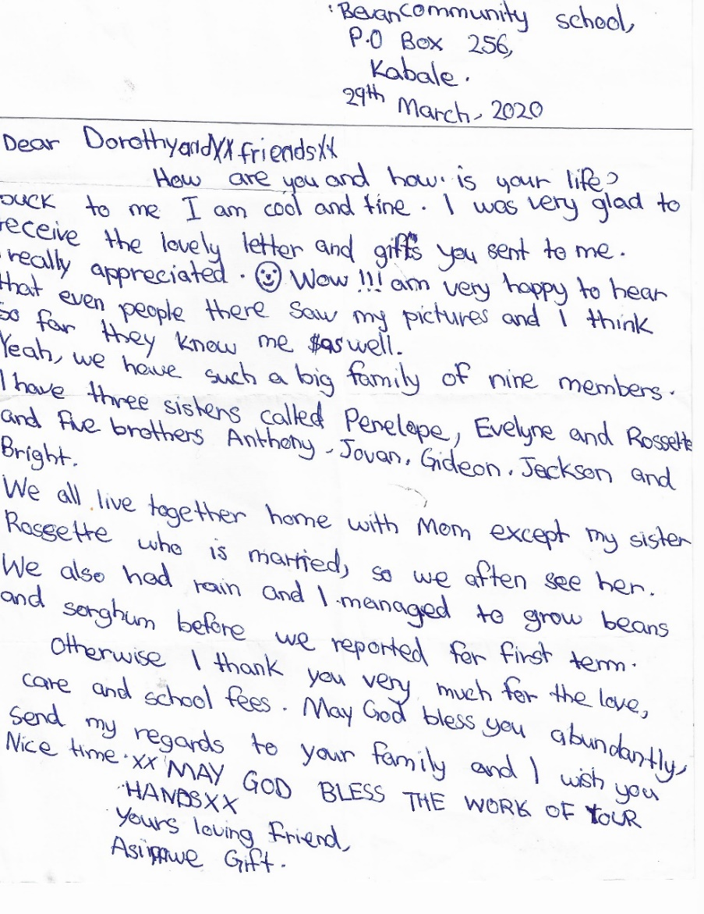
Next, I want to share a letter with you that Dorothy Kirbyshaw has sent me. It is from the girl we support from the money we make from the coffee on Sundays. Rather than telling you about it I thought you might value reading it for yourselves. This is a real piece of Christian charity that changes a young girl’s life.

Lastly, I want to say again how grateful I am to the Pastoral Leaders and Corona Telephone Team, for their continuing faithful contact with the members and friends in the church. I am conscious, with the expanded list of people we are now writing to, and are joining us online, we will have to pick up again the conversation we started before the lockdown into how we reach out. But time enough for that later. Bless you all. Ian
Christ Church Stocksbridge LEP, Manchester Road, Stocksbridge, S36 1DY : 0114 288 7899
Rev Ian Lucraft, 136 Wadsley Lane, Sheffield, S6 4EE
ianlucraft@btinternet.com : 0114 234 7153 : 07428 744 014
Website for Worship is www.christchurchonline.org : and on Facebook at @christchurchstocksbridge

