
Call to worship
Christ Church Stocksbridge
Together at Home
Sunday 10th May 2020

Welcome and introduction
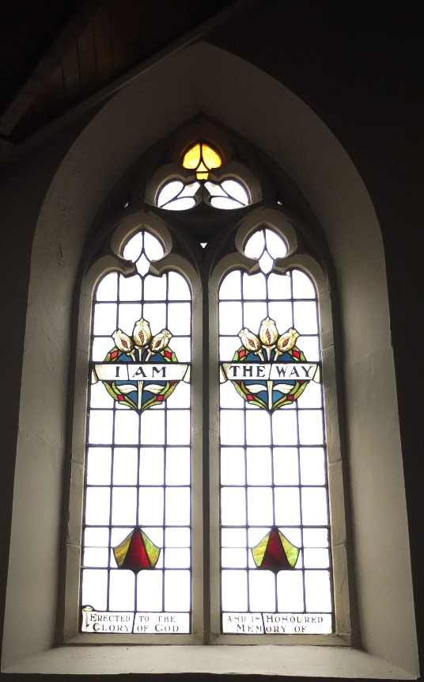
Dear Lord, we thank you that you have brought us together to make your church, that you are in us and we are entwined with each other.
Here’s the church; here’s the steeple;
open the door and here are the people.
Thank you for your presence in our church – inspiring us, comforting us, strengthening us and encouraging us.
Here’s the church; here’s the steeple;
open the door and here are the people.
Thank you for worship, companionship, conversation and challenge.
Here’s the church; here’s the steeple;
open the door and here are the people.
Amen.
Christian Aid
Activity Sheet
Shall we say this prayer together?
Merciful Lord,
We pray for all whose desperation leads them to the sea,
to undertake perilous voyages,
often following dangerous journeys over land:
those escaping brutal wars,
those fleeing religious persecution,
those escaping climate disasters and economic ruin,
those looking for hope in a hopeless situation.
May we look beyond our own fears and concerns
to the needs of those who have nothing,
risk everything
and depend on the kindness of strangers.
May our hearts be opened,
our leaders be challenged
and our self-interest be called out,
in Jesus’ name.
Amen.
Hymn Longing for light, we wait in darkness.
Longing for truth, we turn to you.
Make us your own, your holy people,
light for the world to see.

Christ be our light!
Shine in our hearts.
Shine through the darkness.
Christ be our light!
Shine in your church gathered today.

Longing for peace, our world is troubled.
Longing for hope, many despair.
Your word alone has power to save us.
Make us your living voice.

Longing for food, many are hungry.
Longing for water, many still thirst.
Make us your bread, broken for others,
shared until all are fed.

Longing for shelter, many are homeless.
Longing for warmth, many are cold.
Make us your building, sheltering others,
walls made of living stone.

Many the gifts, many the people,
many the hearts that yearn to belong.
Let us be servants, to one another,
making your kingdom come.

Bernadette Farrell

VE Day Remembrance and Celebration
Celebration and Reflection
Silence, Prayer and Hymn

This is my song, O God of all the nations,
A song of peace for lands afar and mine.
This is my home, the country where my heart is;
Here are my hopes, my dreams, my holy shrine;
But other hearts in other lands are beating
With hopes and dreams as true and high as mine.

My country’s skies are bluer than the oceans,
And sunlight beams on clover leaf and pine.
But other lands have sunlight too, and clover,
And skies are everywhere as blue as mine.
Oh, hear my song, thou God of all the nations,
A song of peace for their land and for mine.

This is my prayer, O Lord of all earth’s kingdoms,
Thy kingdom come; on earth thy will be done.
Let Christ be lifted up till all men serve him,
And hearts united learn to live as one.
Oh, hear my prayer, thou God of all the nations.
Myself I give thee; let thy will be done.

Lloyd Stone and Georgia Harkness

I am the Way, the Truth and the Life
Reading John 14 : vv 1-14 :
Shall we read this together?
Jesus Comforts His Disciples
14 “Do not let your hearts be troubled. You believe in God^{[a]}; believe also in me. ² My Father’s house has many rooms; if that were not so, would I have told you that I am going there to prepare a place for you? ³ And if I go and prepare a place for you, I will come back and take you to be with me that you also may be where I am. ⁴ You know the way to the place where I am going.”
Jesus the Way to the Father
⁵ Thomas said to him, “Lord, we don’t know where you are going, so how can we know the way?”
⁶ Jesus answered, “I am the way and the truth and the life. No one comes to the Father except through me. ⁷ If you really know me, you will know^{[b]} my Father as well. From now on, you do know him and have seen him.”
⁸ Philip said, “Lord, show us the Father and that will be enough for us.”
⁹ Jesus answered: “Don’t you know me, Philip, even after I have been among you such a long time? Anyone who has seen me has seen the Father. How can you say, ‘Show us the Father’? ¹⁰ Don’t you believe that I am in the Father, and that the Father is in me? The words I say to you I do not speak on my own authority. Rather, it is the Father, living in me, who is doing his work. ¹¹ Believe me when I say that I am in the Father and the Father is in me; or at least believe on the evidence of the works themselves. ¹² Very truly I tell you, whoever believes in me will do the works I have been doing, and they will do even greater things than these, because I am going to the Father. ¹³ And I will do whatever you ask in my name, so that the Father may be glorified in the Son. ¹⁴ You may ask me for anything in my name, and I will do it.
Word
Joys and Concerns
Prayers
In a world where there is warfare and violence,
many people live in fear of the bullet and the bomb;
many have had their lives and livelihoods destroyed;
many grieve for loved ones who have been killed.
That they may know your strength and peace, loving God: be for them a rock and a stronghold.
In a world where harvests have failed;
where there have been droughts and floods;
many do not have money to pay for food and power;
many are reaching the end of their tether.
That they may know your strength and peace, loving God: be for them a rock and a stronghold.
In a world where many people are alone;
many do not know where to look for comfort and encouragement;
many see no purpose or future;
some cannot see the point of anything.
That they may know your strength and peace, loving God: be for them a rock and a stronghold.
In our lives when we struggle and doubt;
when we don’t know what to say or do;
when life overwhelms us and we turn to you.
That we may know your strength and peace, loving God: be for us a rock and a stronghold.
In the name of the living Lord Jesus,
our Saviour and companion. Amen
The Lord’s Prayer
Offertory
Hymn

All I once held dear, built my life upon
All this world reveres, and wars to own
All I once thought gain I have counted loss
Spent and worthless now, compared to this
Knowing you, Jesus
Knowing you, there is no greater thing
You're my all, you're the best
You're my joy, my righteousness
And I love you, Lord
Now my heart's desire is to know you more
To be found in you and known as yours
To possess by faith what I could not earn
All-surpassing gift of righteousness
Oh, to know the power of your risen life
And to know You in Your sufferings
To become like you in your death, my Lord
So with you to live and never die.
Graham Kendrick
Benediction and Vesper
Now let’s all enjoy a coffee or tea together.

