
Call to worship
Christ Church Stocksbridge
Together at Home
Sunday 17th May 2020
The Spirit beside us

Welcome and introduction
Spirit of truth, come close to us.
Unite us into the body of Christ.
Enable us to worship God in Spirit and in truth.
Help us to support and encourage each other.
Help us to love as we are loved.
Spirit of truth, come and abide in us.
Amen.
Children
Activity Sheet
Hymn
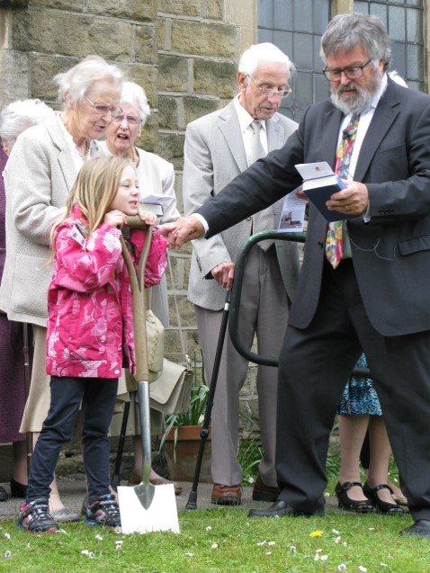
Come down, O Love divine,
seek thou this soul of mine,
and visit it with thine own ardour glowing;
O Comforter, draw near,
within my heart appear,
and kindle it, thy holy flame bestowing.
O let it freely burn,
till earthly passions turn
to dust and ashes in its heat consuming;
and let thy glorious light
shine ever on my sight,
and clothe me round, the while my path illuming.
And so the yearning strong,
with which the soul will long,
shall far out-pass the power of human telling;
for none can guess its grace,
till Love create a place
wherein the Holy Spirit makes a dwelling.
Bianco da Sienna c 1350 – c 1434

Joys and Concerns
Reading John 14 : vv 15-21 :
Shall we read this together?
Jesus Promises the Holy Spirit
¹⁵ “If you love me, you will keep my commandments. ¹⁶ And I will ask the Father, and he will give you another Helper, to be with you forever, ¹⁷ even the Spirit of truth, whom the world cannot receive, because it neither sees him nor knows him. You know him, for he dwells with you and will be in you.
¹⁸ “I will not leave you as orphans; I will come to you. ¹⁹ Yet a little while and the world will see me no more, but you will see me. Because I live, you also will live. ²⁰ In that day you will know that I am in my Father, and you in me, and I in you. ²¹ Whoever has my commandments and keeps them, he it is who loves me. And he who loves me will be loved by my Father, and I will love him and manifest myself to him.”
Verse
She sits like a bird, brooding on the waters,
Hovering on the chaos of the world’s first day;
She sighs and she sings, mothering creation,
Waiting to give birth to all the Word will say.

She wings over earth, resting where she wishes,
Lighting close at hand or soaring through the skies;
She nests in the womb, welcoming each wonder,
Nourishing potential hidden to our eyes.

She dances in fire, startling her spectators,
Waking tongues of ecstasy where dumbness reigned;
She weans and inspires all whose hearts are open,
Nor can she be captured, silenced or restrained.

For she is the Spirit, one with God in essence,
Gifted by the Saviour in eternal love;
She is the key opening the scriptures,
Enemy of apathy and heavenly dove.
John Bell

Hymn

Spirit of the Living God, fall fresh on me
Spirit of the Living God, fall fresh on me
Melt me, mold me, fill me use me.
Spirit of the Living God, fall fresh on me

Spirit of the living God, move among us all;
make us one in heart and mind, make us one in love;
humble, caring, self-less, sharing.
Spirit of the living god, fill our lives with love.
v1 Daniel Iverson, v2 Michael Baughen

Word

Prayers of intercession
Dear Lord, we bring into your love
those who do not know you and your love;
those who have turned away from you;
those who struggle to accept you;
those who refuse to listen.
May your love touch them,
and transform their lives.
Dear Lord, we bring into your love
those who need parental love;
those who are alone;
those who are abused;
those who are neglected.
May your love touch them,
and transform their lives.
Dear Lord, we bring into your love
those who seek the truth;
those who work in the justice system;
those who campaign and advocate on behalf of the voiceless.
May your love touch them,
and transform their lives.
May we show the power and presence of your love in our church, our community and our world – for Jesus’ sake. Amen.
The Lord’s Prayer
Our Father, who art in heaven, hallowed be thy name; thy kingdom come; thy will be done; on earth as it is in heaven. Give us this day our daily bread. And forgive us our trespasses, as we forgive those who trespass against us. And lead us not into temptation; but deliver us from evil. For thine is the kingdom, the power and the glory, for ever and ever. Amen.
Hymn
Lord, the light of your love is shining
In the midst of the darkness, shining
Jesus, Light of the world, shine upon us
Set us free by the truth you now bring us
Shine on me, shine on me

Shine, Jesus, shine
Fill this land with the Father's glory
Blaze, Spirit, blaze
Set our hearts on fire
Flow, river, flow
Flood the nations with grace and mercy
Send forth your word
Lord, and let there be light.

Lord, I come to your awesome presence
From the shadows into your radiance
By the blood I may enter your brightness
Search me, try me, consume all my darkness
Shine on me, shine on me

As we gaze on your kingly brightness
So our faces display your likeness
Ever changing from glory to glory
Mirrored here may our lives tell your story
Shine on me, shine on me.
Graham Kendrick

Benediction
Go in peace to live in love, to show God’s love, to receive God’s love – everywhere, and at all times. Amen
The Grace and Vesper
Now let’s all enjoy a coffee or tea together.

