Call to worship
Christ Church Stocksbridge
Together at Home
Sunday 31st May 2020
Let anyone!

Spirit of fire, warm us with your everlasting love.
Spirit of wind, blow away hurtful words that
damage relationships.
Spirit of earthquake, carry away our fears.
Spirit of breeze, restore our peace with your
calming breath.
Spirit of the living God, speak to us in words
we can understand.
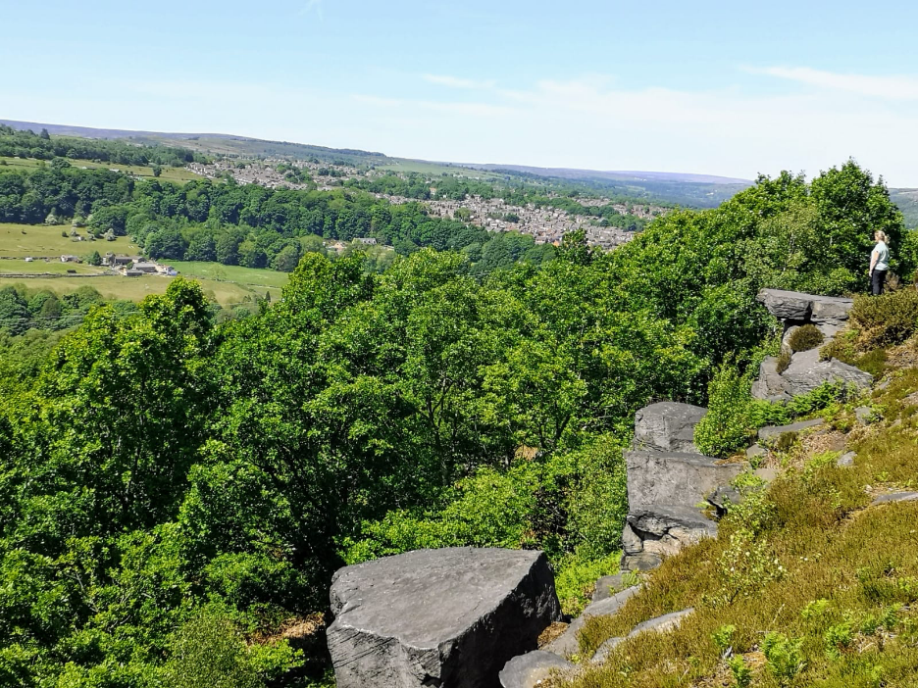
Amen.
Welcome and introduction
Children and Activity Sheet
Father of everlasting grace,
your goodness and your truth we praise,
your goodness and your truth we prove;
you have, in honour of your son,
the gift unspeakable sent down,
the Spirit of life, and power and love.
Send us the Spirit of your Son,
To make the depths of Godhead known,
To make us share the life divine;
send him the sprinkled blood to apply,
send him our souls to sanctify,
to bless and seal us with this sign.
Stocksbridge from Wharncliffe Crags
by
Julie Lowry
So shall we pray, and never cease;
So shall we thankfully confess
your wisdom, truth, and power, and love;
with joy unspeakable adore,
and bless and praise you evermore,
and serve you as your hosts above:

Till, added to that heavenly choir,
we raise our songs of triumph higher,
and praise you with a bolder voice,
out-soar the first-born seraph’s flight,
and sing, with all our friends in light,
with everlasting love rejoice.
Charles Wesley
Joys and Concerns
Reading Acts 2 1-21 Shall we read it together?
When the day of Pentecost came, they were all together in one place. ² Suddenly a sound like the blowing of a violent wind came from heaven and filled the whole house where they were sitting. ³ They saw what seemed to be tongues of fire that separated and came to rest on each of them. ⁴ All of them were filled with the Holy Spirit and began to speak in other tongues as the Spirit enabled them. ⁵ Now there were staying in Jerusalem God-fearing Jews from every nation under heaven. ⁶ When they heard this sound, a crowd came together in bewilderment, because each one heard their own language being spoken. ⁷ Utterly amazed, they asked: “Aren’t all these who are speaking Galileans? ⁸ Then how is it that each of us hears them in our native language? ⁹ Parthians, Medes and Elamites; residents of Mesopotamia, Judea and Cappadocia, Pontus and Asia, ¹⁰ Phrygia and Pamphylia, Egypt and the parts of Libya near Cyrene; visitors from Rome ¹¹ (both Jews and converts to Judaism); Cretans and Arabs—we hear them declaring the wonders of God in our own tongues!” ¹² Amazed and perplexed, they asked one another, “What does this mean?” ¹³ Some, however, made fun of them and said, “They have had too much wine.” ¹⁴ Then Peter stood up with the Eleven, raised his voice and addressed the crowd: “Fellow Jews and all of you who live in Jerusalem, let me explain this to you; listen carefully to what I say. ¹⁵ These people are not drunk, as you suppose. It’s only nine in the morning! ¹⁶ No, this is what was spoken by the prophet Joel:

“‘In the last days, God says, I will pour out my Spirit on all people. Your sons and daughters will prophesy, your young men will see visions, your old men will dream dreams. ¹⁸ Even on my servants, both men and women, I will pour out my Spirit in those days, and they will prophesy. ¹⁹ I will show wonders in the heavens above and signs on the earth below, blood and fire and billows of smoke. ²⁰ The sun will be turned to darkness and the moon to blood before the coming of the great and glorious day of the Lord. ²¹ And everyone who calls on the name of the Lord will be saved.’
Hymn There's a spirit in the air,
telling Christians everywhere:
‘Praise the love that Christ revealed,
living, working in our world!’

Lose your shyness, find your tongue,
tell the world what God has done:
God in Christ has come to stay.
Live tomorrow's life today!

When believers break the bread,
when a hungry child is fed,
praise the love that Christ revealed,
living, working in our world.

Still the Spirit gives us light,
seeing wrong and setting right:
God in Christ has come to stay.
Live tomorrow's life today!

When a stranger's not alone,
where the homeless find a home,
praise the love that Christ revealed,
living, working in our world.

May the Spirit fill our praise,
guide our thoughts and change our ways.
God in Christ has come to stay.
Live tomorrow's life today!

There's a Spirit in the air,
calling people everywhere:
Praise the love that Christ revealed,
living, working in our world.
Brian Wren

Word

Prayers Will you read this prayer with me?

Christ has died.
Here, where hope seems overturned,
and God's purposes prevented,
here we meet with you, the Lord who gave up heaven
to take on human life.
Here we meet a saviour who knows risk,
and pain, and loss.
Here we meet the Christ who died for us,
and knows us in all our hurts and fears.

Christ is risen.
Lord, now we celebrate and sing of your wonderful awakening from death,
and give praise to God for the hope and promise
of life lived in an eternal manner.
Here we meet the Christ who has broken the power of sin and death,
and opened to our sight the splendour of God's plan.
Here we meet the Lord of hope and joy
who invites us to share his life.

Christ will come again.
Lord, we do not know the hour, but we do know that you have come to us already.
Here we meet the Lord whose work is not complete,
who lives with hope that all shall be brought in,
who calls us to hear his voice and follow him.
Here we place our trust in the God who reveals his unfolding purposes through his son, our saviour, Jesus Christ.
Our Father, who art in heaven, hallowed be thy name; thy kingdom come; thy will be done; on earth as it is in heaven. Give us this day our daily bread. And forgive us our trespasses, as we forgive those who trespass against us. And lead us not into temptation; but deliver us from evil. For thine is the kingdom, the power and the glory, for ever and ever. Amen.
Hymn (five verses only)
The Spirit lives to set us free,
walk, walk in the light;
he binds us all in unity,
walk, walk in the light.
Walk in the light,
walk in the light,
walk in the light,
walk in the light of the Lord.

Jesus promised life to all,
walk, walk in the light;
the dead were wakened by his call,
walk, walk in the light.
He died in pain on Calvary,
walk, walk in the light;
to save the lost like you and me,
walk, walk in the light.
We know his death was not the end,
walk, walk in the light;
he gave his Spirit to be our friend,
walk, walk in the light.
The Spirit lives in you and me,
walk, walk in the light;
his light will shine for all to see,
walk, walk in the light.
Damian Lundy

The Grace and the Vesper
Take, oh take me as I am; summon out what I shall be; set your seal upon my heart, and live in me. Repeat
Now let’s all enjoy a coffee or tea together.

