
Call to worship
Christ Church Stocksbridge
Together at Home
Sunday 3rd May 2020 : Communion

Introit
Welcome
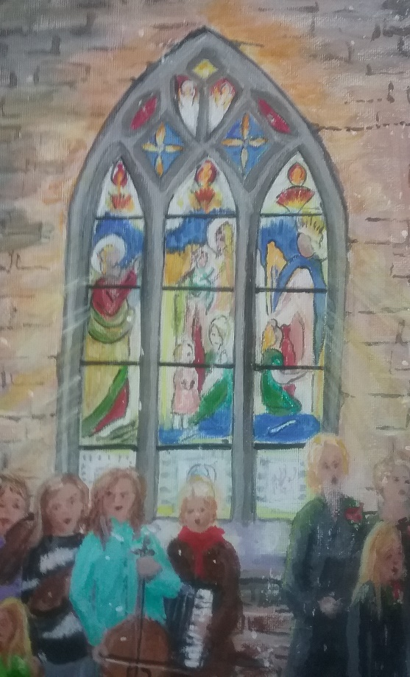
There’s a wideness in God's mercy
Like the wideness of the sea;
There's a kindness in his justice
Which is more than liberty.
There is plentiful redemption
In the blood that has been shed;
There is joy for all the members
In the sorrows of the Head.
There is grace enough for thousands
Of new worlds as great as this;
There is room for fresh creations
In that upper home of bliss.
For the love of God is broader
Than the measure of man's mind;
And the heart of the Eternal
Is most wonderfully kind.
But we make his love too narrow
By false limits of our own;
And we magnify his strictness
With a zeal he would not own.
If our love were but more simple,
We should take him at his word;
And our lives would be illumined
By the presence of our Lord.
Frederick William Faber
An extract of the painting of carol singers at Christ Church, by our member Sandra Taylor, reproduced with her permission.
Children
Joys and Concerns
Offertory
Reading John 10:1-11, 14-16
Shall we read this together?
The Good Shepherd and His Sheep
“Very truly I tell you Pharisees, anyone who does not enter the sheep pen by the gate, but climbs in by some other way, is a thief and a robber. ² The one who enters by the gate is the shepherd of the sheep. ³ The gatekeeper opens the gate for him, and the sheep listen to his voice. He calls his own sheep by name and leads them out. ⁴ When he has brought out all his own, he goes on ahead of them, and his sheep follow him because they know his voice. ⁵ But they will never follow a stranger; in fact, they will run away from him because they do not recognize a stranger’s voice.” ⁶ Jesus used this figure of speech, but the Pharisees did not understand what he was telling them.
⁷ Therefore Jesus said again, “Very truly I tell you, I am the gate for the sheep. ⁸ All who have come before me are thieves and robbers, but the sheep have not listened to them. ⁹ I am the gate; whoever enters through me will be saved.^{[a]} They will come in and go out, and find pasture. ¹⁰ The thief comes only to steal and kill and destroy; I have come that they may have life, and have it to the full. ¹¹ I am the good shepherd. The good shepherd lays down his life for the sheep. ¹⁴I am the good shepherd; I know my sheep and my sheep know me— ¹⁵ just as the Father knows me and I know the Father—and I lay down my life for the sheep. ¹⁶ I have other sheep that are not of this sheep pen. I must bring them also. They too will listen to my voice, and there shall be one flock and one shepherd.
Word
God whose love is all around us,
who in Jesus sought and found us,
who to freedom new unbound us,
keep our hearts with joy aflame.
For the sacramental breaking,
for the honour of partaking,
for your life, our lives re-making,
young and old, we praise your name.
From the service of this table,
lead us to a life more stable,
for our witness make us able;
blessing on our work we claim.
Through our calling closely knitted,
daily to your praise committed,
for a life of service fitted,
let us now your love proclaim.
Fred Kaan
Prayers
Communion
Our help is in the name of the Lord.
Who made the heaven and the earth.
Let us recall the words of Jesus: Jesus said: “You must be perfect, even as your Father in heaven is perfect.”
Jesus also said: “I came not to call the righteous but sinners to make a new start.”
Lord, your words disturb us and restore us. If our prayers make us hypocrites, if our money distorts our lives, if our anxiety stops us being free to live, you know our condition and you can heal us. Make us honest with ourselves, yet deliver us from despair. Giver of life and hope we come to you neither to plead nor to boast, but as we are. Accept us we pray.
Therefore my brothers and sisters, I implore you by God’s mercy to offer your very selves to him: a living sacrifice, dedicated and fit for his acceptance, the worship offered by mind and heart. Adapt yourselves no longer to the pattern of this world but let your minds be remade and your whole nature thus transformed. Then you will be able to discern the will of God and to know what is good, acceptable and perfect. (Romans 12 vv 1-2)
Lift up your hearts. We lift them to the Lord.
Let us give thanks for God’s glory. We give thanks, we rejoice in the glory of all creation.
All glory be to you, O Father, who sent your only begotten Son into the world, to be a man, born of a woman’s womb, to die for us on a cross that was made by. He came for us. Help us to accept his coming.
He walked among us, a man, on our earth, in our world of conflict, and commanded us to remember his death, his death which gives us life: and to wait for him until he comes again in glory. We remember his death. We live by his presence. We wait for his coming.
On the night he was betrayed, the Lord Jesus took bread, he gave thanks, he broke it and gave it to his disciples saying: “Take, eat, this is my body. Do this in remembrance of me.” He also took the cup, he gave thanks, and gave it to them, saying: “Drink of it, all of you; this is my blood of the covenant, which is poured out for many for the forgiveness of sins.” Come, Lord Jesus, come.
Therefore, remembering his death, believing in his rising from the grave, longing to recognise his presence, now in this place we obey his command; we offer bread and wine, we offer ourselves, to be used. Everything is yours, O Lord. We return the gift which first you gave us.
Accept it Father. Send down the Spirit of life and power, glory and love, upon these people, upon this bread and wine, that to us they may be His body and His blood. Come, risen Lord, live in us that we may live in you.
Now with all people who ever were, are and will be, with all creation in all time, with joy we say: Holy, Holy, Holy, Lord God Almighty, all space and all time show forth your glory now and always. Amen.
The Lord’s Prayer

Sharing the bread and wine

I, the Lord of sea and sky,
I have heard my people cry,
All who dwell in dark and sin,
my hand will save.
I who heard the stars of night,
I will make their darkness bright.
Who will bear my light to them?
Whom shall I send?

Here I am, Lord, Is it I, Lord?
I have heard you calling in the night.
I will go Lord, if you lead me,
I will hold your people in my heart.

I, the Lord of snow and rain,
I have borne my people’s pain,
I have wept for love of them,
they turn away.
I will break their hearts of stone,
give them hearts for love alone,
I will speak my word to them,
Whom shall I send?

I, the Lord of wind and flame,
I will tend the poor and lame,
I will set a feast for them,
my hand will save.
Finest bread I will provide
till their hearts be satisfied,
I will give my life to them,
Whom shall I send?
Daniel L Schutte

Benediction and Vesper
Now let’s all enjoy a coffee or tea together.

