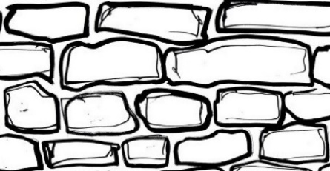
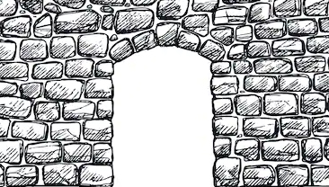
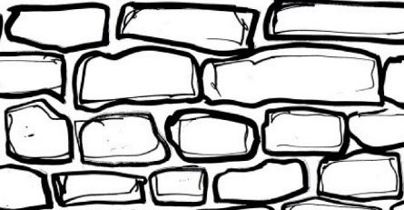
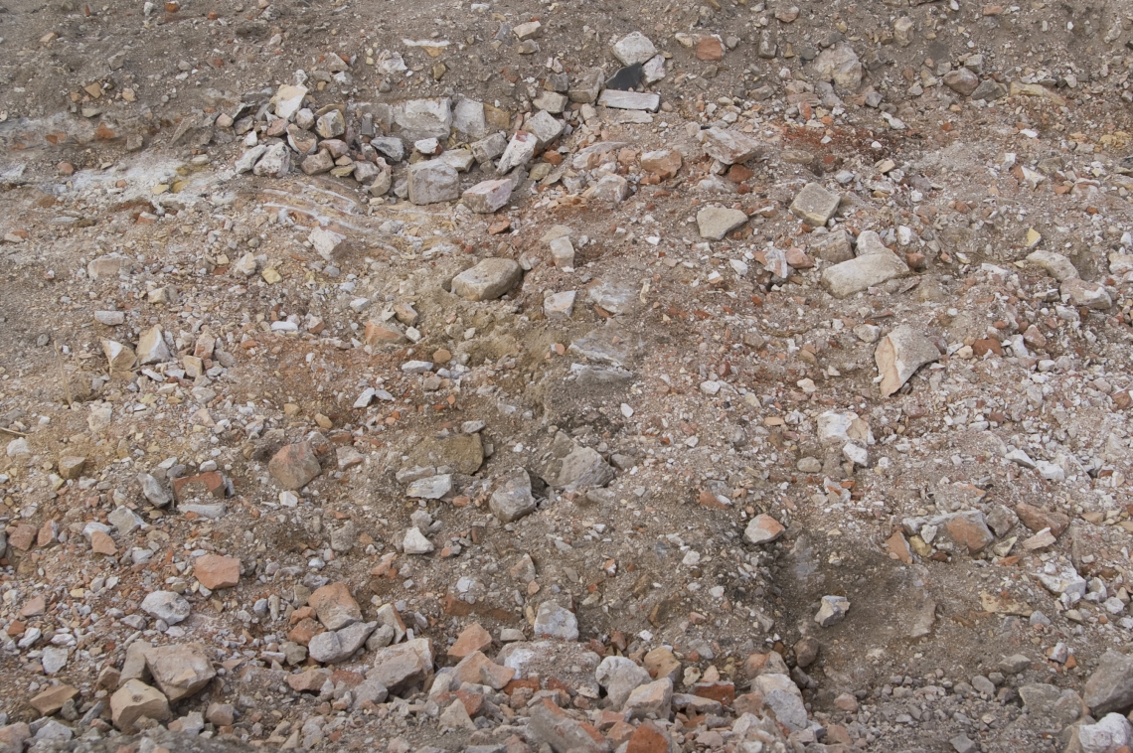
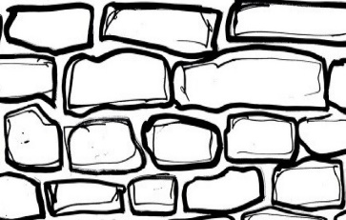
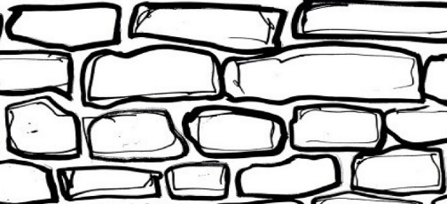
The Good Shepherd
Jesus said: “I am the good shepherd.”
First cut round the sheet to remove the white border.
Colour the walls if you want.
With the gravel side up, fold each side up to create the walls.
Make ONE snip at each corner, to give you a flap at each corner to turn round the corner and stick it down. This will create the sheep pen.
Carefully snip out the hole for the sheep gate.
Cut out and colour the figure of Jesus and the various sheep, always keeping the sticking tabs.
I’ve put some wool in the letters to families with children. Stick it on the sheep?
Add your figures to the diorama.
You might have a twig on a plant in the garden with some leaves on that you could add to make a tree in one corner?
Or whatever your wonderful creativity suggests.
Well done! Now why not take photo and post it on WhatsApp, or text/email it to me?
I’ll post it on the church website.

