


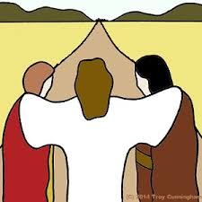




Emmaus Group

A Bible study group which meets at church. It is an open group exploring the tough issues of faith to try to understand the message of the Gospel of Jesus Christ in today’s society.

Fourth Friday of each month at 7.00 pm
Worship

Family Worship, Sundays at 10.45.
Holy Communion is on the first Sunday in the month as part of the morning service.

Café Church, Reflective Meditation and Film Night are on Sunday evenings, each once a month, at 6.00 pm
Busy Little Hands

A lively and happy toddler group for parents and carers and their pre-school children.
Lots of wonderful toys, play activities, crafts, healthy snacks.

Fridays at 9.45 am
Lunch Club

This is a new service for older people in the community to meet and talk and share a meal together on Thursdays. There’s a home-cooked two course lunch and interesting activities.

Volunteer drivers and escorts urgently needed.

Choir

We are really pleased that we have an enthusiastic church choir, which not only leads the music on Sundays but also holds other events for us. New members always welcome.

Choir Practice is Wednesdays at 7.00 pm
Guild

The Guild is an afternoon meeting that has a varied programme of meetings. Sometimes there is a devotional afternoon, and sometimes it is a speaker or a shared activity. Always cake!

Wednesdays at 2.00 pm.
The Meeting Place

This is a new project on Monday mornings to help local people make friends and find support for their lives in our local community. Most members come by referral.
If you would be interested in being a project volunteer please ask.
Sunday School

We have a Sunday School every Sunday at 10.45. The first 15-20 minutes are with everyone in church and then the children have their own session downstairs before returning to join us after church. Parents are welcome to come with their children.

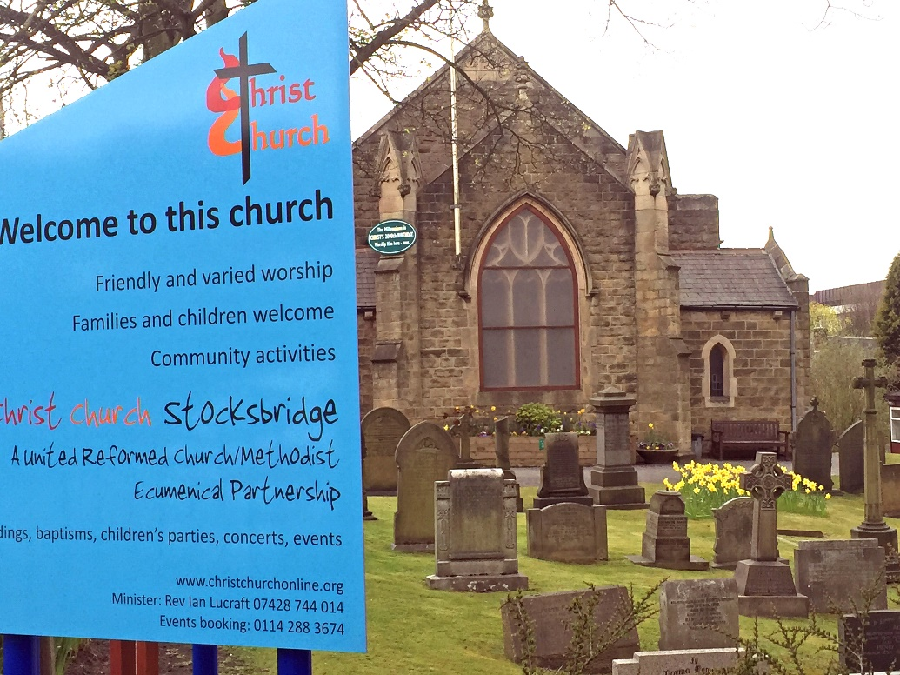
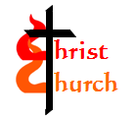



Community Activities and Children’s parties

We are pleased to be able to host several community groups on a regular basis. We are also available for children’s parties.

Bolsterstone Archaeology : Third Wednesday 7.00 – 9.30 pm
Fox Valley Singers : Monday evenings 6.00 - 7.00 pm
Noodle Performance Arts : Tues 4-4.45 & Sats 9–12 (Term time)
SMART : Support Group, Tuesdays at 2.00 pm
Steel Valley Beacon : Young people’s drama, Tuesdays 6-8 & Fridays 6-9pm
Stocksbridge Arts Society : Tuesdays mornings from 9.45 am
Stocksbridge and Dist. Historical Society : Second Thursdays at 7.00 pm
Stocksbridge Women’s Institute : First Wednesdays at 7.00 pm
Two Probus Groups : Alternate Wednesdays from 9.30 am

To enquire about hiring rooms, please call Jenny Clarke on 0114 288 3674.

Good Days Project

We are proud to be the host of this amazing service run independently for adults with Autism and Profound Multiple Learning Difficulties.

Daily Monday-Saturday
Over 60’s Club

A relaxed social afternoon including table games and social card games, refreshments and a lot of chat.

Mondays at 2.00 pm.
Christ Church is a merged congregation of the former
Stocksbridge United Reformed and Stocksbridge Methodist Churches.

Weddings and Baptisms by arrangement.

Minister : Rev Ian Lucraft 07428 744 014 : ianlucraft@btinternet.com
www.christchurchonline.org
You’ll find a warm welcome here at
Christ Church….

…. there might be something for you!
Christ Church Stocksbridge

A United Reformed and Methodist Churches
Local Ecumenical Partnership

