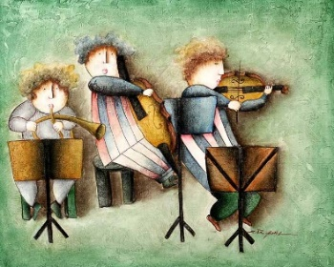

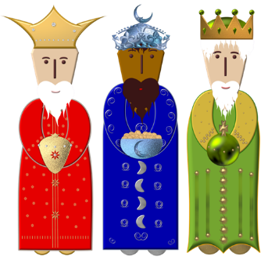


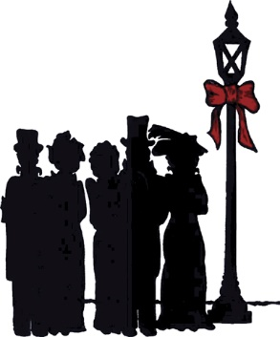


Festive Craft Group
for young children

Sunday’s 4th, 11th & 18th December
from 10.00 – 11.00 am (10.30 on 18th)
Music, song, craft, games, treats, Singing Nativity and Father Christmas,
led by Amanda and Heather
Waldershelf Choir
St John’s School Choir

Tuesday 13th December 7.00 pm
We are delighted that Waldershelf and the wonderful St John’s Choir are singing again at Christ Church this year.
Tickets available but get yours early.
Nativity Service

Sunday 18th December, 10.45 am

An upbeat Nativity Service, with the children putting on their special songs and dressing up. Refreshments afterwards. Led by Amanda and Heather, and Rev Ian Lucraft and others.
Festival of Local Carols and other Christmas music

Sunday 11th December, 6.30 pm
All the old local carols, with the local words and music. Fun, sharing and mince pies afterwards. Christ Church Choir, conductor Frank Hardman.
Christingle

Sunday 11th December, 10.45 am

Come and make a Christingle Candle to take home, children’s Christmas carols, and coffee and cake afterwards.
Carols by Candlelight

Sunday 18th December, 6.00 pm

A serene candlelit evening carol service with readings and favourite carols old and new.
Rev Ian Lucraft and others.
Pearl’s Youth Concert

Friday 11th November at 7.30 pm
Tickets £4 (Children free)
Pearl conjures up for us again the magic of young people performing live music. The proceeds are shared between UNICEF and the church. Refreshments included.
Toy Service

Sunday 27th November, 10.45 am

We all bring gifts of NEW toys for children who are suffering this Christmas. Children’s songs, and a treat for everyone. Rev Ian Lucraft and others.
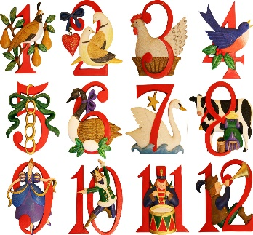
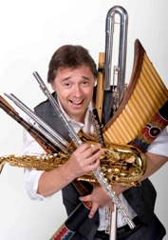
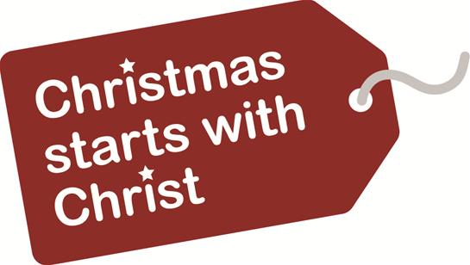

Welcome to Christmas at Christ Church

Singing carols, concerts,
making Christingle candles, old and new songs.
Twelfth Night Celebration

Saturday 7th January 2017 7.00pm

After all the hectic Christmas rush, a fun party to mark the end of the Christmas season, with music, games and other joyful activities.
Christ Church is a united congregation
of United Reformed and Methodist Churches
worshipping here and reaching out from this church to everyone in the community.
Sunday morning worship each week at 10.45 is a happy occasion, and children are always welcome.
Sunday evenings at 6.00 we have a mix of Café Church, Film Night and Reflective Mediation on different Sundays.
Minister : Rev Ian Lucraft
07428 744 014 : ianlucraft@btinternet.com

www.christchurchonline.org
Simeon Wood Concert

Saturday 19th November

A welcome return for this gifted and inspiring musician who presented a magical concert full of love and fun and faith here last year
Ring 0114 233 7542 for tickets

Christmas Day

Sunday 25th December, 11.00 am

A short morning service celebrating the birthday of our Lord
Families and children with toys welcome

