Phased Start
We are going to start the first couple of weeks with a smaller group of members, perhaps about 10. This is so that we can start comfortably and get used to how things run, before we welcome more members.
So if we are not able to accommodate you in the first week, you will not be left out. We will welcome you as the Club develops over the first couple of months.
Arrangements
The Lunch Club will operate on Thursdays. It will be open from 10.30, when free tea and coffee will be served.
A minibus will go out about 9.15 to start collecting some members and bring them into the Club about 10.45.
There will be some activities from 11.00 – 12.00.
A two course lunch will be served at 12.00. Free tea and coffee will be served after lunch. The meal will cost £4 per head.
The minibus will start taking people home at 1.30 and the Lunch Club will close at 2.00 pm.
Membership List
We expect that members will want to come most Thursdays, but we realise that people have other things like holidays, hospital appointments and the like, and so we know that no-one will be able to come all the time. But if you want to be a member we would expect that it is because you would want to come most Thursdays. We are not operating like a drop-in; we are operating a membership list.
If you want to come to the Club there is a form that Wendy will need to fill in as she talks with you, so that she gets the details that she needs to make sure that we look after you carefully, and make the correct decisions about who needs transport. She will need to ask you for your closest family member contact details, who to ring in an emergency, your doctor’s name and address, your own name and address and your date of birth, if you have any food allergies or issues, and a few other questions.
All these forms will be kept securely in a locked cabinet where we file our confidential papers.
Personal Services
We are not able to provide personal services at the Lunch Club. This means:
- you must be able to go to the toilet on your own without help inside the toilet. (If you need an arm to help you there, or a push for a chair, of course we would do that. But we cannot come into the toilet to help you there, except in an absolute emergency.)
- you must be able to eat your meal yourself. We can help with cutting up, and we will always serve you something you can manage, but we cannot provide feeding services to individuals.
Of course if you want to come, and you need this help, and you have a carer who can come with you to ensure you can manage these things, then that is usually possible if you talk it through with us.
We plan to be dementia-friendly, but we will not be capable of coping with serious cases of dementia. Often, though, people with early stage dementia can still function well with a bit of help, and we will expect to provide that. And of course sometimes where a couple want to come together, it is possible that one partner may be able to help the other.
We will always make contact with the caring relatives or carers, so that we know what the needs of each person are.
Transport
The minibus will be prioritised to help people who cannot get on their own any other way. This means that even if you would like transport, it may not be possible. We will be evaluating this as we receive requests to come to the Lunch Club. The form you fill in with Wendy will help us to make these initial judgements.
We will be charging £3 for the return journey once we have our own minibus. Until then it will depend on the cost of the transport we manage to arrange temporarily.
Of course, if we are not able to provide you with transport, and it is not possible for you to get to Lunch Club without transport, or you live outside our catchment area, you could either get here by signing up for ‘Dial a Ride’ or getting a taxi or using public transport. This would be at your own expense of course, but you would be most welcome to get yourself there under your own steam.
The Food
We will be cooking all the meals on the premises in our wonderful new catering kitchen. We expect to serve a variety of traditional meals that everyone will like.
We are not able to provide choices. But we will provide an alternative for individuals who have a specific dietary need, such as vegetarian, gluten, allergy or similar. Part of taking your details at the start is to make sure that we don’t give you the wrong food.
Methodist Homes for the Aged (MHA)

We are thrilled that we are able to enter into a partnership with MHA, which will make it possible to run a brilliant lunch club.
Contact details
If you, or a member of your family, wants to talk about coming to the Lunch Club, please ring or email:
Wendy Law on 0739 926 8622 or wendylaw750@gmail.co.uk



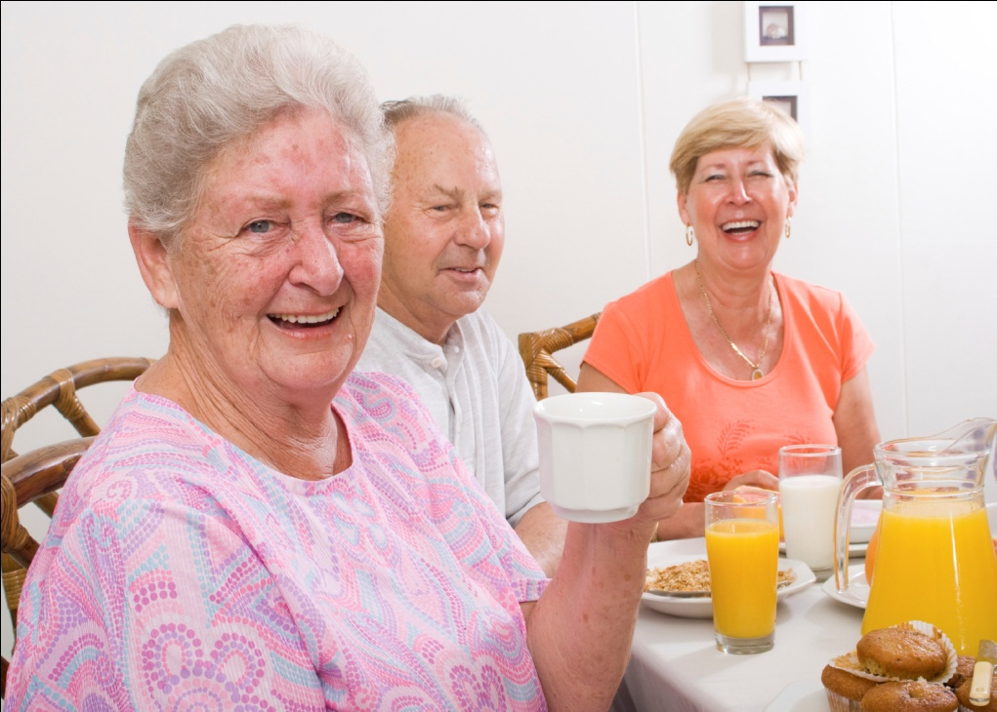

Our new Lunch Club
Invitation leaflet

Do you want to come to our new Lunch Club at Christ Church?
Our new lunch club at Christ Church will start on Thursday 8th September 2016.
Wendy Law, our new Lunch Club Co-ordinator is visiting you with this leaflet, to find out if you want to come.
You can ask Wendy any questions about the Club that you want.

