Tackling Vulnerability and Isolation in Stocksbridge and Deepcar

A Proposal

The proposal is to set up a project which will link together lots of community resources to tackle some of the emerging issues around vulnerability and isolation for some individuals in The Valley, (Stocksbridge and Deepcar).

Central to the project will be a dedicated worker, based at Christ Church, who will liaise with other agencies, organisations, churches and individuals in The Valley, to develop ways of supporting isolated people and assisting them to make connections with activities that would improve their sense of well-being, their health and welfare, and help them to become integrated into the wider community.

While part of the project will be to work out ways of developing such support, there are two initial projects which will act as a focus for development in the first year of the scheme. The planning for these two new activities will aim to have them operational by the autumn of 2015, by which time the new community hall should be completed. Detailed planning needs to take place before these are ready to operate, but the initial shape of the two first services is now evident.

A new lunch-club service, based at Christ Church, one day a week, and staffed by local volunteers from the church and the community, which will identify isolated and lonely older people, especially those for whom mobility or access to the town is a problem. The lunch club service will have the following features:
- accessible (wheel-chair lift) minibus to collect people with mobility needs;
- a hot meal, cooked on the premises, with endless tea and coffee;
- dedicated volunteers to support isolated individuals make their first outings to the Lunch Club;
- ‘wellness’ activities at the Lunch Club;
- craft activity options at the Lunch Club;
- social activities;
- a mix of members to ensure that there are able and less able members to ensure integration.
A new ‘Social Café’, based at Christ Church Stocksbridge, in the new community hall when it is built. It will operate one morning a week and provide a breakfast club service for individuals in the community who need companionship, support with access to service, help with finding out about activities and organisations and services in the Valley. While the Social Café, led by the project worker, will be run by volunteers from the church and the community, it will not itself take on the responsibility of advice or specific individual support. Such advice and support will be provided by dedicated officers in the relevant agencies. The Social Café will have the following features:
- direct referrals into the café from statutory and voluntary agencies;
- self-referral to the Social Café;
- agreed referral routes out to specific individuals in local and statutory services to respond to needs and agreed regular visits from specific local services to be ‘on-hand’ to respond to individual needs;
- agreed links to individuals in specific local services, such as the food bank, community care, housing, social services, debt services, drug and alcohol services etc.;
- links to training programmes for personal development and life skills, run at other local venues;
- links to a network of activities of interest, sports, training, etc., in the community to make first steps in integration;
- a simple free breakfast item and tea and coffee, and newspapers in a warm and friendly environment;
- writing support for letters and emails etc. and helping with finding access to services and facilities;
- support for form-filling;
- training for volunteers.

Background

Several of the key services and workers in Stocksbridge have identified an issue around vulnerable and isolated men aged 30 – 60 who need additional support in Stocksbridge area. Several services have had difficulty in being able to support these men as Stocksbridge is far from the city centre and it is therefore difficult for people to access specialist services. The Social Café would be open to both men and women: adult males are the presenting issue. A key aim of the project is to reduce the need for individuals to access emergency services, through neglect or inability to deal with minor issues that erupts into crises.

The Social Café idea has been developed through early discussions among the group listed below. In other parts of the city (Parson Cross, Bramall Lane and Manor) Social Cafés are regular events held at different venues. Their purpose is for people who are feeling fed up and would like someone to talk to, to drop in and have a chat with others in similar situations over a cup of tea or coffee. The Cafés are run by experienced staff and volunteers, providing a relaxed atmosphere, optional wellbeing activities and of course refreshments. (http://www.sheffieldmind.co.uk/services/social-cafes)

Stocksbridge is within the North Local Area Partnership (LAP) area which has a priority around Health and Wellbeing with a particular focus on tackling social isolation. The Sheffield Locality Officer for the North LAP, Oonagh Mcclean, has a remit to encourage partnership working on matters around this priority. She has led a series of meetings in the Library, where interested parties have met to discuss this idea and develop a plan for the Stocksbridge area that could address this issue.

The people and local groups that have been involved in these discussions, either directly or by other communication, have included (apologies for any omissions):
- Oonagh Mcclean, SCC Locality Officer
- Leigh Buchanan Adult Social Care
- The Community Care Project
- The Food Bank
- The Hub
- Christ Church
- The Christian Centre
- The Salvation Army
- Stocksbridge Town Council
- Soar Community Project
- The Health Service
- The Health Centre in Deepcar
- The Housing Department
- SCC Social Services
- SCC Adult Care Services
- SCC Library Service.

Environment

The Valley is a classic case of a community somewhat separated from a major city, in which there has been a historic heavy industry presence, and where the employment that industry provides has reduced dramatically in recent years. For people outside Stocksbridge a similar well-known example might be Corby. The consequence of the reduction in employment of the steelworks from over 10,000 perhaps 20 years ago, to less than 1,000 today, has had a major impact on employment. A consequence of that has been a deterioration in local shops and services and in the ability of the community to be as progressive and independent as it once was.

The exodus of young people has left a population which is more aged than the norm, and with fewer wage-earners per head than the norm. The vacancies in property in the area have been used by the somewhat distant Sheffield City Council to re-house single and other adults from the Sheffield homelessness list.

Stocksbridge people will say that not too long ago everyone knew each other, there was always someone to help, there were lots of social and community activities and it was a self-supporting small town, somewhat separate from the main city 10 miles away. While there have certainly been significant changes, much of that community infrastructure remains, though much of it is more fragile. However, this is not an easy environment in which older people always have solid family support structures, and younger people, and people re-housed in the Valley, have a less easy time making connections, finding friends and accessing services.

The contraction of services has meant that many services are no longer provided full time, or at all, in the Valley. For individuals with poor coping skills, who are in poverty or have recently been re-housed from the big city, a set of appointment-driven services at a variety of locations in Sheffield a long and expensive bus-ride away, is not the answer to their needs for connection, support and integration.

The local officers of the services, and local community groups have recognised this, and want to develop a network of support that will enable individuals to find their way to support themselves; but they need a helping hand to start.

Evidence of need

The demographic data for Stocksbridge and Deepcar shows that it is not one of the most deprived areas of the country taken as a whole unit. However, there are clear geographic pockets of serious deprivation. There are also groups of individuals who by nature of their minor health, mental health or social needs, are in isolation and poverty and need support to find their ways forward. [Specific demographic data will be inserted here for the main bid.]
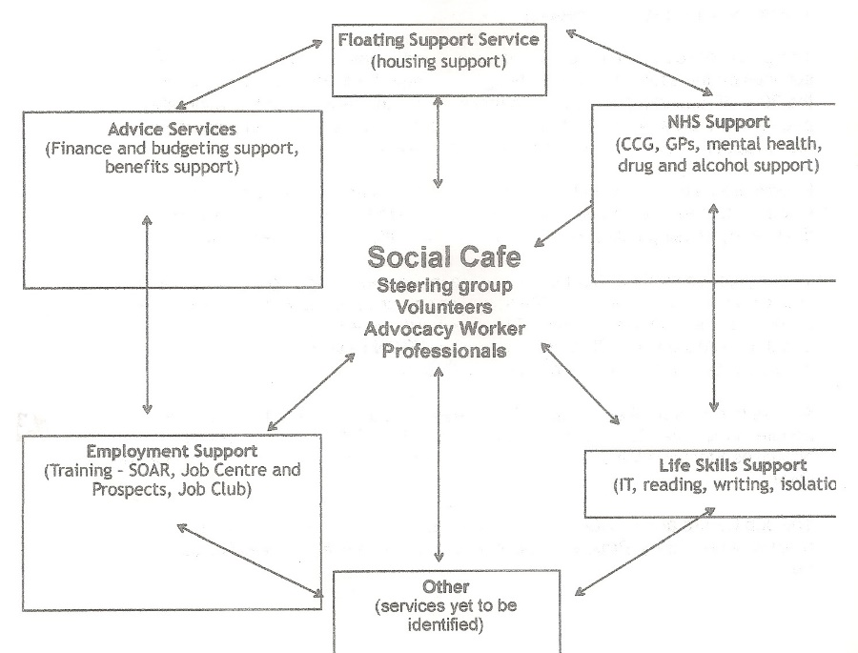
The Isolation working group has commissioned some research, conducted by one of the Adult Care workers based in the Stocksbridge Town Hall. This research involved face-to-face interviews with a set of individuals identified as being at risk of isolation by the various services. This research showed that all of the adult males interviewed displayed a mix of low level health, mental health, housing, substance abuse, debt and lack of skills, meaning that they were unable to make the best of the services available without some support.

The Health Service has done some wider research on the needs of individuals and the potential responses to them. A key finding was that it was not sufficient to provide a service from professionals in the town that was seen as an institutional response and clients were not able effectively to relate to it. Nor did it work well when the service was presented as an “access to services” provision, which usually had the flavour of ‘a place for needy people’. What makes the difference was food and a social environment, where trained volunteers, who would not themselves be advisors, more befrienders, would be supported by professionals from the various services. First steps to integration could then be taken.

Partnerships

This project will only work if it is able to build on existing partnerships and develop new ones. Partnerships already identified include:

- Sheffield City Council has proposed a health trainer to be based in Stocksbridge. The worker would need to be based outside the council and within a church or other organisation. Christ Church has indicated it is prepared to be the umbrella for this. Salary arrangements (To be confirmed)
- The Health Service has offered to support interventions to reduce isolation and develop some form of social café option. (To be confirmed.)
- Pitsmoor and Shiregreen Community Transport hopes to commission a dedicated accessible minibus for Stocksbridge (To be confirmed.)
In addition, all the groups listed on the accompanying graphic have participated in the thinking for this proposal and will be partners in its delivery.
The project will be managed by a project steering group drawn from Christ Church and the Isolation Team members and will be an activity created under the umbrella of Christ Church Community Project.

The project will have its own set of accounts. The salary will be paid through the existing Methodist Church national payroll arrangements.

Staffing

It will not be sufficient to deliver the Vulnerability and Isolation Project only with a volunteer team, though a team of volunteers of both genders and a mix of ages will be necessary. The minimum that is needed is a dedicated worker to lead the project, and support the voluntary activities which are linked to it. It is proposed to apply for funds to support such a worker from the national churches and other funding bodies.

In addition a portion of the time of one of the part-time lay workers at Christ Church will be assigned to the project to support the Lunch Club one session per week.

A team of volunteers from Christ Church and the community will be recruited (some are already identified) to create and run the Lunch Club. There will be close liaison with the Community Care project.

A team of volunteers to run the Social Café will be recruited from around the Valley, including from local churches and community activities. There will be close liaison with the Hub, which hosts the Food Bank, which is managed by two members from Christ Church.

A nominated team of named individuals from the various agencies will be assigned by their agencies with a direct responsibility for being the lead contact and referral point and source of expertise in the specific agency area.

Proposed Annual Budget

This project is NOT to set up lots of un-sustainable activities. A key element of the project is that networking among existing services and activities is the most important factor in delivering successful outcomes.
Income | £ | Expenditure | £
MATP Fund* | 10,000 | Salary 1 person | 18,000
URC Synod* | 7,500 | On-costs | 2,000
Town Council | 1,000 | Operating budget | 2,500
Well-being services* | 5,500 | Lunch Club use of rooms | 1,000
The Bridge Shop | 500 | Social Café use of rooms | 1,000
Rotary | 500 | Admin and phone costs | 500
Other local funds | 2500 | Publicity and networking costs | 1,000
Christ Church | 500 | Transport services | 1,000
Income budget | 27,000 | Estimated expenditure | 27,000

The scoping of the budget allows for one worker, with a small operating costs budget. The project will be tasked with developing a strategy for sustainability and we are anxious to ensure that the project does not become too expensive, so that it is unviable over the longer term.

Part of the work of the first three-year phase will be to develop options for sustainability. Having said that an initial annual budget is indicated above. The plan is to seek a three year funding plan for this from the various funders. Where funders are listed, their contribution will be requested for the three year initial period.

Both the Lunch Club and the Social Café will have their own accounts for their specific activities. They will handle their own user group contributions, costs of food and transport, and other running costs.

*MATP This is the Methodist ‘Mission alongside the poor’ fund and it has indicated that it will consider a bid if it arrives by 2nd March 2015.
*URC The Yorkshire Synod has indicated that it would be prepared to consider a small grant once the new community hall is built at Christ Church.
*Well-being This is a ‘catch-all’ for the various emerging funding streams aimed at reducing demand on the NHS. There are several possible routes to funding, one of them specifically able to support Social Cafes.

Why the Church?

Why is the church, in the form of Christ Church, getting so involved in this work?

First, we believe that Jesus called his followers to love their neighbours. But he was more specific than that. He called us to stand beside vulnerable and isolated people, the poor and people from outside our community. He called us to bring hope to the poor and release to the captives. In this context we know who some of the poor are, we know some of them are strangers among us, and we know how some aspects of our current life can capture people in their grip and cause them to be vulnerable and isolated.

Second, the churches in the Valley have a long tradition of practical action that supports communities and individuals. Among these are the Community Care Group, the Bridge Shop and the Food Bank. These are all supported and run by members of the churches in the Valley. This is a new project for a new time, which will work alongside these continuing Christian manifestations of compassion.

Third, the churches in the Valley have a history of collaboration, and we believe that there is room for this to develop in this project.

Fourth, the redevelopment of the buildings at Christ Church are precisely so that they can be of benefit to our community, and this means some tough actions, as well as some easy actions.

Rev Ian Lucraft, January 2015

