

Development Update 5 : July 2014

Property Committee recommendation to the Church Meeting on 27 July 2014

This is the recommendation of the Property Committee to the Church Meeting, which, as agreed at the last Church Meeting, would be presented in writing to an extra-ordinary Church Meeting when ready.

Tenders

As I have reported at various meetings, the tenders came back at higher figures than estimated. Excluding two builders who submitted very high prices indeed, we have been considering in detail the two lowest bidders. These builders are called Wombat who tendered at £434,000 and Restoration of Glossop who tendered at £447,000.

Cost of Build

We have met with these two lowest bidders to work out savings on their bids. In each case we have been able to identify savings, in line with the suggestions that we reported in June. We have identified about £40,000 savings from the Wombat proposals and about £58,000 from the Restoration proposals. Therefore the final proposed contract prices for the two bidders are very close. There is still some detail that we will have to finalize with either one, but the tender prices are now approximately £394,000 for Wombat and £389,000 for Restoration. By the time we have added in the other costs of the build, planning, architects, surveyors, VAT, legal and other charges and the cost of fitting the kitchen, this means that the total cost of build is now about £468,000. (The Property Committee is adding to that an allowance for Contingencies of £31,000.)

Terms of contract

When we issued the tender, we asked the builders to agree to a fixed price contract. This means that once we have agreed the specification and the price to be charged, that is it. The builder agrees to build the building for that price. Restoration has agreed to that arrangement, but Wombat, because it is a significantly smaller business has not felt able to agree to those terms. However, Wombat has proposed that we agree an estimated price, and any savings would be passed on to the church, though of course any extra costs would be the responsibility of the church to pick up.
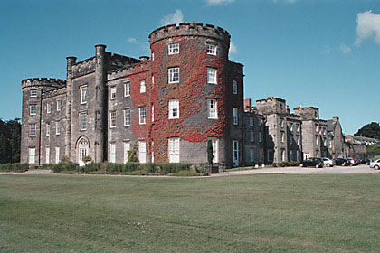

Timescale

We understand from Restoration that they have the capacity and availability to start as soon as we can finalize URC consents, and that could be in September if we get the URC agreements through in time, and then
Two year project by Restoration to restore and convert to flats Bretby Hall in Derbyshire, with new roofs and buildings, working with English Heritage

complete the build in 24 weeks. Wombat has come back to us this month and said that they are agreeing some other contracts, and so may not be able to deliver our building in the timescale that we hope for.

Capacity

Both builders have given us some details of some of the buildings that they have previously built. The Property Committee is convinced that the quality of the Wombat build is good. Restoration have built substantially larger and more complex building projects, often in old churches, and four members of the property committee have been to Glossop and seen one of these. They report that the quality and scale of the buildings gives the Property Committee full confidence in the capacity of Restoration to build our building.

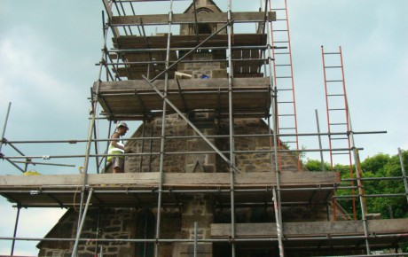

Major repairs and re-building by Restoration of parts of the ancient Christ Church King Sterndale for the Church of England

Funding

I am pleased to announce that this week we have heard from the Rank Trust that they have agreed to make a grant of £20,000 to the building. This means that the funding in summary is now:

Pre-payments 25,069
Other Christ Church Funds 202,682
New grants and Development Fund 226,158
Total Funding to date 453,909

(This excludes the £72,000 that we are keeping back in our church reserves and not using for the building fund.)

We also have a grant application in to another trust for £15,000 for kitchen equipment and another trust for £10,000. We expect to raise amongst ourselves about £6,000 in the next 12 months. We are also continuing to seek other funds from Veolia and elsewhere.

This means that we already have £453,909 towards the actual cost of build which is £468,000, (leaving aside contingencies) and we are awaiting other funders for over £30,000, which means that we will have enough money to pay for the building costs.

We also have to get the approval of the URC Yorkshire Synod to the funding arrangements. (They have agreed the property consent.)

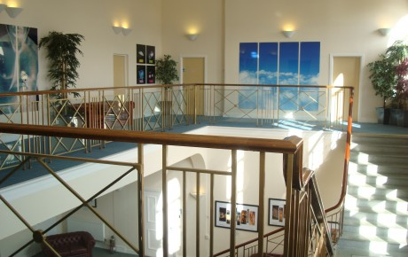

Internal and external restoration by Restoration of former a Victorian building for a national company

Summary

We have raised sufficient funds to pay for the building at its reduced costs.

It has been well worth the wait, because we have raised about £251,000 of NEW money, to add to the money that the church already had of about £202,000 for the build. The new money is more than the total of what we already had.

Recommendations

The Property Committee makes the following recommendation:

The Committee believes that having examined the tenders of the two bidders under construction it should recommend to the Church Meeting that Restoration of Glossop be chosen as the builder.

It justifies this recommendation on the following grounds:

- The revised price from Restoration is slightly lower than the Wombat revised estimate;

- Restoration is prepared to agree a fixed price contract, whereas Wombat will only agree a variable contract;
- Restoration has more experience of the size and complexity of the building required;
- Restoration is able to start as soon as we can agree for them to commence, and complete within a fixed timescale of 24 weeks.

The Committee invites the Church Meeting to accept this recommendation, and proceed to appoint Restoration as our builder, ‘subject to contract’.

You can see lots of examples of Restoration’s work in the display in the Organ Loft.

You can also see more about Restoration on their website at www.restorationprojects.co.uk

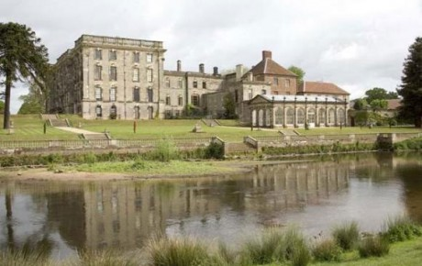

Stoneleigh Abbey where a 2 year project by Restoration restored almost the whole building

Project Plan

There are some items now to finalize before the build can start:

- We have to get the URC to sign the legal charge for Viridor;
- We need the URC to agree we have a satisfactory funding plan to allow us to spend the money;
- Once we have agreed the contractor we need four weeks for the architect and the contractor to agree final drawings and details to finalize the works and the price;
- Restoration have said that they need four weeks from the signing of the contract to begin on site.

That indicates a start date on site around 22 September, provided all the required actions are completed on time.

Ian Lucraft
on behalf of the Property Committee
July 2014

