

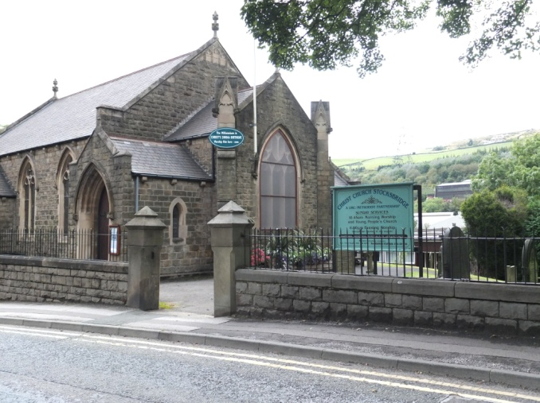

Check us out
To enquire about booking our rooms, please ring Jenny Clarke on 0114 288 3674. We have a very reasonable scale of charges for events, and we can discuss your needs.
Our office holders are CRB checked and our volunteers have all undertaken safeguarding training. Our premises are checked for fire arrangements.

Having your own event here ?
You might want to use our premises for:
- A children’s party
- a meeting
- a conference
- a baptism or naming celebration
- a wedding and maybe a reception
- a funeral and funeral refreshments.

- We have really good facilities, clean rooms, practical seating and a range of room sizes.
- The hall has a small kitchen, either to use yourself or to bring in a catering company.
- We have overhead projection, microphone support and other equipment to make life easy at your event.
- We can usually arrange for crèche, flowers, music, catering or whatever your needs are, either ourselves, or by bringing in other capable people.

- Community Groups
These community groups use our premises:
Stocksbridge Arts Society informal arts class
Tuesday mornings at 9.45 am

Fox Valley Probus
Alternate Wednesdays at 9.30 am

Don Valley Probus
Alternate Wednesdays at 9.30 am

Stocksbridge and District Historical Society
Second Thursday of month at 7.00 pm

Stocksbridge and District Floral Arts Society
Third Thursday of month at 7.00 pm

Please ask for contact details, or see the website.

Christ Church is a Local Ecumenical Project, created by the merger of the former Stocksbridge United Reformed Church, and the former Stocksbridge Methodist Church. We are registered as a charity through both these national churches. We belong to Churches Together in Stocksbridge.
Christ Church Stocksbridge
Manchester Road
Sheffield: S36 1DY
Bookings: Jenny Clarke 0114 288 3674
www.christchurchonline.org

Church Community Workers
Heather Haigh
Emma Evans
Rev Ian Lucraft 0114 234 7153
ianlucraft@btinternet.com 07428 744 014

……….your united church

Christ Church Stocksbridge

Worship and fellowship
Everyone is welcome!

Family worship Sundays at 10.45 am.
Junior Church meets at the same time as Family Worship
Café Church : first Sunday of the month at 6.00 pm.
Reflective meditation : third Sunday at 6.00 pm.

Are you a visitor?

There’s lots we’d like to say, but…..
First ……………, a BIG welcome to you !
We hope that you will feel a warm welcome from the people you meet here, but if you want to keep a reserved distance, we will certainly respect that.
Second …………, we hope that in some way you will find something of what you are looking for by coming here. If it is to find out more about Jesus, and what he might mean for you, we would be happy to help you talk about that, but we won’t thrust ‘study groups’ at you! If it is to make friends, or find out about what we do, we will greet you and ask you what you want.
Third ……… we hope you will want to come again. We hope that not because we need you to help run the church, but because we deeply believe that the journey of discovery about life that we are on, informed for us by the teachings of Jesus, helps us live hopeful and meaningful lives. If you want to join in that journey with us we would love to walk that path with you.
Choir
We’ve got a choir which loves to sing, either on Sundays, or at special events that the church runs. They are a very friendly bunch, and would always welcome new members.
Christ Church Guild
The Guild, for men and women, meets on Wednesday afternoons at 2.00 in the Church Hall. There is always a speaker, sometimes on a religious topic but often not, lots of tea and cake and chatter, and a chance to make new friends or catch up with old ones.
Please ask for a programme with dates.

Fourth ……….we’d like to know who you are, to keep in touch, and so there are visitor’s cards to fill in the entrance lobby, if you want to. We promise not to pester you.
……. and finally, there usually is coffee after church, please do share a cup with us.
You can find out more about us on our website at www.christchurchonline.org

Busy Little Hands (Toddlers)
is the name of our babies and toddlers group From 9.45 to 11.15 in the main church building .
You can walk right in from the street without any steps. There is space inside to keep your buggies safe and dry. We have a large play space, a story circle, and a snack area. There are large and small toys and creative craft activities. All the leaders are CRB checked.
We are members of the Pre-school Learning Alliance, and fully insured.

Good Days Project
We are privileged to be the hosts for an amazing project which provides sensory and developmental support for young people with severe learning difficulties. This is a highly personalized, therapist led, specialist day service for people with Autism, profound multiple learning disabilities (PMLD), complex needs and challenging behaviour. The project operates in the lower hall of church during the week.
Community Activities
Christ Church is working to develop more links with the community using our premises, or working with us on community based activities.
We are currently sharing with a consultation among local Stocksbridge organizations about how the church can help reduce isolation for adults and older people in the town.
If you have any ideas, or want to be involved in the thinking about these exciting new steps we are taking, please speak to someone, or email one of the ministers.

More information
For the weekly details, please see the notice outside the church, or pick up a newsletter. If you can’t see one, please ask!
We’ve got leaflets about celebrating the birth of your child and getting married at the back of church.
There’s more information on the church website at: www.christchurchonline.org

